# Top 5 Questions (Completed)Top 5 Questions (Completed)

Make sure slow down

1. **Introduction:** Tell me about yourself?

My name is ********

I am an automation and manual, tester about **** years now . Throughout my career, I have gained valuable experience in different areas of testing.

I have a strong background in automation testing ,Manual testing and Agile Scrum methodology and also I have a deep knowledge of programming languages such as Java SQL, that I have been using in my job as a tester.

I have a different set of experience in testing, and i have worked in many projects which helped me to become proficient in different tools. I am on the automation , and I am also a cross-functional team member working on manual testing as well.

I am well-experienced in different tools that I have used in my IT industry , such as Soap UI, Karate API, Postman, Rest Assured. JUnit, TestiNG, Cucumber,c#

Jira, Selenium Web Driver, and Maven for UI & API automation and Jenkins for continuous Integration. I have experience working with Jira for test management and reporting defects. I also have knowledge and experience in performing different types of testing including, API testing black box testing, Integration testing, UI testing, back-end testing smoke testing, regression testing.to share my projects and work with my team, I use GitHub

## I would describe myself as highly curious and focused on learning in all parts of life, personal and professional. In my professional life, I look for the hardest problems to solve and where I can learn and develop the most

I am a highly competitive person, but I also enjoy working in a team and taking part in a challenging environment where I contribute and learn from others

I always make myself available to help my team and do not hesitate to ask for help should I need it.

currently looking for new job opportunities to continue to grow in my career, and I am confident that my skills, experience, and attitude will make a positive impact in this position.

1. **Project:** Tell me about your project?

**Project 1:** Electronic Medical Record System

**Domain:** HealthCare

**`Application Name:** Electronic Medical Record (EMR) System

**Application Type:** Web-based Application

**Description:**

The Electronic Medical Record (EMR) System is a web-based application used by healthcare providers to manage patient medical records. The system is designed to replace paper-based medical records, making it easier for healthcare providers to access patient data and track their medical history.

The EMR System includes a range of functionalities that enable healthcare providers to manage patient data more efficiently. Some of the key functionalities include:

* Patient record creation and management - The system allows healthcare providers to create and manage patient records, including demographic information, medical history, and visit notes.
* Medication administration - The system allows healthcare providers to manage patient medication administration by recording prescribed medications, dosage, frequency, and

,...duration.

* Lab test result entry and tracking - The system allows healthcare providers to enter and track patient lab test results, including blood tests, urine tests, and imaging tests.
* Physician notes - The system allows physicians to record and access visit notes, including patient complaints, diagnosis, and treatment plans.
* Insurance claims processing and billing system integration - The system integrates with other healthcare systems, such as insurance claims processing and billing systems, to ensure that patient billing and claims are accurate and up-to-date.

## Overall, the EMR System's functionalities are designed to improve patient care by making it easier for healthcare providers to access and manage patient data. It also improves communication between healthcare providers and enables better coordination of care across different healthcare settings.

##### **:** Tell me about your framework?

Currently, the framework I am using is **BDD with POM.** It is a combination of **data driven, keyword driven** and **behavior driven frameworks**. It supports **UI Automation, API Automation,** and **data validation**.

initial stage of framework creation, and I was **heavily involved** with the development process.

Upon joining my current organization, they didn’t have an automation framework, and they were in the

To build the framework, we used different tools including **Selenium WebDriver, Selenium Grid,**

**Cucumber, JUnit, Maven, Karate API, GitHub, Jenkins, JDBC and Java for Programming Language**

For any **User Stories** that is related **Front End** we are using **Selenium**.

* + We follow **SOME** of Page Object Model Design Pattern Concepts. Any business logic or validation for the specific class are kept in the specific Page Class.
  + Instead of storing the web element objects in the Page class or creating object repository in page

class, **we are actually keeping in Property File.**

* + All of our application web element objects are stored in the property file and accessed during runtime to retrieve the locator information.

For any **User Stories** that is related to **API** we use **Karate API.**

* + Karate API is built on top of cucumber in which we don’t have step definition class.
  + Usually with cucumber we have feature file which contains scenario steps and step definition class that has the java methods for each step-in feature file.
  + With Karate API we don’t need step definition class, because everything is done in feature file.
  + With Karate API, we can also call Java methods, connect to database perform assertions, call one scenario from another scenario and perform parallel execution

For **data validation**,

* + We use JDBC when interacting either with test repository or application database in SQL Server.
  + For both API and UI User Stories we cross validate against the database to make sure the data that is displayed on UI or retrieved from Server is matching the data stored in application database. else can **pass the test data** from **different sources.**
  + We can connect to database using **JDBC** and retrieve the data then use in our test scenario.
  + We can also use to store the test data in **external file** like **Excel, JSON, XML or Property File** then use in our test scenarios
  + Third way we pass the test data **directly in feature file** with **scenario outline or data tables.**

In terms of **Reporting**,

* + We are using **Logger**, **TestNG Assertions, and** we have built **TestResultTrackerUtility Class** which

**keeps track of execution results.**

* + Pretty much **every testcase we are running** will have some **type of validation,**
    - it can be **field validation,**
    - **data validation**
    - or **error message validation,**

Whenever we are **doing validation** we will update the **Execution_Detail** Table in **Test Repository** of **SQL Server** and then **generates 2 types of report,**

* + **Cucumber Report** and
  + **Extent Report.** The Extent Report will have everything, including a screenshot, logs and **graphical representation** which is **very useful and easy to share** with management and the rest of the team.

For **Version control**,

* + We use **GitHub**, we follow common practices among teams by stashing, pulling or pushing when interacting with GitHub.

For **CI,** we use **Jenkins**.

* + We have scheduled automated jobs that run on a daily basis and jobs that trigger automatically when new build comes to our environment. Both Smoke Suite and Regression Suite are executed on Jenkins Server

1. **Role & Responsibility:** Tell me about your role & responsibilities?

Tell me about your Role & Responsibilities?

I am responsible for testing the user stories assigned to me in the sprint planning meeting. While we are in-sprint automation, it is my responsibility to automate the testing by the end of our sprint.

My first responsibility is to understand the requirements and be familiar with how the

functionality of the application operates. After that I need to write test cases against those requirements and write some test data if we don’t have it.

I contribute to the overall code quality by integrating automated testing into the continuous integration/continuous deployment (CI/CD) pipeline. This helps identify and address defects early in the development process.

I'm also Identifying and documenting defects or issues found during testing

I am also responsible for performing various types of testing including Smoke Testing, Regression Testing, Functional Testing and Black Box Testing.

I’m also responsible for managing and developing the automation framework, automating the smoke suite, regression suite and setting up jenkins jobs.

I also help the manual tester in our team to create test cases and perform these tests and it helps when I’m writing automation scripts.Currently, about 20% of my time is spent supporting the automation frameworks team and 80% of my time is spent working on scrum related projects. I am responsible for executing test cases and generating reports. If needed, I support the creation of new framework components and migration of tools.

As we progress through our sprint ceremonies, I do take part in the spring planning, sprint grooming, sprint review, and sprint retrospective meets and provide my insight in relation to testing.

And also i am currently supporting 2 scrum projects teams and am also part of the test automation framework.

Test Reporting:

* Generating test summary reports and communicating testing progress, results, and any significant issues to stakeholders.

a. **Day-2-Day Activities:** Tell me about your day-2-day activities?

Tell me about your Day-to-Day Activities?

I start my workday at 8AM and usually first thing I do is open emails and check if there is any email that needs my immediate attention. After I have looked at the emails, I check the reports for smoke testing to make sure nothing is broken from the last smoke test.

If there is any defect or bug found, then I bring to the responsible person quickly and check with them if the defect can be fixed quickly before daily stand up. If the defect is serious and won’t get fixed quickly, then I mention during the daily stand up.

By the way, our daily stand up at is at 10:30 EST which last about 14-20 minutes. So, we have

enough time to work on the bug before daily stand up. If the issue doesn’t get fixed, then I create a bug report for it in Jira and assigned it to the developer.

After daily stand up, I attend other various meetings throughout the day with different team members. For example, usually at 11AM, I also connect with the remaining of the automation

team and discuss the progress and check if anyone needs assistance with their work.

If I am not in the meeting, then I work on the task assigned to me. We are moving forward in

sprint automation, so I make sure that I am up to speed with the sprint and that my task is completed by the end of the sprint. Once the day is done, and before I log off, I log the hours spend on the task and log the report on Jira board.

**Team(Complete)**

1. **Scrum Team:** Tell me about your scrum team, sprint duration?

We follow **agile methodology**, specifically **scrum**. My **Scrum Team** consists of **11 members.**

We have:

* + **5 Developers**
  + **3 Testers ( 1 Functional Tester and 2 Automation Tester)**
  + **1 BA**
  + **Scrum Master**
  + **And Product Owner**

Our **Sprint iteration** is **3 weeks**, and we perform **IN-SPRINT AUTOMATION**,

* + So pretty much all the **User Stories** need to be **automated within the same sprint in order for PO to accept or mark the User Story as complete.**

I am one of the **Automation Engineer**

* + And I perform both **manual** and **automation testing**,
  + Participate in different **agile ceremonies**.
  + And make sure the testing activities are taken care of for my project.

I have a **very close relationship** with my team and **work closely with them**.

* + Depending on the **User Stories**, I **team up with different Developer** each Sprint.
    - And **work closely with them** to make sure the **requirements are tested and automated.**

I also communicate with my **internal QA team.**

* We have **internal review sessions** for testcase and automation script.
* And I **provide support** if they need support with automation or manual testing activities.

##### **Scrum Meetings:** Explain each scrum ceremonies and your contribution as SDET in each meeting?

**Stand Up**

The stand-up meeting for my current team **happens daily first thing in the morning at 9:00am**. Typically, our stand up lasts for **15-30 mins.** During this meeting each team member provides **status updates**.

When providing updates, we pretty much talk about:

* + **What we did the previous day,**
  + **What we are planning to work on today,**
  + **And bring up if we are facing any blockers.**

**Our stand up is divided up into 2 parts:**

* + In The **1st – 15 mins** we go in circle and provide status update.
  + In The **last 15 mins** we discuss about the **blockers**, **issues**, **challenges**, or **any updates related to Project.**

**Sprint Grooming**

We have **2-3 Sprint Grooming meetings each Sprint**, which typically happens **every Tuesday around 1PM**.

During this meeting we are focused on **grooming the User Stories** by **go over the Requirements** and

**provide input to PO**.

We need to make sure the **User Story is groomed** and the **input from QA & Dev team also included before going to the Sprint Planning Meeting**.

**One of the rules** we have when going to the **Sprint Planning meeting**,

* + The **User Story must be groomed** then we can go over **otherwise** we **will not consider as part of upcoming Sprint.**

**Sprint Planning**

Our **Sprint Planning** happens on the **first day of the Sprint** and during this meeting we **actually have our webcam on** and takes **almost half of the day, starts at 10 AM and goes up to 2PM**.

**During the meeting,**

* PO goes over the list of User Stories in Product Backlog
* And we as a team discuss, ask questions and provide story point from QA and Dev standpoint.

**The goal of the Sprint Planning**,

* Is to set the Sprint Goal for the next 3 weeks.
* It is important we plan out properly.
  + And go over any dependencies, challenges we might encounter and find out team capacity.

During this meeting, I am **pretty active and try to understand the requirement** from the **testing standpoint** and ask follow up questions if anything unclear.

**Sprint Review**

Our **Sprint Review meeting** usually is on the **last of the sprint and it usually takes about hour.** This is one of the formal meetings which we p**resent our progress to the management and stakeholders.**

The **meeting is divided into different parts,** our **PO kicks** with **introduction and going over the slides**

which contains **summary and status for the sprint tasks team worked**.

We have **different slides that summarizes**

* List of User Stories **team completed.**
* List of User Stories **team couldn’t complete and reason.**
* **Defects and any challenges we have faced.**

**Once PO is done then**

* **QA Team takes over and does demo on User Stories** that we have developed and tested.
* I usually do **demos on the User stories that I have tested**
  + And sometimes fill in other team members part **in case if they are not able due demo.**

Once we are done with the demo, the last part of the meeting, we usually **gather feedback from stakeholders and management** and answer any questions that come up.

**Sprint Retrospective**

**Sprint Retro** is the **last meeting** which **follows right after our Sprint Review meetin**g. It lasts anywhere from 30-60 mins **depending on how our sprint went.**

In **Retro meeting** We **usually take a step back as a team**

* And **go over the progress,**
* **Challenges** we faced during the Sprint.
* And **discuss any improvements** or **changes** we need to focus on as a team to improve the process.

This is **important from a team standpoint** to have an opportunity to **celebrate what we did well** and

**determine how to carry** on those successes into our next sprint.

#### User Story Process

Once the **User story is assigned to me during** the **Sprint Planning meeting**, I usually **spend some time understanding the requirement** and **plan out on how I will be working** on the User Story in order to provide the quality testing and deliver the User story by the due date.

After reviewing the User Story, depending on the requirements, I usually **split the User Story in multiple Sub-Tasks and assign to myself on JIRA board.**

The **sub-task I will be creating are**:

* Prepare Test Cases
* Prepare Test Data
* Test Case review
* Prepare automation script
* Execute manually
* Execute via automation script
* Demo to PO

Our **sprint iteration is 3 weeks**, while the **developers are working on the User story to develop the functionality**, in **parallel I will be working on the subtasks**. Basically, I will be preparing test cases, test data, automation script and have the test case review internally with the other testers in my team.

**Once the developers finish and deliver the build in scrum region**, I will continue working with the remaining subtasks. **Perform the manual testing first** then **execute the automation script** to make sure the expected and actual results are matching.

**Once I am done with testing** the user story and if there are no issues found then **last step I have to demo to my PO** and she has to approve otherwise provide feedback in case if I miss something from the requirement.

##### **Story Point:** Explain how many user story you work each Sprint and how do you estim

1. ​
2. ​

##### story points?

The number of **User Stories** that I work on during each sprint can vary depending on their

* + **complexity,**
  + **size, and**
  + **the capacity of the testing team**.

When **estimating story points**, we use the **Fibonacci Sequence**. During the estimation process, we

**consider several factors such as the**

* + **Effort required to Develop & Test User Story**
  + **Complexity of the User Story,**
  + **Risks, and**
  + **Any dependencies associated with each User Story.**

In our **Estimation Process**,

* + Each **User Story** is assigned a **story point value from the Fibonacci Sequence**, typically ranging from **1, 2, 3, 5, 8, 13, 21**, and so on.
  + ‘,kThe **larger the story point value,** the **more effort and complex** the **User Story** is.

During the **Sprint Planning meeting**,

* + Once our **PO goes over the requirement**, as a team we **together discuss and evaluate each User**

**Story.**

* + We **compare the new User Stories with previously completed** ones to have an idea for estimation.
  + We consider the **similarities and differences** in terms of **complexity and effort required**.

During this **collaborative discussion,**

* + We try to come up with a **story point estimate** for each User Story.
  + By going through the estimation process it helps us as a team **pick the appropriate number of User Stories** based **each members availability during the sprint and overall teams capacity.**

Typically, **each sprint** I work with a range of **9-10 story points**. However, the **number of user stories that make up this total can be different on their individual story point values.**

1. **Definition Of Done:** What is the definition of Done for your project?

The **Definition of Done (DoD)** for our project outlines the criteria that a **User Story must meet in order to be considered complete and ready for release.**

It is pretty much d**efined by the PO** and agreed by the **Development Team including BA, QA and Dev**. This helps our team work together and establish a shared understanding o f the criteria that **User story must meet in order to be considered complete.**

**For our Project Definition of Done includes of:**

**Code Review and Unit Testing needs to be done by Dev Team:**

* Once the **User Story functionality has been implemented** by the developer then Dev Team must have **internal code review** and **perform Unit Testing**.
* **Unit Test passing percentage must be 85% or above** before they deploy to the **Test Environment.**

**Functional Testing needs to be done by QA team: ///b**

* The User Story should be tested including manual and automation by the QA Team

**Test Case Review and Test script Review needs to be done by QA Team:**

* QA Team should have internal review session to ensure we have proper test cases and

**And Performance Testing needs to be done by Performance Team**

* Once we deploy in higher region, Performance Testing Team responsible running different type of testing to ensure the performance of application is stable and aligned towards the expectations.

1. **Not Complete US:** What happens when the US is not completed by the end of Sprint?

When a **User Story** is **not completed by the end of a sprint**,

* + we usually **take a step back and as a team**
    - **review the incomplete User Story** and
    - **analyze the reasons why it is not completed.**

Once we know the reason behind it, which could be

* **unexpected problems,**
* **dependency or**
* **any other challenges that caused not complete.**

During our **Sprint Review meeting**,

* We pretty much do **demo to the stakeholders and to the management** on the **overall status of the sprint.**
* For any **User Stories** that we **couldn’t complete,** we will **provide status updates and explain the reasons for non-completion.**

Usually, our **Sprint Retro meeting** is right after the **Sprint Review.**

During the Retro meeting

* We will discuss about the **incomplete User Story** and the **factors that lead to its non-completion**.
* During this meeting we will try to discuss and **focus on how we can improve** and prevent running into similar situations in future sprints.

As a team we will determine which part of the **requirements were completed** and **which ones were not completed** and adjust the story point and the requirement scope if need it.

**Then we will carry over to the NEXT SPRINT**.

##### **Late Deploy:** What happens when the dev team deploys the code late or on last day of the sprint?

**In initial stage of our project,**

* + This was common things for our team, we used to get the **code from dev team 1 or 2 days before end of the sprint.**
  + Which put **QA team in pressure position** because as soon it was deployed then our **PO or management would ask about the testing status update.**
  + Sometimes, we had to stay **off business hours to continue with the testing activities**, even **login over the weekend** to make sure we **tested thoroughly before sprint ends.**

Although we as QA Team overcame and ensured that we tested thoroughly **before signing off,** it was **not the correct process** which could **impact the quality of the application and testing activity**.

First of all, when we **run into this type of situation,**

* I am very flexible, and I will make myself available to make sure we complete the testing before the sprint ends.
* I will ensure to communicate with the team,
  + If required, I don’t mind working additional hours, reprioritize tasks.
  + And **keep the QA manager in loop** in case if we need assistance from other team members to ensure we test thoroughly.

Incase if we **could not finish the testing activity** or we **found the defect,**

* Then **we won’t be able to sign off** and **mark the user story as incomplete** then **carry over to the next sprint**.

If we were **able to finish the testing activity**

* Then that will be **good accomplishment** for us to overcome the challenge and work as a team to deliver.

**On last of the Sprint,** We have a retro meeting, and

* I will definitely **bring up about the challenge** we run into **due to late deploy from dev team.**
* I will go over **how the late deployment can impact the testing activity** and as a team discuss how **we can improve the deployment process.**

It is important **QA and Dev Team works together and communicate** to improve the development and testing process.

1. **What to Automate:** How do you determine which user stories require automation testing?

In my current team, we perform **in-sprint automation**, pretty much **majority of the user stories** we are testing needs to be **automated with in the same sprint**. There are some of testcase that may or may not qualify.

When it comes to **deciding which test case to automate**. We usually automate:

* Test cases that are **executed repeatedly**. By automating repetitive testcase we can save a lot of time.
* Test cases that **involve complex or repetitive steps.** With automation we can handle more efficiently and accurately compared to manual execution, which can reduce the chance of human errors.
* If test cases **involve large data set or data driven scenario**, then we can generate random fake data based on the business requirement from script and use it our test case. Preparing test data manually will consume a lot of time.
* Test cases that **focus on core functionality of the application**
* Test cases with **longh execution time**
* Test cases that **require compatibility testing**. Where we test same scenario with different browser, device, or operating system.

1. **Estimate Testing Efforts:** How do you estimate the amount of testing effort required for a US during the Sprint Planning?

When **estimating the amount of testing effort required** for a **User Story during Sprint Planning**,

* + I **usually take a step back** and try to **understand the Requirement.**

**Before coming to the Sprint Planning Meeting,**

* + I usually allocate sometime to **review the User Stories**
    - By going over the **Acceptance Criteria** and
    - Any **relevant documentation** that is attached or available on **confluence page** and **make notes.**

**During the Sprint Planning Meeting** when **PO goes over the requirement.**

* + I will **try understanding** and **see from testing point of view**
    - Then a**sk my follow up questions** if unclear about the requirement.

**Once the requirement is clear**,

* + I will try to **break down the User Story into smaller sub tasks** and
  + Think about the **level of effort for each part of task** based on my knowledge and experience.

The **sub-task I will be considering are**:

* Test case preparation
* Test data preparation
* Automation Script development
* Manual Testing effort

**I will also keep in mind**

* + About the **complexity of the User Story**,
  + The **number of testcases** we have to come up,
  + Do we **have test data that we can reuse**, or **we have to create** which sometimes can be very time consuming.
  + Do we **have automation scripts that we can re-use or have to build new functionalities?**
  + Allocate time for **testcase review**, for **defects**, **reporting** and **retesting**.

I will also try to **pinpoint the requirements for one of the similar previous User Stories** we have completed. And most importantly, **discuss with other QA members** about the challenges and dependencies that might encounter.

By following these important points, I can **provide correct and proper estimation for testing efforts.**

##### **Estimate for not enough Requirement:** Can you describe a time when you had to estimate the testing effort for a user story during Sprint Planning when there were not enough requirements or dependencies available? How did you approach this situation?

One of the User Stories that I had to test few sprints back had to do with the

* + Retrieval Page in our application which has a **search functionality that allows users to retrieve specific member information** based on **different type of searching criteria** like **member number, date range and or by name.**

During the **Sprint Planning Meeting,** when **PO was going over the Acceptance Criteria,**

* + Different number of questions raised to me **from testing point of view**
    - And realized the **requirements were incomplete**
    - And **missing some of the important points** about the functionality we were planning to develop and test.

**The Search Criteria Validation was not provided.**

* We have different validation rules and error handling within our application and for this specific story the validation rules and error handling were missing.
* For example, if I search by **member id that does not exist** vs **data range which does not contain data what should system display.**

**Sorting and Filtering capability for the search result were not provided**.

* It was **unclear whether the result** should be **sorted by date, or membered or by other columns.**

I usually take **notes and pay attention** until PO finishes going over the requirement,

* Once She finished, then I had opportunity to ask follow up questions

**o** And **bring up my observations to get clarification on the missing parts of the requirements.**

Once I brought up about the **error handling** and **sorting & filtering capabilities**, somehow **PO missed discussing this part of the requirement with stakeholders.**

We **couldn’t move forward with this story** because PO had to reconnect with stakeholders and verify the options.

**Project (Completed)**

1. **Project:** Tell me about your project? **(Pending)**

##### **Technology & Architecture:** What technology development team using to build the application. Explain High Level Architecture of your application (UI -API-Data – Layer)

**SUMMARY**

The **current application** I am working on is a **web-based application** and our **development team** uses different technology stack to build each layer.

First of all, the application consists of

* + **Presentation Layer,**
  + **Business Logic Layer,**
  + **Data Layer and**
  + **Middleware Layer**

The **Presentation Layer** utilizes **HTML**, **CSS**, and **JavaScript** for creating the user interface. **Dev Team** uses

* + **JavaScript frameworks** like **React**
  + And **CSS frameworks** such as **Bootstrap** and **Materialize**,
  + And **JavaScript libraries** like **jQuery** and **AJAX**.

The **Business Logic Layer** uses **Java** with **Spring** and **Hibernate** as a **Java-based web framework**. **It implements**

* + **REST APIs** for communication,
  + **JSON** as the data format,
  + and **SQL** for database querying.

The **Data Layer** uses different relational databases including

* + **SQL Server Management** and **Oracle DB** for **data storage.**
  + **JDBC** is used for **database connectivity.**

The **Middleware Layer** includes

* + **Apache Tomcat** and **Jetty** as application servers,
  + **Apache** as a web server,
  + And **Amazon Web Services (AWS)** for **hosting**, and **deployment**.

1. **Technology & Architecture:** REFERENCE NOTES

**NOTE:** Q2 &Q3 is same, Q2 has the summary we can use during the interview Q3 is for you to gain more knowledge

**What technology is used to build the application by the dev team?**

1. **Presentation Layer (Front-End/UI)**
   1. HTML, CSS, JavaScript
   2. React, Angular ( JavaScript Frameworks)
   3. Bootstrap, Materialize (CSS framework)
   4. JQuery, AJAX (JavaScript Libraries)
2. **Business Logic Layer( Back-End/API)**
   1. Java, Spring, Hibernate (java-based web framework)
   2. Rest API (API protocol)
   3. JSON (data format)
   4. SQL ( database query language)
3. **Data Layer (database)**
   1. MySQL, Oracle DB, SQL Server (Relational Database)
   2. JDBC ( java database connectivity)
4. **Middleware Layer**
   1. Apache Tomcat, Jetty(Application Server)
   2. Apache ( web server)
   3. Amazon Webservice (Cloud services)

**REFERENCE FOR YOU:**

* The **Presentation Layer** is responsible for creating the user interface of the application and displaying data to the user. The front-end technologies listed above are used to create the visual and interactive components of the application.
* The **Business Logic Layer** is responsible for processing data and executing business logic, and uses the back-end technologies listed above to do so. This layer handles tasks such as data validation, database management, and API design.
* The **Data Layer** is responsible for managing the application's data, and uses database technologies such as MySQL, PostgreSQL, or Oracle to store and retrieve data.
* The **Middleware Layer** is responsible for connecting the various components of the application together and facilitating communication between them. It uses technologies such as Apache Tomcat or Jetty as application servers to run the application, and Apache as a web server to serve the application to the user. Amazon Web Services is a cloud service that can be used for hosting and deployment of the application.

1. **N Environment:** How many Environments do you have and what is the process?

We have so many **different environments**. We have

* + **Dev Environment**
  + **Scrum Environment**
  + **Sit Environment**
  + **Performance Environment**
  + **Stage Environment**
  + **And Production Environment**

**Dev & Scrum Environment** considered **Lower Environment**

* + And **the Dev Team works in dev environment** to implement the requirements.
  + Once **Dev Team finishes** with implementation, they will deploy to the **Scrum Environment for QA Team to perform the testing.**

**During the 3 weeks of Sprint Iteration,**

* + There will be **many deployments and fixes** that will happen **between dev & scrum region.**
  + And **towards the end of the sprint** once everything is tested in scrum environment
    - Then it will be **deployed to the Sit Environment**

**Sit Environment** is considered Higher Environment

* And it is always **1 Sprint behind.**
* We have **SIT Tester**, pretty much he **re-tests the features we have tested in Scrum Environment**

and makes sure it didn’t affect other part of application code.

Once the **testing is completed in SIT environment**

* Then it will be deployed to the **Performance Environment**
* And the Performance Team takes over and performs the performance testing.

Once the **Performance Testing is completed** then code is **deployed in Stage Environment** and from there it **goes to the Production.**

##### **Release:** What is the release cycle? How often the project goes to release?

Within our organization we have **3 different types of release**, We have

* + **Quarterly Release,**
  + **Minor Release and**
  + **Emergency Releases**

**Quarterly Release**

* + Is a **planned release** that is **scheduled once every 3 months.**
  + Mainly in our **Quarterly Release we include a**
    - **set of new functionalities,**
    - **enhancements,**
    - **and any bug fixes for our application.**

**Minor Release**

* Are **more frequent** compared to the **Quarterly Release**
* And depending on **circumstance and urgency**
  + If we have an **urgent request or demand from the stakeholder**
  + Or we have **critical bug fixes** that **cannot wait until the next Quarterly Release** then our application will go under Minor Release.

**Emergency Release**

* Are **unscheduled and outside the regular release cycle.**
* Incase if we have **critical issues**, **security vulnerabilities** or **performance issue** that is causing

**major impact for our end users**

* + Then we will **apply necessary solutions to fix** and go through the **Emergency Release** to ensure our end users **do not have to much down time.**

1. **Type of Testing:** What type of testing do you perform?

As an **Automation Engineer** working in Scrum Team, I perform **different types of testing**. The current application I am working on is a **web-based application.**

We have the **UI Layer**, **API Layer** and **DB Layer.**

* About **60%** of our **User Stories** are focused on the **UI Layer**
* And **40%** of the **User Stories** are focused on the **API Layer.**

I also interact with **Database Layer** a lot for **data validation.**

* To ensure the **data flows correctly,**
* And the **application database is reflecting** and **aligned** whenever we **remove**, **add**, **update** or

**create new entry to our application.**

In terms of the **type of testing** I perform,

* I mainly focused on the **Functional Testing aspect**,
  + To ensure the **functionality** of the application is **aligned with the requirements**.

I am very comfortable performing **Functional Testing** including

* **Smoke Testing,**
* **Regression Testing,**
* **End to End Testing,**
* **Component Level Testing,**
* **And Sanity Testing.**

I am comfortable with **UI Testing**, **API Testing** and **data validation** with **database** both **manual** and

**automation.**

##### **Smoke Test Suite:** What is Smoke Test, how many test case do you have in your Smoke Suite, how often do you execute and how do you execute?

**One of my responsibilities** is to ensure we perform the daily **Smoke Testing** first thing in the morning and provide execution result update to the team prior daily stand up. **Initially when I joined the team**, the **Smoke Testing** was performed **manually** by our Functional Tester.

Once I had access to the tools and application, I was able to automate the Smoke Testcases and configure **Jenkins Job** to kick of **Monday – Friday 6AM**.

Currently, in our **Smoke Suite** we have **5 testcases** that focus on the main functionality of the application, and it kicks of daily by **Jenkins**. The execution takes about 2-3 minutes.

If any of the **testcases fails**, I usually **take a step back**, **refer to the logs** and **figure out the root cause** of the **failure**. Sometimes **failure** can be because of the

* + **Test Data issue**
  + **Or Environment related issue**
  + **Or Test Script issue**
  + **Or an application defect.**

Depending on the **failure type**, I usually take necessary steps and provide updates to the team during our **daily stand up**.

* + If it is **Test Data issue**, or **Test Script issue**, I will **ensure to apply necessary fix** to the script then push to the remote and **re-execute the Smoke Job**.
  + If it is an **Environment Related issue**, I will **document my observation** and put a word document file with screenshots and explanation **then reach out to the Environment Team** and let them know about the issue.
  + If it is **Application Defect**, I will **cross validate against the requirement**, **double check to make sure I can reproduce**, then **check other environments to see if the defect exists in other regions**.
    - Once I am **done with my analysis and verification part** then I will put a **document together** and **provide steps to reproduce along with screenshots** and any additional information that will be helpful for our developer.
    - **Once I have put together the document**, then I will **create a defect in Jira and attach the file** then **bring it up during the stand-up meeting**, so the rest of the team is aware of the issue.

#### Test Case Examples (Pending)

1. **UI Testcase Example 1**

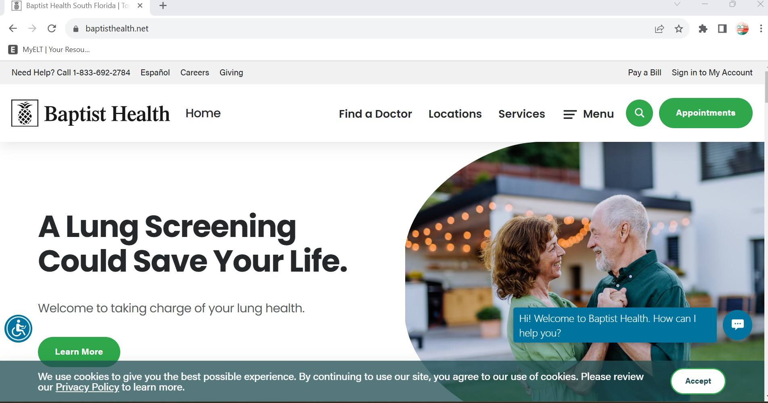

1. **UI Testcase Example 2**
2. **UI Testcase Example 3**
3. **API Testcase Example 1**
4. **API Testcase Example 2**
5. **API Testcase Example 3**

#### Defect Examples (Pending)

1. **UI Defect Example 1**
2. **UI Defect Example 2**
3. **UI Defect Example 3**
4. **API Defect Example 1**
5. **API Defect Example 2**
6. **API Defect Example 3**

**Automation Framework(Completed)**

1. **Create Framework from Scratch:** What is the process of creating framework from scratch?

GOOOREAD

In order to **create framework from scratch,**

* + First of all, I need to **understand the requirements**, learn more about the **project** and the

**domain**.

* + I also need to learn more about the **technology stacks** that are used to **build the application by the dev team**.

From there, it is important for me to also know about the **testing activities**.

* + What **type of testing we are performing,**
  + How we are **reporting the test case results,**
  + How are we **generating the test data** and **managing** the testcases.

Once I have gathered all this information I will take a **step back**, then categorize and come up with a plan. When building framework, it will be important for us to keep in mind about **design, reusability, maintainability and flexibility.**

For instance, if we are performing **UI automation**

* + We can leverage **Selenium WebDriver, Grid.** It allows us to automate different browsers and

operating systems.

* + Along with **Selenium**, we can integrate **Maven** for **build management,**
  + **Cucumber** to write our testcase,
  + **TestNG** for assertions and we can use **Extent Report** to generate report

If we are performing **API testing,**

* + We can continue building on top of UI automation by integrating the **Karate API.**

We also have to **consider the test data,** how we will be passing the test data to the testcases. To achieve that

* + We can use **Test Repository by connecting to database** and grabbing from there based on the requirement then using in our test scenario,
  + Or we can have **external file like JSON, EXCEL** where we can store large data set and read from there,
  + Or we can **directly pass in feature file** and use in our scenario
  + Or we can use **javafaker library to generate random testdata** based on our requirement and use that during the execution.

In terms of **version control and CI tools**,

* + If the organization already has in placed and used by the dev team we can also use that by creating our repository in GitHub or Bitbucket and then we will have **capability to create Jobs** that will **kick off automatically** using **Jenkins or any other CI Tool.**

Once we have all this placed, what **I can do is pick 1-2 Requirements and automate**, then **demo to the team and gather their feedback.**

Then we can go from there by putting a **road map and start the implementation process.**

**Framework Enhancements:** Provide an example of which part of framework you enhanced.

###### Enhancement 1: ObjectMap Class

One of the Utility Classes I have implemented to enhance the framework is the **ObjectMap Class and use Property File to create Object Repository.** Initially we decided to use the Page Object Model Design Pattern with PageFactory Class. Our application has many pages, and we end up creating java class for each page and in each page class we created Object Repository by adding all the web elements.

From maintenance standpoint it was too much and time consuming, and we had many duplicate codes because when using PageFactory with Page Object Model, we had created WebElement Object for each element in the page then provided method to perform action.

First, I created **ObjectRepository Property File** and in there I came up with structure which we can keep the element name, locator type and locator value.

Then, I created **ObjectMap class** which we pass the Property file as argument in constructor and the ObjectMap class reads and loads the application property.

I also implemented **getLocator()** method that takes the name of the property or web element then it retrieves the locator type and locator value. Once the locator information is retrieved then method returns By object for locating element on web page and use it in our **findElement()** to locate the element.

By using this approach, we have **Single Object Repository** for entire project, and we don’t have to write duplicate methods for each WebElements, instead re-use the generic methods we have implemented in our CommonUI class.

=

###### Enhancement 2: WebDriverManager

For our **Regression Test**, we use **Virtual Machines** for the executions. The Regression Job is kicked from **Jenkins**, but the **execution actually happens** in **Virtual Machines** instead of **Jenkins Server**. Because our Regression Suite takes almost 7 – 8 hours to finish and the DevOps team does not want us to occupy Jenkins Server for a long period of time. My team has **2 dedicated Virtual Machines**, and we use **Selenium Grid** to redirect the execution from Jenkins Server to Virtual Machines.

The **challenge we faced with Virtual Machines** was because Virtual Machine controlled by the **Security Team,** and they **usually release new updates** which would cause our **Regression Testcases fail**. For example, if the browser version updated over the weekend and our Regression Suite Running then it will automatically fail because we do not have correct browser driver.

I initially brought this challenge to management and tried to touch base with the Security Team if there is a way for QA Team to be in loop whenever new updates are released.

The Security Team agreed and kept us in the loop for a few weeks but then we started running into the same issue again. I had to take a step back and wanted to find a solution where we don’t have dependencies towards the security team.

To overcome this challenge, I spent my weekend researching and ran into **WebDriverManager API** which we can add to our framework. WebDriverManager removes the manual part, and we no longer depend on the Security Team.

With **WebDriverManager**, we no longer need to download and add to project the driver executable file because it takes care for us. When we kick of execution, WebDriverManager first checks our browser version then checks if we have the correct driver executable, if we have then it will use that, if not then it will download automatically and use it.

By adding this enhancement, we didn’t have to worry about failures because of browser version or depending on Security Team.

1. **Framework Contribution:** Provide an example of which part of the framework you developed.

Upon joining my current organization, they **didn’t have a stable framework** and they were in the initial stage of framework development process. I wa**s part of the framework creation and implementation process from the initial stage.**

While building the framework, there were **many Utility Classes** which I was responsible for developing the script. In our utility package we have many Utility Classes:

###### Utility Class Development 1: DBUtil Class

I implemented the **DBUtil Class**. In **DBUtil Class** we have all the **generic methods** that allows us to

**interact with database** and **perform different Operations** including

* + Retrieving the ResultSet,
  + Updating existing record values in Table
  + Inserting new record in Table
  + Deleting record from table
  + Handling store procedures

Along **DBUtil Class**, I also came up with **Json file** where we will keep the **environment related information**. We have many environments, and **each environment has it is own database.** To keep all the environment information, I kept in Json File and loaded the data based on the region we are executing the test.

###### Utility Class Development 2: Reporting

One of the important features our framework was missing initially was the **reporting and keeping track of validation points.**

We built all the good capabilities that run all our UI and API testcases, but it was **hard to showcase** to **management** or **stakeholders** because showing the execution was not enough. We had to come up with metrics and reports that can summarize what was executed and what validation performed for specific testcase.

To build this future I used different libraries including Logger, TestNG Assertions and develop

**TestResultTrackerUtility Class** which **keeps track of execution results.**

Pretty much **every testcase we are running** will have some **type of validation,**

* + it can be **field validation,**
  + **data validation**
  + or **error message validation,**

Whenever we are **doing validation** we are using **TestNG Assertions** and **store the outcome** in the

**TestResultTrackerUtility Class.**

At the **end of the execution** based on the assertions if everything is passed we are marking passed otherwise failed and capture the reason.

For **reporting**, once we capture everything,

* + we will update the **Execution_Detail** Table in **Test Repository** by providing **high level information**

about the **testcase**, like

* + - **Sprint number,**
    - **User story number,**
    - **Testcase name,**
    - **Execution status,**
    - **Region executed,**
    - **And if failed then the reason.**

Once the Test Repository updated framework **generates 2 types of report,**

* + **Cucumber Report** and
  + **Extent Report.**
    - The Extent Report will have everything, including a screenshot, logs and **graphical representation** which is **very useful and easy to share** with management and the rest of the team.

##### **Test Data Handling:** How do you handle test data and what are the different ways you pass the test data

Within my automation framework, we have the **capability to pass the test data** from **different sources.**

* + First of all, we have **Test Repository** within our team where we can **write SQL query and retrieve the data** then use in our test scenario.
    - It is very helpful to **re-use the existing data instead of creating new ones** which might take time.
    - In our framework we have functionality where we can **connect to database using JDBC**, **pass our query, retrieve the resultset** and use that in our **scenario dynamically.**
* Incase if the **test data is not in database**, we build **Utility classes** that we can **read & write from external files** like **Excel, JSON, XML or Property File.**
  + For some of our API scenarios we use **JSON file** where we **dynamically generate the testdata using javafaker library** based on our requirement then **store in the JSON File** and use that in our request body before sending request to server.
* Third way we pass the test data **directly in feature file** with **scenario outline or data tables.**

##### **OOP Concepts:** Explain how you applied each OOP concept in your framework.

Java is Object Oriented Programming Language. The main concepts of Object-Oriented Programming are Inheritance, Encapsulation, Polymorphism and Abstraction. In my test automation framework, to improve the code readability and reusability I have applied these concepts.

###### Inheritance

**Inheritance** allows us to create **Parent-Child Relationship** between two classes using the **extends**

keyword.

In my **framework,** I have used it in many cases, for instance

* + We have a **Constants Class** which consists of global objects that is shared among different classes,
  + And we have **ObjectInitialize Class** which **inherits** the **Constants Class.**
  + By creating relationships, it allows us to have the direct access and we are able to initialize the global objects that is used between different classes

###### Encapsulation

**Encapsulation** is the process of **hiding the implementation details of a class** from the user by binding the variable and methods together.

We can **achieve Encapsulation**

* + by **declaring the variables or objects PRIVATE**
  + And provide **PUBLIC getters** and **setters method** to access indirectly.

In my framework, I have used it in many of the **Utility Classes**. For instance

* + In our **DBUtil class** we have all the generic methods that allow us to connect and interact with databases. The **Connection Object** in **DBUtil class** is declared with **Private Access Modifier** and we provide **getter** method for other classes to access
  + Another class I have applied is the **PropertyReaderUtil Class**, in which the **Property Object** is declared with **Private Access Modifier,** and we provide **getters** and **setters** method to access outside the class.

###### Polymorphism

**Polymorphism** is the **ability of an object to take many forms**. We have **two types** of **Polymorphism**.

* **Compile Time Polymorphism**
* **And Runtime Polymorphism**

**Method Overloading** is an example of **Compile Time Polymorphism**. This is where in the same class we have 2 or more methods with the same method name but different in parameters.

When it comes to parameter,

* It can be different in number of parameters,
* Or it the data type of parameter can be different
* Or the sequence of parameter data type can be different.

**Method Overriding** is an example of **Runtime Polymorphism.** This is where we have **IS-A Relationship**

between two classes and the child class wants overrides the parent class method. To achieve method overriding

* First we must have IS-Relationship
* Second, child class must have same method name as parent
* And the parameters in child class method must be same as parent class method.

In my framework, I have **TestResultTrackerUtil class** which is used to **keep track of validation details**

including **expectedData**, **actualData**.

In this class I have **addTestResult()** method which uses the **Method Overloading** or **Compile Time Polymorphism**.

I have **6 different AddTestResult() methods**, the method name is same, but the data type of parameters is different for expectedData and actualData.

For UI automation,

We have **CommonUI class** which consists of all the **generic methods** that are used by PageClass. Some of the methods including **entering a value to field** or **handling the dropdown** is

**overridden** by the **Child Classes** which is an example of **Runtime Polymorphism.**

###### Abstraction

**Abstraction** is the process of **hiding the implementation details from the user** and showing only functionality to the user. We can achieve abstraction by **Abstract Class** and **Interface**.

In my framework, I **cannot recall creating abstract class or interface**, but I have used **Abstract Class** or

**Interfaces**. I used **List**, **Map**, and **Set interface** a lot within my automation.

Also, we use **WebDriver instance** pretty much all the time when performing **UI Automation. WebDriver**

in Selenium is an **Interface** which the **implementations are provided by the Child Classes.**

1. **Report Generation:** How do you report the execution result and type of reports do you generate

In my automation framework, during the execution, we are using **Logger**, **TestNG Assertions** and we have built **TestResultTrackerUtility Class** which **keeps track of execution results.**

Pretty much **every testcase we are running** will have some **type of validation,**

* + it can be **field validation,**
  + **data validation**
  + or **error message validation,**

Whenever we are **doing validation** we are using **TestNG Assertions** and **store the outcome** in the

**TestResultTrackerUtility Class.**

At the **end of the execution** based on the assertions if everything is passed we are marking passed otherwise failed and capture the reason.

For **reporting**, once we capture everything,

* + we will update the **Execution_Detail** Table in **Test Repository** by providing **high level information**

about the **testcase**, like

* + - **Sprint number,**
    - **User story number,**
    - **Testcase name,**
    - **Execution status,**
    - **Region executed,**
    - **And if failed then the reason.**

Once the Test Repository updated framework **generates 2 types of report,**

* + **Cucumber Report** and
  + **Extent Report.**
    - The Extent Report will have everything, including a screenshot, logs and **graphical representation** which is **very useful and easy to share** with management and the rest of the team.

1. **Collection Framework:** Explain how you applied Collection Framework in your framework.

###### LIST Example 1

One of the scenarios which I have recently automated required me to retrieve **all the values from the drop-down** and I had to test each option with different test data to make sure that the functionality of the application is behaving as expected based on the drop-down value selected.

In order to deal with dropdowns, first of all, I had to **create an Object of Select class** and using the **getOptions()** method, I would **store all the values of dropdown in the List** because the **return type of getOptions() method is List of WebElement**.

Then I would **iterate through the list of options** and choose the applicable value from the list based on my requirements and test data that I am passing

By using the **List interface**, I was **able to test the drop down with different test data** to make sure **functionality behaves as expected** based on the value, I select from the drop-down.

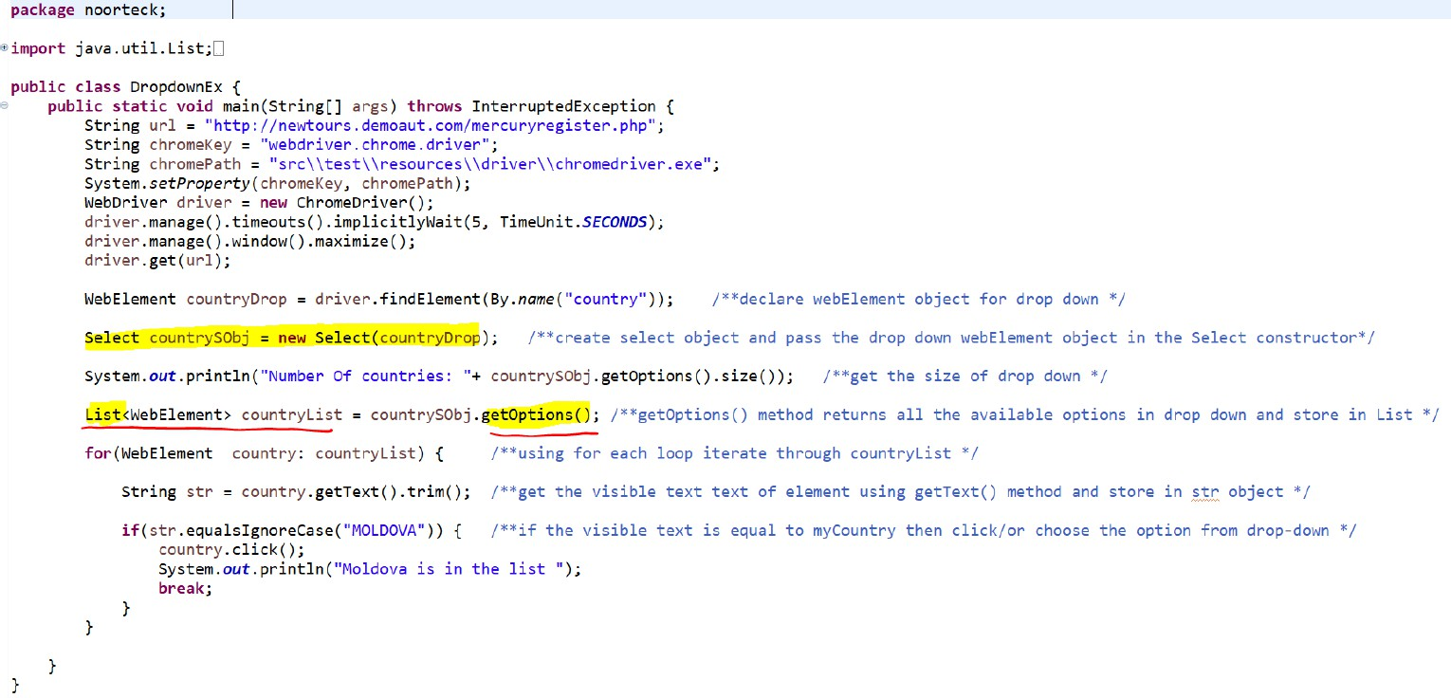

###### SET Example 1

One of the user stories which I automated in the previous sprint was to **verify the Member Details Page displays the correct information.** To make sure that **back-end** (database) and the **front-end**(UI) of our application are aligned and **consist of the same information**.

One of the ways we can retrieve the member information in my application is to look up with member ID from the search page. Once I provide the member ID and search, the application will provide the output in the result section.

To validate the member information, I need to click member from the result table, then

**it will direct me to the Details page in a new window.**

To handle multiple windows, I needed to **keep track of each window and switch between each** in my automation script. Selenium provides **two useful methods** that will **allow us to switch between different windows**. It **assigns a unique ID for each window** opened by the script.

Using the **getWindowHandle()** method we can **retrieve the current window ID** and using the **getWindowHandles()** method we can **retrieve the Set of all window ID**. Since each window contains a unique ID, we can use the **Set Interface.**

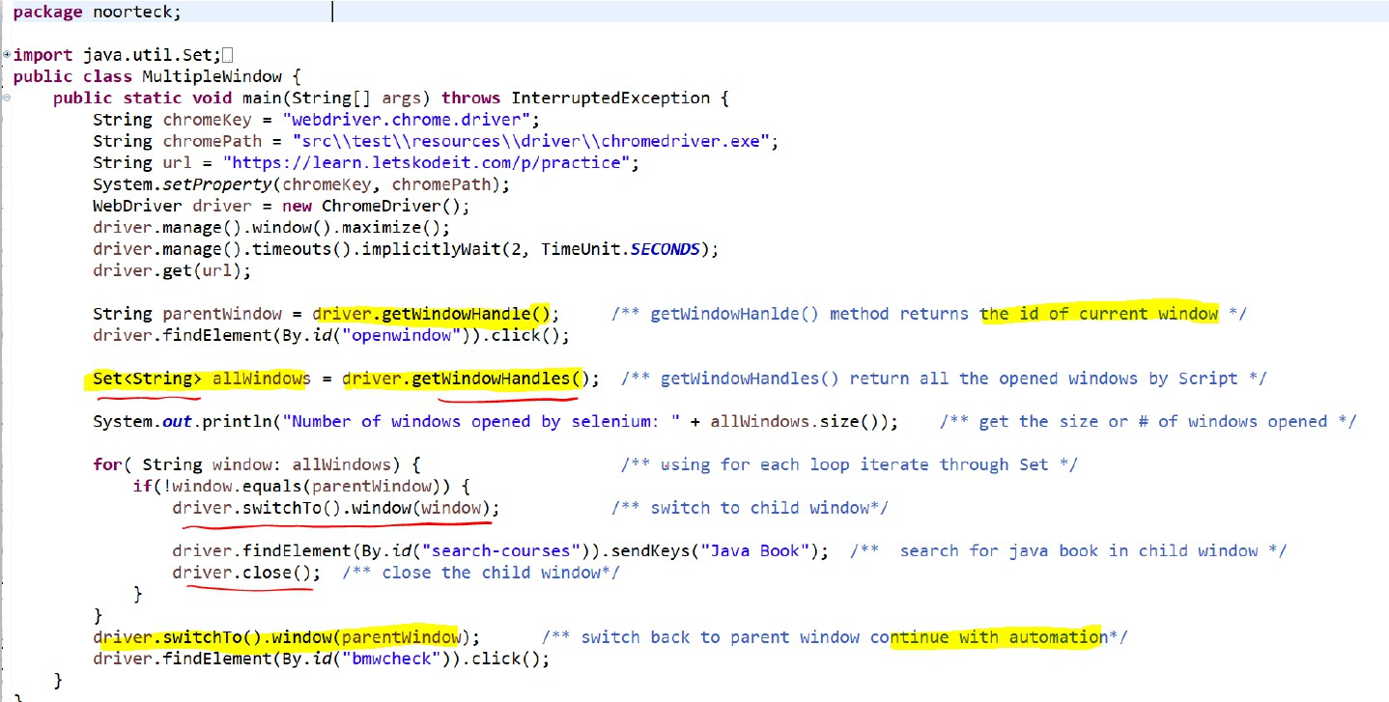Then I would iterate through the **Set of windows** and **switch to the Details Page** to verify the member information.

###### MAP Example 1

In some of my **scenarios in Feature File** I am using **Cucumber DataTable**. With **Cucumber DataTable** we can pass the **data in tabular format** which includes the **table header and table data.**

To handle the DataTable in our **step definition class** we can use **List of Maps**, where **each row in our DataTable will be treated as single Map** and this will be **stored in the List**.

Depending on the **requirement and logic**, I will be **accessing the Map to retrieve the key and value** then use it my automation.

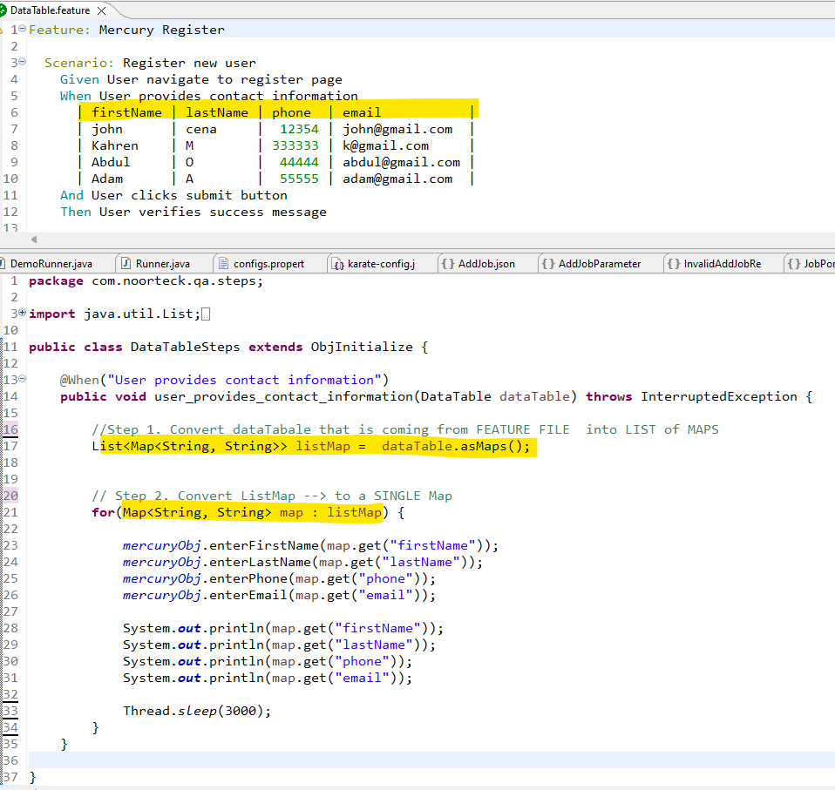

##### **Excel File:** What is the process of reading/right Excel File?

Whenever I worked with a **large data set**, where I had to **pass the data into scenario** during the execution, instead of passing directly to feature file I used **excel file**.

In order to **read/write** the data from an Excel file, First I need to make sure that I have the **dependencies**

in my **pom.xml** file.

* + The dependencies I used to interact with Excel was **Apache POI library**, that has functionalities to read/write.

When **working with Excel file** it’s important we understand how Excel files. In Excel file we can have

**different sheets** and in each sheet we can have data in **rows and columns format.**

###### Reading from Excel File

To **read an excel file** in java. First I need to make sure the **excel file** is stored somewhere within my project, we usually keep inside **src/test/resource** package.

Once I have the file, I need to **creating instance** of **FileInpustStream class** and pass the **location of the excel file as parameter**.

FileInputStream file = **new** FileInputStream(**new** File("excelFilepath"));

Then I will **create workbook instance** and **set that equal to by calling** the **create() method** from

**WorkbookFactory class** and **pass file as parameter**.

Workbook workbook = WorkbookFactory.*create*(file);

Once, workbook instance created, I will **create Sheet instance** and **set that equal to by calling** the

**getSheetAt() method**, **pass the sheetName or IndexNumber as parameter**

Sheet sheet = workbook.getSheetAt(0);

Once I have the sheet instance, I will use **2 loops**.

* + The **outer loop** will be iterating through the **rows**.
  + The **inner loop** will iterate through **each cell** in the row.

**for** (Row row : sheet) {

**for** (Cell cell : row) {

Inside **inner loop**, we can **read cell the value** by **getCellType()** and then **checking the type of cell value**,

* + If it is **String**, **Numeric**, **Boolean** or any other value.

CellType cellType = cell.getCellType();

**if** (cellType == CellType.***STRING***) {

} **else if** (cellType == CellType.***NUMERIC***) {

Based on the **requirement and logic**, I will be **capturing the value**s and applying them throughout my automation.

Once I am **done reading the excel file**, I will **close** the workbook and file

workbook.close(); file.close();

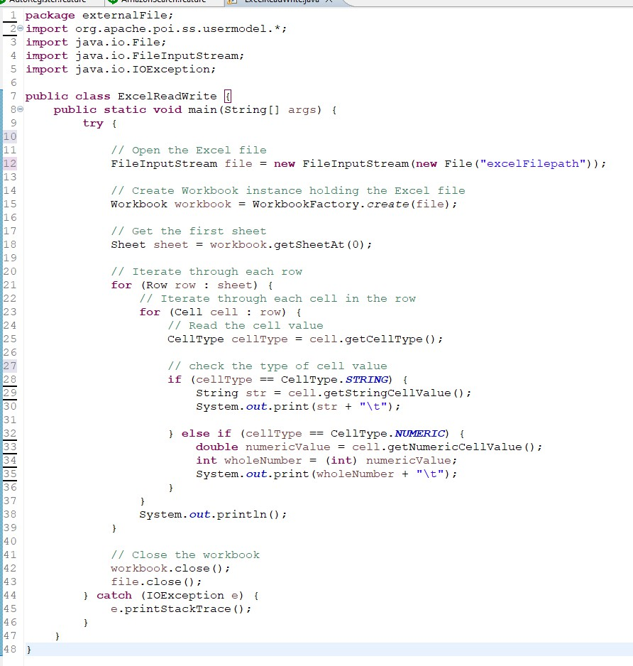

###### Writing to Excel File

To **write on excel file** from java. First I need to make sure we have the **Apache POI dependency** in my

**pom.xml** file.

Then, in order to write, I will **create workbook instance** and **set that equal to by calling** the **create() method** from **WorkbookFactory class** and **pass true as parameter**.

Workbook workbook = WorkbookFactory.*create*(**true**);

Once, workbook instance created, I will **create Sheet instance** and **set that equal to by calling** the

**createSheet() method**, **pass the sheetName parameter**

Sheet sheet = workbook.createSheet("Sheet1");

Once I have the sheet instance, I will **write a data in the sheet**.

* + Row 1 will be the headers and
  + Starting row 2 we will have the test data.

To create header row, we can use **createRow() method** and **pass the row number**

Row headerRow = sheet.createRow(0);

Then to for **data row** we can use **createCell() method** and **setCelValue() method** and pass the **row cell number** and **cell value** as parameter

headerRow.createCell(0).setCellValue("Name"); headerRow.createCell(1).setCellValue("Age");

Once the data is added to the sheet, then I have to **create an object of FileOutputStream class**. When creating an object of **FileOutputStream** class **I need to pass the path of the excel file in constructor as argument**.

FileOutputStream fileOut = **new** FileOutputStream(**new** File("excelFilePath"));

Then we can call the **write() method** and pass the **FileOutputStream object as parameter** to write on excel

workbook.write(fileOut);

Once I am **done writing to excel file**, I will **close** the workbook

workbook.close();

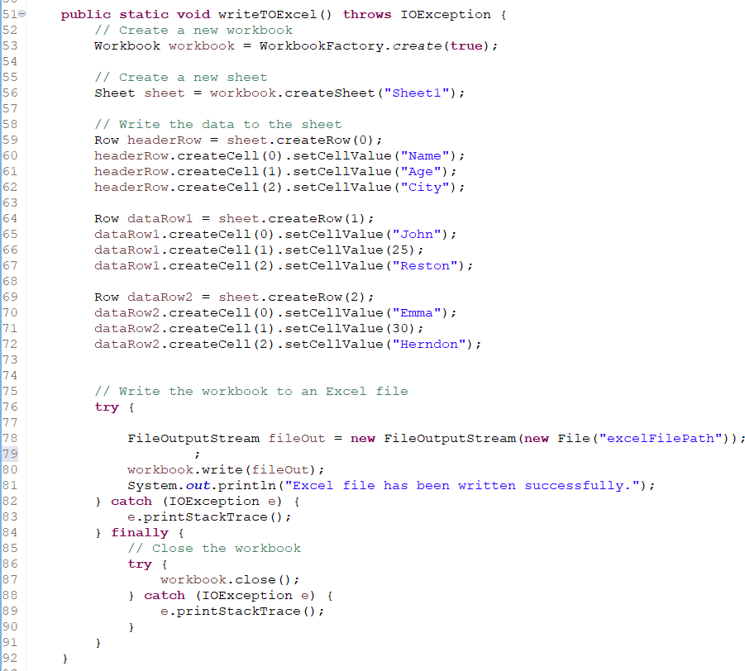

1. **Property File:** What is the process of reading/right Property File?

###### Reading from Property File

In order to **read a property** in Java, we can use the **Properties class** from **java.util** package.

* + **First** I have to **create an object of Properties class**

Properties prop = **new** Properties();

* + Then I have to **create an object of FileInputStream class**. When creating an object of **FileInputStream** class **I need to pass the path of the property file in constructor as argument**. Usually within our framework, we keep the property file in resource source package.

FileInputStream file = **new** FileInputStream(filePath);

* + Once FileInputStream object is created, then we have to **load the property file** by **using property object and passing the file object as argument** to **load()** method

prop.load(file);

* + To **retrieve the values from the property file** we can use **getProperty() method** and **pass the key as parameter**. In property file we keep the data in **key=value** format

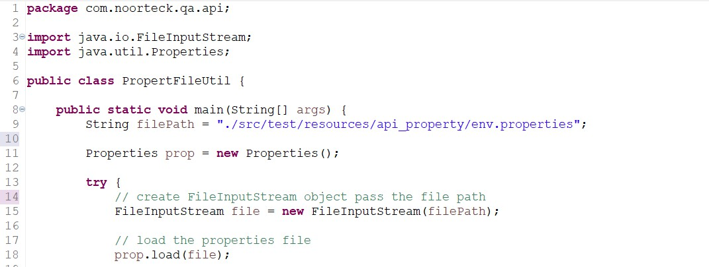String username = prop.getProperty("region"); String url = prop.getProperty("url");

###### Writing to Property File

In order to **write into a property** in Java, we can use the **Properties class** from **java.util** package.

* + **First** I have to **create an object of Properties class**

Properties prop = **new** Properties();

* + Then, we can use **setProperty()** method to pass key-value pair data we want to write to the property file.

prop.setProperty("username", "admin"); prop.setProperty("region", "scrum");

* + Once the data is added to the property, then I have to **create an object of FileOutputStream class**. When creating an object of **FileOutputStream** class **I need to pass the path of the property file in constructor as argument**.

FileOutputStream file = **new** FileOutputStream(filePath);

* + Once **FileOutputStream** object is created, then we have to **store the property file** by **using property object and passing the file object as argument** to **store()** method

prop.store(file);

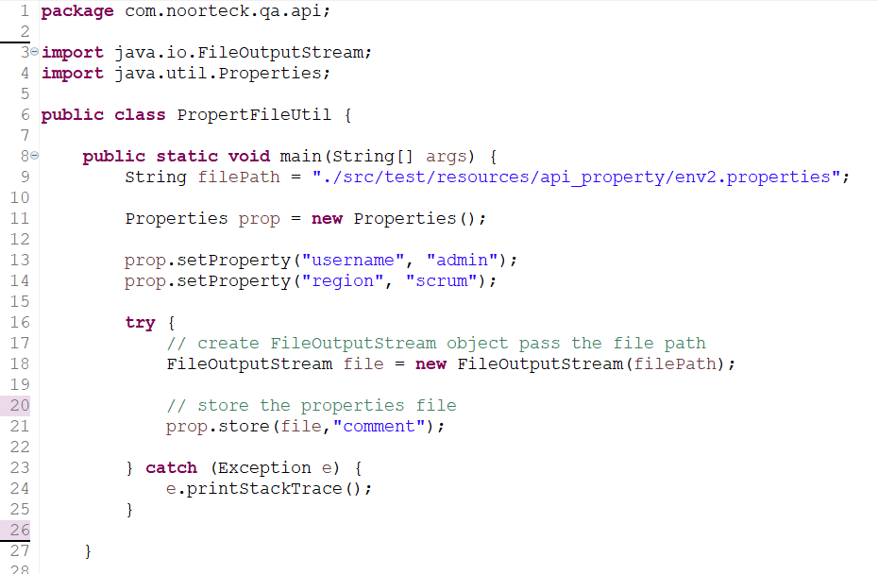

##### **Text File:** What is the process of reading/right Text File?

###### Reading from Text File

In order to **read a textfile** in Java, we can use the **FileReader & BufferedReader class**

* + **First** I have to **create an object of FileReader class and pass the filePath**

FileReader fileReader = **new** FileReader(filePath);

* + Then I have to **create an object of BufferedReader class** and pass the **fileReader object** as argument in constructor.

BufferedReader reader = **new** BufferedReader(fileReader);

* + Then I will create **while loop** to and **set the while loop condition to true**
  + And in the body I will use **reader object** and call the **readLine()** method to **retrieve the value of the line** and **store the value to String object.**
    - Then I will add **if condition to check if the value of String object** is **null** after retrieving

then it means **end of file** and **we can break out from loop.**

**while** (**true**) {

line = reader.readLine();

**if** (line == **null**) {

###### break;

}

System.***out***.println(line);

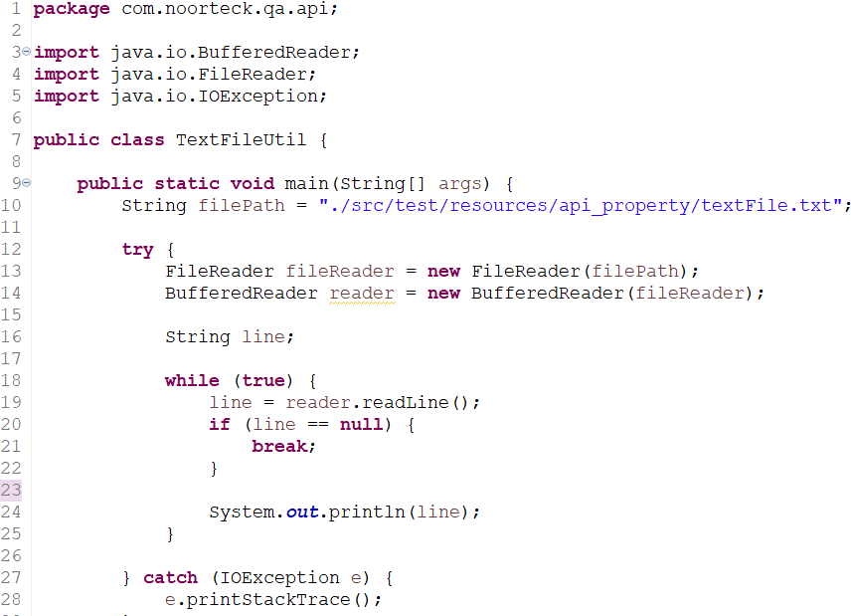}

###### Writing to Text File

In order to **write a textfile** in Java, we can use the **FIleWriter & BufferedWriter class**

* + **First** I have to **create an object of FIleWriter class and pass the filePath**

FileWriter fileWriter = **new** FileWriter(filePath);

* + Then I have to **create an object of BufferedWriter class** and pass the **FIleWriter object** as argument in constructor.

BufferedWriter writer = **new** BufferedWriter(fileWriter);

* + Then to write any content to the file we can use the **write()** method. Along with **write()** method we can also use **newline()** to write the text from **new line.**

writer.write(“Tis is text”); writer.readLine();

* + Once we are done writing into file, **last step** we have to call the **flush()** method to make sure the

**content is written to the file.**

writer.flush();

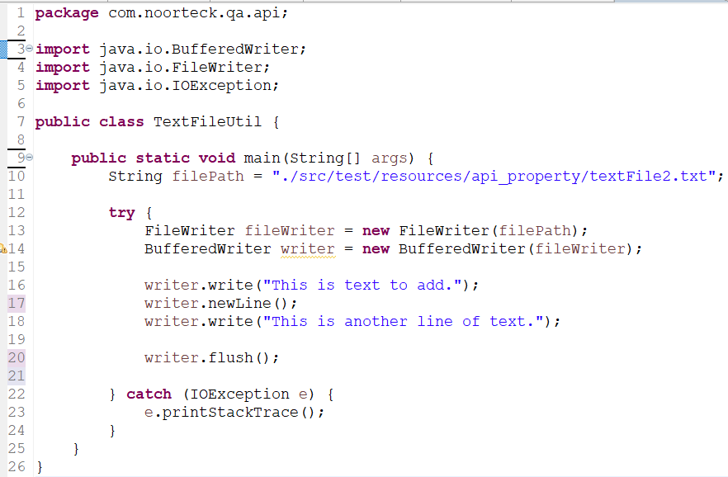

#### DD vs TDD vs Hybrid Framework

* + **TDD** is a Test-Driven Development, it is an approach we follow where we write the test first and make that test fail because the functionality does not exist yet. Then we go back and write the code to make the test pass. TDD approach is mostly used and practiced by the developers, where they write their unit test first, then go back and work on write the functionality.
  + **BDD** is a Behavior Driven Development, it is an approach that focuses on describing the behavior of the functionality from user’s standpoint. In BDD we use a common language that is understandable for technical and non-technical team members which is called Gherkin. Using different keywords like Given, When, Then we can describe the behavior of the system.
  + **Hybrid Framework** is a type of testing framework which can include a combination of

data-driven, keyword-driven, behavior driven framework. With Hybrid driven framework we can take a different framework type approach and combine it into one that suits the most for our automation and testing activities.

* + In **Data-driven framework** , the test logic or test script is designed to be generic and can be used with different test data. Usually, the test data is stored in external file like excel, or json, or xml file or database then during the execution we are accessing and executing same script with different data set.
  + In **Keyword Driven framework**, the script is written using predefined keywords that represent different actions or operation that needs to be performed. Each keyword will be associated with a specific functionality.

**Maven(Completed)**

#### What is maven?

**Maven** is a build management tool based on concept of **Project Object Model** (POM) that includes project information and configuration like

* + Directory structure
  + source directory
  + dependency
  + test source directory
  + Goals
  + plugins, etc.

#### How maven works?

**Maven** reads the **POM.XML** file and in the **POM.xml** file we have

* + **dependencies,**
  + **plugins and**
  + **properties.**

**When we execute Maven project,**

* + **First,** it checks the **LOCAL REPOSITORY** which is located in **.M2** folder, if the jar files for dependencies mentioned in our **POM.xml** file exist or not.
    - If the **LOCAL REPOSITORY does not have the dependency jar** files then it will go to

**CENTRAL REPOSITORY** and **download** into our **LOCAL REPOSITORY**

* + - If the **LOCAL REPOSITORY** has the dependency jar files then it **will not go** to the

**CENTRAL REPOSITORY**

* **Once we have the jar files** for dependencies mentioned in our **POM.xml** then we can **start using the classes, methods, interfaces** of that library.

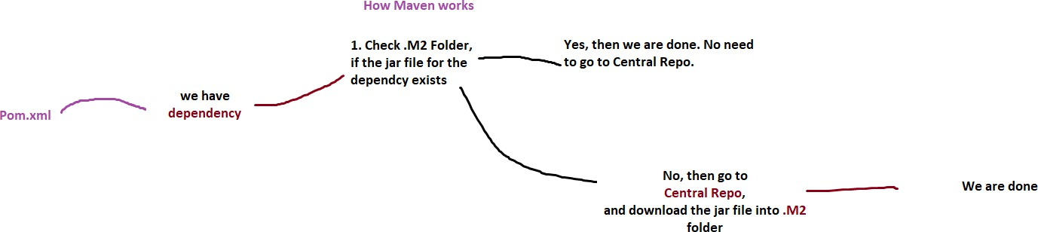

#### Types of Maven Repository

1. **Maven Life Cycle?**

When we **build a maven project**, it executes a set of tasks based on how we configuration the project in

**pom.xml.**

There are mainly **3 phases** in **Maven Life Cycle**. We have the

* + **Clean Lifecycle**
  + **Default Lifecycle**
  + **Site Lifecycle**

The **Clean Lifecycle** phase will **remove any artifacts or files generated from previous build or execution.**

The **Default Lifecycle** phase **handles the entire build process**. It consists of **multiple sub-phases**

including validate, compile, test, package, verify, and deploy.

The **Site Lifecycle** phase **generates project documentation and reports**.

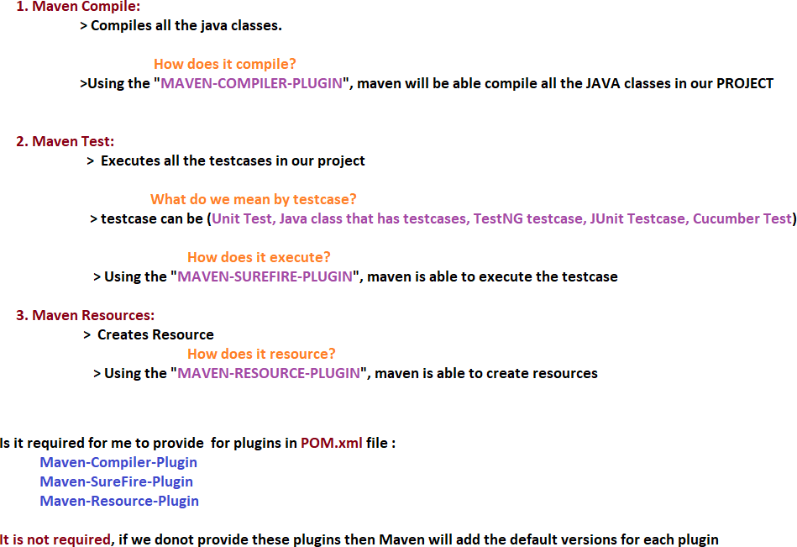

#### Where does the maven store all the dependency jar files?

All the **dependency jar files** are stored in **Local Repository .M2 folder.**

#### List of maven commands and purpose?

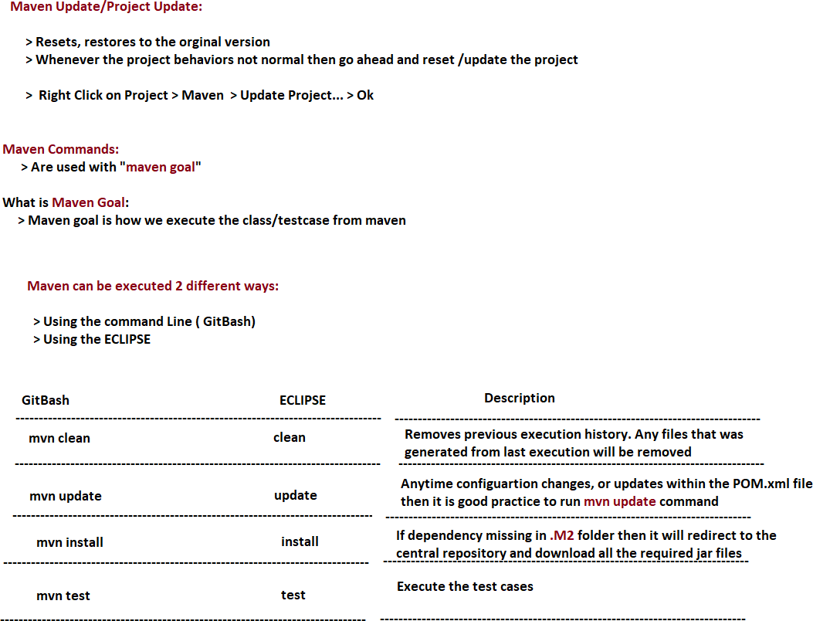

1. **Maven goal to execute runner class?**

**clean -Dtest=Runner test**

#### Maven goal to execute runner class with tag?

**clean** -**Dtest=Runner test -Dcucumber.filter.tags="@smoke"**

**clean -Dtest=Runner test -Dcucumber.filter.tags="@smoke or @release1_2"**

# Jenkins(Completed)

1. **Jenkins Process:** What is the process of setting up Jenkins Job?

The **process I have to follow** in order to set up a job, I need to make sure that I have the automation scenarios script ready which will be used part of the execution.

**When creating a job**, I need to make sure my **script is available on GitHub**:

* + **Then I need to provide**
    1. **the URL of my repository**,
    2. **Branch name**
    3. **Maven goal** which contains the information on what to execute
    4. Lastly, I need to **configure the cucumber report** so it generates report after execution which will be available to all the team members.

###### There are 3 different ways I can set up job on Jenkins:

1. I can either **schedule the job to execut**e Monday through Friday to execute at certain time.
2. Or I can **trigger the job automatically whenever new build comes** to scrum region.

o **For example,** my shakeout **automatically kicks off when developer finishes developing User Story and deploys the code from Dev Region to Scrum Region**. If the **Build comes successfully** to scrum region then my **shakeout automatically kicks off** without my other team members interference.

1. Lastly, I can **create a job and manually Build** whenever I **need to do quick smoke testing**.
2. **Job vs Pipeline:** What is the difference between Jenkins job and Jenkins Pipeline?

A **Jenkins job** is like a single task or job that we define in Jenkins. We create separate jobs for each specific task in our building process. For example, we can have jobs named Smoke Job or Regression Job, where each job focuses on a particular part of the build or testing process.

A **Jenkins Pipeline** is like a combination of different jobs or tasks that we put together to form a complete workflow. In our project, we have a pipeline that includes several jobs. For instance, we have a pipeline that consists of the dev build, unit test job, and smoke job. These jobs are executed one after the other or even in parallel, depending on how we configure the pipeline.

# Git(Completed)

##### **Git Process:** Explain the process of how you interact with GitHub(Version Control)

We are currently using GitHub as our version control system for managing our framework, which is shared among multiple team members and teams. To ensure smooth collaboration and minimize conflicts and downtime, we follow a common practice.

* + When I work on automation, I perform all the scripting on my local workspace using the Dev Branch. This allows me to work independently without affecting the main codebase.
  + Once I have completed my scripting, I proceed by stashing my changes. Meanwhile, I also check our team's group chat or email to see if any team members have sent updates regarding their changes. If there are any, I pull the latest code from the remote repository to sync my local workspace.
  + Once my local workspace is up to date with the remote repository, I retrieve my stashed changes and apply them.
  + Next, I push my changes to the remote repository. As I use the Eclipse IDE, which includes a Git plugin, I utilize Git commands within Eclipse to perform the push operation.
  + After pushing the code to the remote repository, I create a pull request to merge my changes from the Dev Branch to the Stage Branch. To make sure code quality, I assign two of our team members as reviewers. They will review the code and, and once they approve they will merge it into the Stage Branch.
  + Finally, to keep everyone updated, I send a message to our group, informing my team that I have pushed my changes and remind them to pull the latest code to incorporate the updates into their own workspaces.

By following this process, we maintain a structured workflow, minimize conflicts, and ensure that our codebase remains up to date and accessible to all team members.

1. **Branching Strategy:** Explain the branching strategy your team follows.

The branching strategy that our team follows involves three main branches: dev, stage, and master.

* + **Dev Branch** serves as the main development branch where all coding and user story automation done.
  + **Stage Branch:** Once we finish the user story automation and push to remote dev branch. Then We will create pull request to merge the code from Dev Branch to Stage Branch. Upon creating Pull Request, we assign 2 reviewers.
  + **Master Branch:** Once the code is stable and reviewed thoroughly then we move from stage branch to Master branch. Master branch is the stable branch where all the Jenkins jobs are executed including smoke & regression jobs.

#### Git Conflicts

###### Explain how to handle Git Conflicts

Git conflicts occur when two or more team members make conflicting changes to the same file or lines of code. In order to handle Git Conflict:

* First, I will Pull the Latest Changes: Before making any changes, it's important to ensure that I have the most up-to-date version of the code. Use the command **git pull** to fetch and merge the latest changes from the remote repository into my local branch.
* Once I have to my local, then I will try to **Identify the Conflict**. When we have a conflict, **Git** will notify us which files have conflicts. We can identify the conflicting sections within the file by looking for **Git's conflict markers**, which usually appear as (multiple less than sign, multiple equal sign and multiple greater than sign) "<<<<<<<", "=======", and ">>>>>>>". These markers indicate the conflicting changes made by different contributors.
* Once I know which file has the conflict, then I will Open the conflicted file in Eclipse. Within the file, we will see the conflicting sections separated by the conflict markers.
* Then I will carefully review the conflicting sections to understand the changes made by each contributor. I will Identify which changes I want to keep and which to discard or modify. Sometimes I might have to discuss with the other team members to make sure we are keeping the right version.
* Once I am done with analyses and discussing with team member then I will Resolve the Conflict by Editing the conflicted file manually, removing the conflict markers and deciding how to combine the conflicting changes.
* After resolving the conflict, I will test the merged code to ensure it works as expected.
* Once I am done with the conflict resolution, I will stage the modified file(s) using the command

**git add <filename>** or **git add** . to stage all changes.

* Finally, I will commit the resolved conflict by running **git commit** with an appropriate commit message then push the changes to remote using git push command.

###### 4ddsExplain how to AVOID Git Conflicts

To avoid Git conflicts, there are several practices my team follows.

* **Communication:** It is important we regularly communicate with the team members. By keeping each other informed about the files or sections of code we are working on, especially if we are frequently making changes. Whenever we make changes and push to remote, we send out email and message to team group chat to let them know that I have pushed my changes.
* **Follow Stash Process:** Before pushing or pulling we always stash our changes. To make sure we always pull the latest changes from the remote repository before pushing our changes.
* **Make Small and Frequent Commits:** Instead of pushing large commits, it is important we focus on small frequent commits, by breaking it down into smaller commits that will make the merging, and review process easier.
* **Make sure to Regularly Push and Pull:** It is important to regularly push our progress to the remote and pull updates from the remote repository regularly to stay in sync with the team’s changes. By doing this we can catch and resolve any conflicts or issues early.
* **Hold Code Review Sessions:** We hold once a week code review session with the team to go over the changes and new implementation to make sure everyone is up to date.

#### Git Commands Definition

###### git init

**“git init” command** creates a new Git repository in the current directory.

###### git clone

**“git clone” command** creates a copy of an existing Git repository, including all of its history, branches, and files. Initial stage whenever I join a team, I usually clone the existing repository to my local using **“git clone”** command.

###### git add

**“git add” command** adds changes in the working directory to the staging area. It allows to specify which files or directories to include before making the next commit.

###### git commit

**“git commit” command** records the changes in the staging area as a new commit in the Git repository. It creates a snapshot of the changes and permanently stores it in the repository's history. When making commit we usually provide commit message that describes the changes made in the commit.

###### git push

**“git push” command** pushes the committed changes from our local branch to a remote repository. It updates the remote repository with our local changes, making them accessible to other team members.

###### git pull

**“git pull” command** fetches the latest changes from a remote repository and automatically merges them into our local branch. It combines the **git fetch** and **git merge** commands to retrieve and apply the changes in one step.

###### git fetch

**“git fetch” command** retrieves the latest changes from a remote repository without merging them into our local branch. It allows us to view and review the changes before merging them manually using other Git commands.

###### git merge

**“git merge” command** integrates changes from one branch into another. It combines the changes from a **source branch** into the **current branch**, creating a new commit that includes both sets of changes.

###### git rebase

**“git rebase” command** reapplies commits from one branch onto another branch. It moves or combines commits to a new base commit, often used to incorporate changes from a feature branch into a main branch while maintaining a linear commit history.

###### git branch

**“git branch” command** lists, creates, or deletes branches in the Git repository. It shows a list of existing branches, allows us to create new branches based on the current branch, or delete branches that are no longer needed.

###### git checkout

**“git checkout” command** switches between different branches or commits in the Git repository. It allows us to navigate between branches, restore files from previous commits, or create new branches based on existing ones.

###### git status

**“git status” command** shows the current state of the Git repository. It displays information about modified files, untracked files, staged files, and the current branch. It helps us understand what changes have been made and which files are ready to be committed.

###### git log

**“git log” command** displays a log of the commit history in the repository. It shows information such as the commit message, author, date, and unique commit hash for each commit. It helps us track the history of changes and understand the chronological order of commits.

###### git tag

**“git tag” command** creates a named pointer to a specific commit in the Git repository. Tags are typically used to mark important points in the history, such as release versions or significant milestones. They provide a way to reference specific commits with a meaningful name.

###### git reset

**“git reset” command** resets the current branch to a specific commit, allowing us to undo changes or move the branch pointer to a different commit. It can be used to discard commits, unstage changes, or modify the commit history.

###### git stash

**“git stash” command** temporarily saves changes that are not ready to be committed yet. It allows us to switch branches or work on other tasks without committing incomplete changes.

###### git remote

**“git remote” command** shows the remote repositories associated with the local Git repository. It allows us to view the names and URLs of the remote repositories and manage their configurations.

###### Pull Request

A **Pull Request** is a way to propose changes from one branch to another branch. It provides a convenient method for code review, discussion, and collaboration. Within my

current team, once I am done with my scripting, I will push my changes to the remote then create Pull Request and assign 2 of my team members to review.

#### Git Command Comparisons

###### git pull vs git fetch

* + **“git pull”** combines the **“git fetch”** and **“git merge”** commands into one. It fetches the latest changes from the remote repository and automatically merges them into the current branch.
  + **“git fetch”** retrieves the latest changes from the remote repository but doesn't automatically merge them. It updates the remote-tracking branches, allowing you to review and manually merge the changes later.

###### git merge vs git rebase

* + **“git merge”** combines the changes from one branch into another branch. It creates a new commit that incorporates the changes from the source branch into the current branch.
  + **“git rebase”** moves or combines commits from one branch onto another branch. It modifies the commit history by replaying the commits on top of a different base commit. It results in a linear commit history and can be useful for maintaining a clean and organized history.

###### git reset vs git revert

* + **“git reset”** allows us to move the branch pointer to a specific commit, effectively discarding or undoing commits. It can be used to remove commits, unstage changes, or rewrite the commit history. It is a more destructive operation as it modifies the commit history.
  + **“git revert”** creates a new commit that undoes the changes made in a specific commit. It adds a new commit that negates the changes, effectively reverting the previous commit. It is a safer option as it leaves the commit history intact.

###### git clone vs git init

* + **“git clone”** creates a copy of an existing Git repository, including all branches, commit history, and files. It retrieves the entire repository from a remote location and sets it up on our local machine.
  + **“git init”** initializes a new Git repository in the current directory. It creates an empty repository with the necessary data structures to start tracking changes to files.

###### git diff vs git status

* + **“git diff”** shows the differences between the current state of the code and the previous commit or between different branches or commits. It provides a detailed view of

line-by-line changes in files.

* + **“git status”** displays the current state of the Git repository. It shows information about modified files, untracked files, and the status of files in the staging area. It provides a high-level overview of the repository's status.

###### git stage vs git unstage

* + **“git stage”** or **“git add”** adds changes in the working directory to the staging area. It prepares the changes to be committed by marking them for inclusion in the next commit.
  + **“git unstage”** or **“git reset HEAD”** removes changes from the staging area, undoing the previous git add command. It allows us to unstage files or changes that we no longer want to include in the next commit.

**SQL(Completed)**

#### How do you rate yourself in SQL?

I would rate myself 7/10 in SQL. I interact with database on daily bases and comfortable writing queries. There is always a room for improvement. In case if there are concepts or theories I don’t mind spending extra time learning and improving.

#### Do you write queries or dev team does for you?

In my current project and previous projects, database interaction was a huge part of the testing activities, automation framework and validation process. I am very comfortable writing complex queries and pretty much interact with the databases on a daily basis. Whether I am performing UI Testing or API Testing, I need to ensure the expected vs actual values matches. To perform data validation, I have to cross validate against the database. In my current project, we have application database as well as the QA Test Repository which we use to retrieve the test data for the automation scenarios.

### JDBC

###### JDBC Process: How do you connect from your automation framework

**In order to connect to database from my automation framework:**

* 1. First, I need to have the **database jar file in my project or database dependencies in my pom.xml file**.
  2. Second, in my scrip I need to **load the JDBC driver** by stating

## Class.*forName*("com.mysql.cj.jdbc.Driver");

* 1. Third, I need to **connect to database by creating Connection** object and using **getConnection() method** from **DriverManger** class. In **getConnection() method**, I will be providing the **URL** of the database, the **Username**, and the **Password**

## Connection con = DriverManager.*getConnection*(url, username, password);

* 1. Forth, then I will **create statement object**. This will allow us to perform database operations such as INSERT, SELECT, UPDATE , or DELETE

## Statement stm = con.createStatement();

* 1. Fifth, using statement object, I will be calling **executeQuery()** or **executeUpdate()**

method to **executing SQL query**.

* + 1. When I am **retrieving** data from database then I will be using **executeQuery()**

method and **storing** the returned data from database to **ResultSet** object

## ResultSet rs = stm.executeQuery(myQuery);

* + 1. When I am **update** or **inserting** test execution result to **database** then I will be using

**executeUpdate()** method.

## stm.executeUpdate(myQuery);

* 1. Sixth during automation execution I will be **accessing ResultSet object to get the data**, **use the data** for input fields and **compare** the expected results with actual results
  2. Seventh, after finishing using the database, then I will **close the databases connection.**

## con.close();

1. During the test script execution when do you access the database and why?

Mainly the database connection is established during the initial stage of the execution in our

**hooks class.**

We have **@Before** cucumber annotation for **setup()** method and in there we are setting up the environment and establishing the connection then connecting database.

Throughout the test execution we are accessing different tables to retrieve the data or to perform certain validation against the application database to ensure the data within the different layers of application is processing as expected.

#### DDL vs DML vs DCL vs TCL

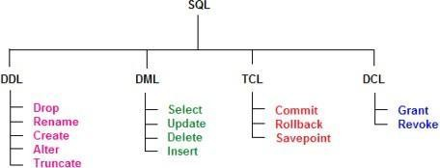SQL commands are mainly **categorized** into four categories

* 1. **Data Definition Language** (**DDL**)
  2. **Data Manipulation Language** (**DML**)
  3. **Transaction Control Language** (**TCL**)
  4. **Data Control Language** (**DCL**)

#### Data Definition Language (DDL)

1. **CREATE**
2. **ALTER**
3. **DROP**
4. **TRUNCATE**

**DDL** is used to **define the database structure and descriptions**, of how the data should reside in the database. DDL **allows to add, modify, delete the logical structures** which contain the data, or which allow users to access or maintain the data.

* + **CREATE**: to create a database and its objects like (table, index, views, store procedure)
  + **ALTER**: Modifies the structure of the existing database
  + **DROP**: Deletes objects from the database
  + **TRUNCATE**: Remove all records from a table and resets tables identify to initial value

#### Data Manipulation Language (DML)

1. **SELECT**
2. **INSERT**
3. **UPDATE**
4. **DELETE**

**DML deals with data manipulation** and it is used to retrieve, store, modify, delete, insert, and update data in database.



* **SELECT**: Retrieves data from a table
  + **INSERT**: Inserts data into a table
  + **UPDATE**: Updates existing data into a table
  + **DELETE**: Deletes all records from a table

#### Data Control Language (DCL)

1. **GRANT**
2. **REVOKE**

**DCL** is **used to create roles, permissions, and control access** to database by securing it. DCL **authorizes user to access and manipulate data** in the database.

* + **GRANT**: Allow users access privileges
  + **REVOKE**: Withdraw users access privileges given by suing the GRANT command

#### Transaction Control Language (TCL)

1. **COMMIT**
2. **ROLLBACK**
3. **SAVEPOINT**
4. **SET TRANSACTION**

**TCL** is **used to manage the changes made by DML statements**. It allows statements to be grouped together into logical transactions.

* + **COMMIT**: Save work done in transactions
  + **ROLLBACK**: Restore database to original state since the last COMMIT command
  + **SAVEPOINT**: Identify a point in a transaction to which you can later roll back
  + **SET TRANSACTION**: Specify the characteristics of the transactions

### ALTER TABLE :DDL

**ALTER** is a **Data Definition Language(DDL)** statement **used to add, delete, or modify columns in an existing table.**

* **ALTER TABLE** – **ADD** □ **Add a column** to an existing table.
* **ALTER TABLE** – **DROP COLUMN** □ **Delete a column** from a table.
* **ALTER TABLE** – **MODIFY COLUMN** □ **Modify the data type** of a column.
* 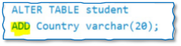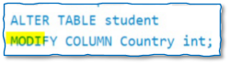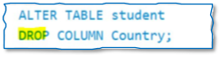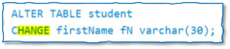**ALTER TABLE** – **CHANGE** □ **Change the column** name in a table.

### INSERT

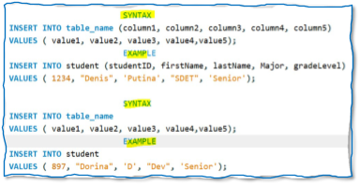**INSERT** is a **Data Manipulation Language(DML)** statement **used to insert data into a table.**

### UPDATE



**UPDATE** is a **Data Manipulation Language(DML)** statement **used modify the records** in

the table.

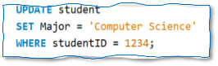**Syntax** to **UPDATE** table

* The query will update **Major** column value to ‘**Computer Science**’ for student that has studentID value **1234**

#### TRUNCATE vs DROP vs DELETE

Truncate, Drop, & Delete are mainly used to remove data from a table, however they have different meaning.

* **TRUNCATE** is **used to delete all the records from the table, but not the table itself.** Only the data will be deleted. Truncate command used to quickly remove all rows from table and reset the table to initial state. With Truncate Operation we **cannot roll back and the deleted data cannot be recovered**
* **DROP** is **used to delete the records and the table from the database.** It deletes both the table structure and the data it contains. When we drop a table all the associated indexes, constraints and triggers are also removed. Dropping table cannot be recovered UNLESS we have a backup
* **DELETE** is used **remove specific rows from a tables based on a given condition**. With Delete command we can specify condition in our where clause. Deleted data can be rolled back.

#### SQL Constraints

**Constraints** are used to **specify rules for the data in a table to maintain consistency and correctness of data**. It enforces rules on the table whenever **data inserted, updated, or deleted from the table.**

**Constraints** can be defined at **table level** or **column level**

* We can create constraint **during creation of table** using **CREATE TABLE**
* Or we can create constraint **after creating a table** using **ALTER TABLE**

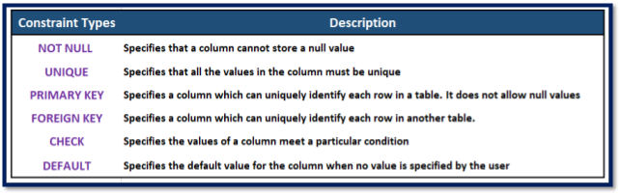

###### Not Null Constraint



**NOT Null** constraint **restricts a column from havin**g a **NULL** value. Once **NOT Null**

constraints is applied to a column, **you cannot pass** a **NULL** value to that column. It enforces to contain a proper value. **Not NULL** constraint **cannot be defined at table level**, only column level

**Example** of using **NOT Null** Constraint

* + The below query will declare the **ID** field of Student table **NOT NULL** which will

###### not take NULL values

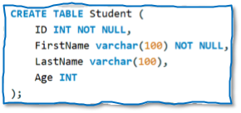

1. **Unique Constraint**

**UNIQUE** constraint **ensures that a column will only have unique values**. **Unique** Constraint **column will not have duplicate value**. This constraint **can be applied** at **column level or table level.** Unique constraint **allows NULL value**

**Example** of using **UNIQUE Constraint**

* + The below query will declare the **ID** field of employee table **UNIQUE** which will

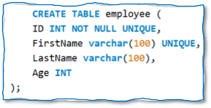

###### only have unique values and will not take NULL values

1. **Default Constraint**

**DEFAULT** constraint is used to **provide a default value for a column**. The **default value will be added** to all new records **if no other value is specified during insertion data into the table**

**Example** of using **DEFAULT** Constraint

* The below query will declare the **SchoolName** field of School table with

**DEFAULT** constraint which contains **‘NoorTeck’** as default value

* When **user inserts record and does not provide a value** for **SchoolName** field then it will add **‘NoorTeck’** for **SchoolName** column for that specific record

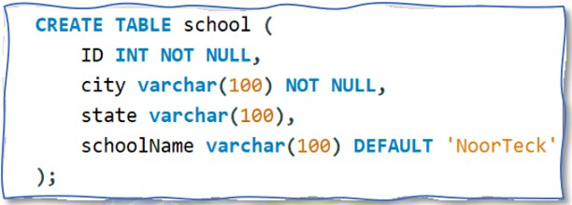

###### Check Constraint



**CHECK** constraint is used to **restrict the values of a column between a range**. It

performs **check on the values**, **before storing them into the database**. It is like condition checking before saving data into a column

**Example** of using **CHECK** Constraint

* + The below query will declare the **Age** field of Vote table with **CHECK** constraint

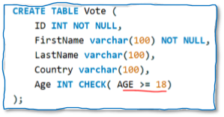

which Age column value must be greater than or equal to 18

###### Primary Key vs Foreign Key Constraints

**PRIMARY KEY** and a **FOREIGN KEY** are two different constraints in SQL and it is used to establish **relationship between tables.**

* **PRIMARY KEY** is a column or a set of columns in table that **uniquely identifies each record in the table**. It serves as a unique identifier for each row and makes sure that there are no duplicate records.
  + **Each value in the primary key column must be unique.**
  + **Primary key values cannot be null.**
* **FOREIGN KEY** is a column or a set of columns in **one table that refers to the primary key in another table**. It **establishes a relationship between two tables as a parent-child relationship**. The foreign key represents a link between the records in the child table to the corresponding records in the parent table

### DISTINCT

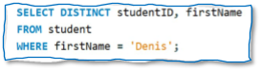**DISTINCT** keyword is used to eliminate duplicate rows from the result set of a SELECT query. It filters out identical rows, so only unique values are returned.

### ORDER BY

The **ORDER BY** clause is used to sort the **resultset** of a **SELECT query** based on one or more columns. It allows us to specify the order in which the rows should be displayed.

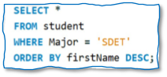The **ORDER BY** clause by default sorts the data in **ascending order**. To sort the data in descending order we can use DESC keyword.

**Syntax** for **ORDER BY** clause

* The query will return the result in **descending order of the firstName**

### LIKE

The **LIKE** clause is used to perform **pattern matching** in a SELECT statement. It allows us to search for **specific patterns** or substrings within a column's values.

The **LIKE** clause uses wildcard characters to represent unknown or variable parts of the pattern. There are two wildcard operators that we can use in LIKE clause

**%** □ The **percent sign** represents **zero, one, or multiple character**

**_** □ The **underscore sign** represents a **single character**

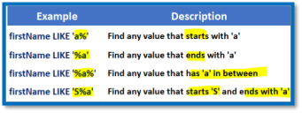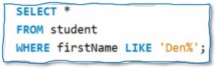

#### Aggregate Functions

1. **COUNT()**
2. **SUM()**
3. **AVG()**
4. **MIN()**
5. **MAX()**

**Aggregate functions** are used to perform calculations on a set of rows and return a **single value**.

Aggregate functions operate on columns or expressions within a **SELECT statement** and are commonly used with the **GROUP BY** clause to perform calculations on grouped data.

* 1. **COUNT(): Counts the number of rows or non-null values in a column.**
     1. Example: SELECT **COUNT(*)** FROM Employees;
  2. **SUM(): Calculates the sum of values in a column.**
     1. Example: SELECT **SUM(Salary)** FROM Employees;
  3. **AVG(): Calculates the average of values in a column.**
     1. Example: SELECT **AVG(Salary)** FROM Employees;
  4. **MIN(): Retrieves the minimum value from a column.**
     1. Example: SELECT **MIN(Salary)** FROM Employees;
  5. **MAX(): Retrieves the maximum value from a column.**
     1. Example: SELECT **MAX(Salary)** FROM Employees;

Along with **Aggregate Function** we can also use **GROUP BY** clause to perform calculations on subset of data. The **GROUP BY** clause **divides the rows into groups based** on the specified columns and applies the aggregate function to each group separately.

And if we need to **apply filte**r or condition to the **grouped aggregate function** sets then we can use **HAVING clause.**

1. **GROUP BY**

**GROUP BY** clause is used with **aggregate functions** to **divide the rows of a table into groups based on one or more columns**. It allows us to perform aggregate calculations on each group separately.

1. **HAVING**

**HAVING** clause is used to **filter the results of a GROUP BY query based on a condition applied**

to the result of an aggregate function.

It is similar to the **WHERE clause**, but while the

* **WHERE** clause filters individual rows before grouping,
* **HAVING** clause filters groups after the grouping has been performed.

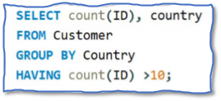

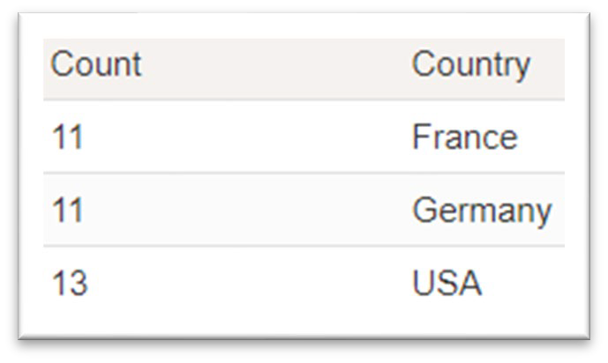

#### Having vs WHERE

**HAVING** clause and the **WHERE** clause is to filter data based on specific conditions. However, they are used in different contexts:

* **WHERE clause:**
  + The **WHERE clause** is used in SELECT, UPDATE, DELETE, and some other SQL statements to **filter individual rows from a table before any grouping** or aggregation occurs.
  + It is typically used with **non-aggregated columns** or expressions.
* **HAVING clause:**
  + The **HAVING clause** is used in **combining with the GROUP BY clause** in SELECT statements to **filter the result set based on conditions applied to the aggregated values**.
  + It is used to **filter groups of rows after the aggregation** has occurred.

### JOINS

**JOIN** operation is used to combine rows from two or more tables based on a related column between them.

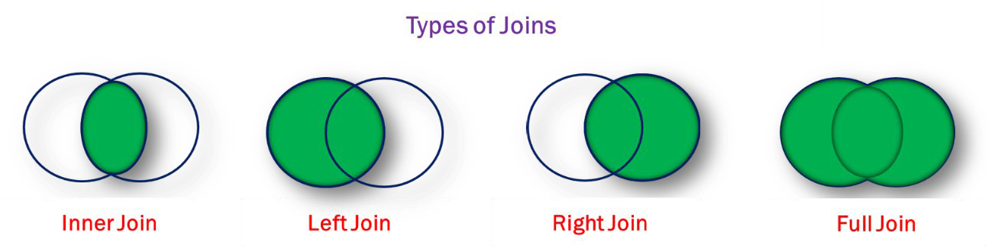

1. **INNER JOIN**

The **JOIN/INNER JOIN** returns records that have matching values in both tables

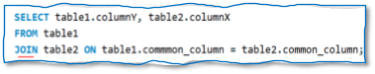 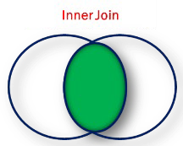

1. **LEFT JOIN**

The **LEFT JOIN/LEFT OUTER JOIN** returns **all records from the left table and the matched record from the right table.** The **result is NULL** from the **right table** when there is **no match**

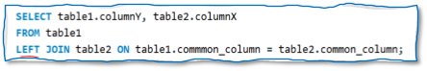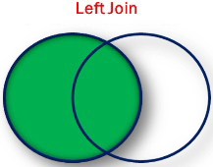

1. **RIGHT JOIN**

The **RIGHT JOIN/RIGHT OUTER JOIN** returns **all records from the right table and the matched record from the left table.** The **result is NULL** from the **left table** when there is **no match**

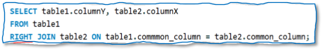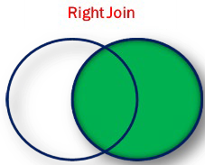

1. **FULL JOIN**

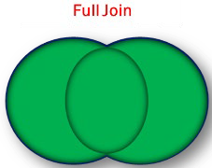The **FULL JOIN/FULL OUTER JOIN** returns all records when there is a **match in left table OR right table records**

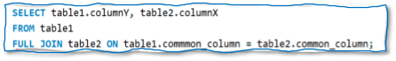

### SET OPERATORS

**Set** Operators are **used to join the results of two or more SELECT statements.** Set Operators are mainly used to **combine the same type of data from two or more tables.**

**RULES** on **Set Operations**

* Each **SELECT** statement **must have the same number of columns**

The **column must also have similar data types**

 The **columns** in each **SELECT** statement **must also be in the same order**

###### Union vs Union ALL

**UNION** is used to **combine the results** of two or more SELECT statements and removes

**the duplicate records.**

**UNION ALL** is used to **combine the results** of two more SELECT statements and DOESNOT **remove duplicate records.**

###### Intersect

**INTERSECT** is used to **combine the results** of two or more SELECT statements, but it ONLY **returns the records which are common from both SELECT statement**

###### Minus/Except

**MINUS/EXCEPT** is used to **combine the results** of two or more SELECT statements and

**returns only the result, which belongs to the first set of the result**

### IEW

**View** is a **virtual table** based on resultset of a SQL statement. It is a **set of saved SELECT queries**.

If we want to execute the **same query multiple times**, we can either save in a file or save the query in the database by creating a view

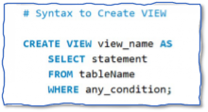

### INDEX

* **Index** is used to retrieve data from the database to **improve the performance**
* Without indexes, DBMS has to **go through all the records in the table** to retrieve the desired results. If we create index, the database **goes to that index first** and then retrieves the corresponding **table records directly.**
* Indexes **increases performance** for **SELECT** and **WHERE** clauses, but it **slows down** data input with the **UPDATE** and **INSERT** clauses.
* The **PRIMARY KEY** constraint **automatically creates a clustered index.**
* We can have **only one clustered index** in a table but **can have multiple**

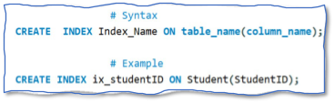

**non-clustered indexes** in the table.

**a) Clustered index vs Non-Clustered Index**

|  |  |
| --- | --- |
| **Clustered Index** | **Non-Clustered Index** |
| **Clustered Index** is used to define the order and it **sorts the table data by alphabetical order.**  **Clustered Index** is similar to **dictionary** | **Non-Clustered** index collects the data at one place and the table records are at another place.  **Non-Clustered** index is similar to the index section in the book. |
| A table can have only 1 **Clustered Index**  and | A table can have many **Non-Clustered Indexes**. |

|  |  |
| --- | --- |
| By default**, Primary Key** constraint is considered Clustered Index. |  |
| **Faster** than the non-Clustered index | **Slower** than the Clustered index |

#### Store Procedure

* **Store Procedure** can be defined as the **set of statements grouped together to perform a specific task**.
* It is similar to **methods/functions** in java or other programming languages.
* It helps to **increase the performance of the database**, the code can be **reused**, increase

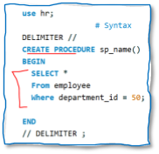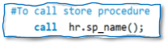

the **security**, and can be **easily** modified.

#### Trigger

**Trigger** is a **special stored procedure** in the database which **automatically invokes whenever a special event occurs.**

**For example**, a **trigger** can be invoked when a **row is inserted into a specified table** or when certain table columns are being updated.

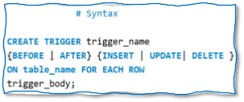

#### Subquery

* **Subquery** is a **query within a query** and embedded within the **WHERE** clause
* **It** can return **individual value** or a **list of records**
* It must be **enclosed within the parenthesis**

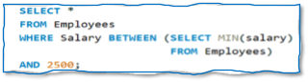

# Selenium WebDriver(Completed)

##### What is Selenium?

**Selenium** is an open-source software used for **automating web browsers**. It supports different programming languages like Python, Java, or C# to automate web applications. It also supports different browser and operating systems.

##### Selenium Architecture

Selenium WebDriver architecture mainly divided into three parts:

* 1. **Language Level Bindings**
     + Programming language **used to write the automation script**
  2. **Selenium WebDriver API**
     + **Contains set of a common libraries** which allows sending a command to respective driver
  3. **Drivers**
     + **Refers to various browsers** that will be used to execute the automation script

##### Advantages of Selenium

The **advantages of Selenium** are:

* Selenium is free and **open source**
* Supports **different programming languages** including java, Ruby, python, C#...
* Supports **different brow**ser (Chrome, IE, Firefox, Safari…)s
* Supports **different Operating System** (windows, Mac, Linux)
* Saves **time and money**
* Supports **Parallel Test Execution**

##### Disadvantage of Selenium

The **disadvantages of Selenium** are:

* Selenium supports only web-based applications, it **does not support windows-based application**
* Selenium **does not have built-in reporting tool**, it needs third party tools for report generation like TestNG, JUnit or Cucumber
* **Captcha and Barcode cannot be tested** using Selenium

##### What type of testing can we automate with Selenium?

Selenium is an **automation tool used to automate web applications**. The types of testing can be done using Selenium are:

* **Functional Testing**
* **Regression Testing**
* **Smoke Testing**
* **End to end testing**

##### Locators

1. What are the different types of locators in Selenium

Locators provide a **way to access the elements on the webpage**. In selenium there **are 8 different types of locators:**

* 1. **ID**
  2. **Name**
  3. **LinkeText**
  4. **ParitalLinkedText**
  5. **ClassName**
  6. **TagName**
  7. **CSS Selector**
  8. **Xpath**

1. Which locator type do you prefer & why?

Type of locator I prefer really type depends on the specific web element and its attributes and properties. I prefer to start with using ID if it's available and static since IDs are unique for each element on the page.

When dealing with complex or dynamic scenarios I use either cssSelector or XPath locators since they provide more functionalities like build-in methods and wildcard searching

1. Dynamic Elements: How do you handle?

To **handle dynamic elements**, we can use **CSS Selector or xpath**. Both of locator’s providers different functionality to identify and work with dynamic elements.

We can use features of Xpath:

* **Contains() method**
* **startsWith() method**
* **text() method**

We can use features of CSS Selector:

* **Appending classes**
* **Using wildcards**
  + **Carrot Sign ^** which represents the **starting text** in the attribute value
  + **Dollar Sign $** which represents the **ending text** in the attribute value
  + **Start Sign \*** which represents the **contained text** in the attribute value

1. CSS Selector vs Xpath

* Xpath allows traversing elements both ways from parent to child and child to parent. Css allows traversal from parent to child only.
* Xpath is slower in terms of performance and speed. CSS has better performance and speed than Xpath.
* Xpath allows identification with the help of visible text appearing on screen with the help of text() function. CSS does not have this feature.

##### Xpath Locator

1. Absolute vs Relative Xpath

###### Absolute xpath

* 1. Represented by **SINGLE SLASH ’/’**
  2. Start with single slash that means starting to search from the **root and traverses from the root to the whole HTML DOM** to reach to the desired element
  3. Disadvantage of using absolute xpath to locate an element is, if during development process **any changes made in the path** then it may lead to a failed xpath expression

###### Relative xpath

* 1. Represented by **DOUBLE SLASH ’//’**
  2. Starts with a double slash that means it can start to **search anywhere in the HTML DOM structure**
  3. **Shorter** than Absolute Xpath
  4. We can **start from the middle of the HTML DOM structure** and no need to write long xpath

1. Ancestor Xpath Example

// Finding a div element that is the ancestor of a specific span element

WebElement ancestorElement = driver.findElement(By.xpath("//span[@id='specificSpan']/ancestor::div"));

1. Following Xpath Example

// Finding the following sibling element of a specific element

WebElement followingElement = driver.findElement(By.xpath("//div[@id='specificDiv']/following-sibling::span"));

1. Child Xpath Example

// Finding all child div elements of a specific parent div

List<WebElement> childElements = driver.findElements(By.xpath("//div[@id='parentDiv']/child::div"));

1. Preceding Xpath Example

// Finding the preceding sibling element of a specific element

WebElement precedingElement = driver.findElement(By.xpath("//span[@id='specificSpan']/preceding-sibling::div"));

1. Parent Xpath Example

// Finding the parent div element of a specific child span

WebElement parentElement = driver.findElement(By.xpath("//span[@id='specificSpan']/parent::div"));

##### Wait

In Selenium, we mainly have 2 types of waits, Implicit Wait and Explicit Wait.

1. Implicit Wait

Implicit Wait tells the driver to wait for a specific amount of time before throwing a “NoSuchElementException”. It is Dynamic Wait, meaning if element is found before the max amount of given time then it will move to next step

Implicit Wait applied globally, once we create an Implicit Wait then it will be used for every element. We don’t have to mention individually to each element of the webpage

When creating an Implicit Wait we need to provide 2 parameters.

* Parameter 1 is the “amount of time”.
* Parameter 2 is the “TimeUnit”. The syntax for implicit wait is



1. Explicit Wait

When it comes to ExplicitWait we have 2 versions. We have WebDriverWait and FluentWait. WebDriverWait or Explicit Wait tells the driver to wait for a specific amount of time with the Expected condition before throwing and “Exception”.

Explicit Wait is also Dynamic Wait, meaning if element is found the Expected Condition is met before the max amount of given time then it will move to next step.

Explicit Wait is not applied Globally, when we create an object of WebDriverWait and specify condition then it will apply only for 1 Element.

When creating an Explicit Wait, we need to:

* First create an object of WebDriverWait and pass 2 parameters. The driver instance and seconds
* Second we have to call the until() method and pass the expectedCondition as parameter

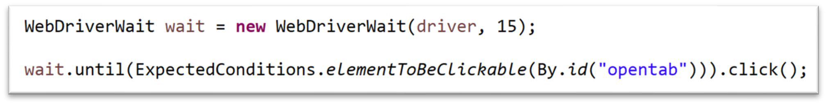

1. Fluent Wait

When it comes to FluentWait, the current version of Selenium I am using is 3.14. After version 3.11 Selenium stopped supporting FluentWait. In my automation I mainly use either ImplicitWait or WebDriverWait.

It has been a while since I used FluentWait. But I know how it works. FluentWait pretty much tells drivers to wait for a specific amount of time, ExpectedCondition and the frequency at which the condition is checked.

FluentWait is dynamic and it applies to 1 element.

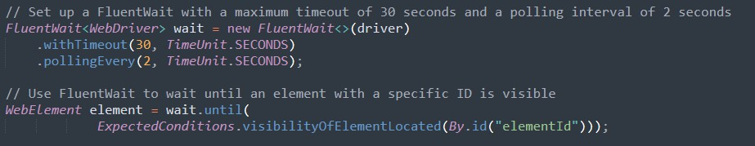

1. Thread.sleep

**Thread.sleep() forces the browser to wait for a specific time**. We use Thread.sleep() only for **debugging purposes**. It is **never good idea** to use in our automation because when executing **Thread.sleep()** it forces to wait driver for the specific amount time mentioned even if the element is loaded on the page.

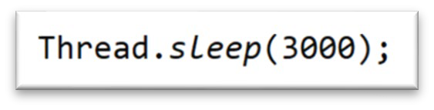

##### close() vs quit()

* **Close():** method **closes the web browser window that the user is currently working on**. If multiple windows opened by script and if we use close() method, it will only close the currently working browser
* **Quit():** method **closes all the windows that the script has opened**

##### findElement() vs findElements()

|  |  |
| --- | --- |
| **findElement()** | **findElements()** |
| Locates Single WebElement within the webpage. It will return the first webElement | Locates List of WebElements |
| Return type of findElement() is WebElement | Return type of findElements() is List of WebElement |
| If element is NOT found or Incorrect Locator then it will throw NoSuchELementException | If element is NOT Found or Incorrect Locator then  instead of throwing an Exception it will return an EMPTY LIST |
| WebElement obj =  driver.findElement(By.*id*("id")); | List<WebElement> valueList =  driver.findElements(By.*xpath*("//")); |

1. get() vs navigate()

***get()*** method is **used to open the specified URL in the current browser window**. The URL must be in the form of **https://**[**www.noorteck.com**.](http://www.noorteck.com/) if the **https** is not included then it will ***throw an exception***. The ***get()*** method takes a String URL as a parameter and returns nothing.

***navigate()*** method **navigates between the URLs**. With ***navigate()*** method we can use ***back()*** and ***forward()*** method without specifying the URLs to go back or forward. The ***back()*** and ***forward()*** method plays similar **role as the back/forward on the browser**.

navigate().to(String url); Loads a new web page in void navigate().refresh(); Refreshes the current page.

void navigate().back(); navigates back to the previous page in the browser's history. void navigate().forward(); navigates forward to the next page in the browser's history.

##### Hard Assert vs Soft Assert

Within the **TestNG or JUnit Assertions** we have **two different types**:

* **Hard Assertions** and
* **Soft Assertions**

All the methods in the **Hard Assertion Class** are **static**, so we don’t need to create a class object to access. We can simply say **Assert**.**assertEquals()**

The methods in the **SoftAssert Class** are **not static**, and we **need to create class object** then we will be able to use the methods.

The **main difference** between **Hard Assert** and **Soft Assert**.

* In **Hard Assert**, when the **actual value** and **expected values does not match** then it will **throw exception** and **STOP the execution**
* In **Soft Assert**, when the **actual value** and **expected values does not match** then it will **NOT throw exception immediately and the execution CONTINUES**.
  + In **Soft Assert**, **at the end of our script** we will use **assertAll()** method. This method will **collection the outcome of all assertions** whether **failed** or **passed**. If any of our **assertions failed** then **it will list out those and then throw an exception.**

##### Dropdown

To select a value, form a dropdown, first we need to i**nspect and find out if the tag of the dropdown is SELECT.** If the element contains the SELECT tag, then we can use the Select class which provides the implementation of the HTML SELECT tag.

We need to **create an object of Select class to have access to the method which allows us to interact with dropdown**. There are 3 different ways we can select a value from dropdown:

* **Using selectByIndex()**
* **Using selectByValue()**
* **Using selectByVisibleText()**

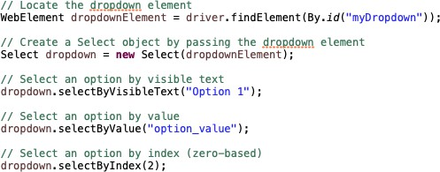

a) Retrieving all the values from dropdown

After locating the dropdown element, then we create a **Select** object by passing the dropdown element to it, so we have access to its method, then we use **getOptions** method to retrieve all options from dropdown as a list of **WebElement** objects.

We can then iterate through the list of options and retrieve their values using the **getAttribute(“value”)**

method.

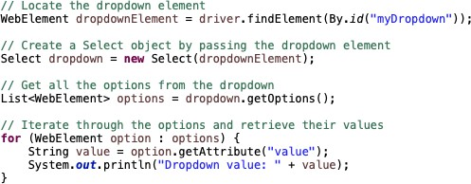

##### Iframe

1. How to handle Iframe?

**Iframe** is a **web page which is embedded in another web page** and contains <iframe> tag. To handle iframe we need to use the **switch()** method and the **frame()** method.

* There are **three ways** we can switch over the elements in frames
  1. **By index** □ **switchTo().frame(int index)**
     + Pass the frame index number
  2. **By name or ID** □ **switchTo(). frame(String frameName)**
     + Pass the frame element name or ID
  3. **By web element** □ **switchTo(). frame(WebElement element)**
     + Pass the frame web element

1. parentFrame() vs defaultContent()

###### switchTo().defaultContent() & switchTo().parentFrame()

* + Used to switching back and forth between iframes and parent page
* The difference between **switchTo().defaultContent()** and **switchTo().parentFrame()**

is that

###### The switchTo().defaultContent() switches the control to the main web page

regardless of the number of frames within the page

* + While the **switchTo().parentFrame() switches the control to the parent frame of the current frame**

##### Multiple Window/Tab

In Selenium, to handle multiple windows we have to use the **switch()** method and getWindowHandle() or getWindowHandles().

###### getWindowHandle()

* + **Purpose** of this method is to **get the window handle of the current window**
  + It will return a **string of alphanumeric window handle**

###### getWindowHandles()

* + **Purpose** of this method is to **get the window handle of all the current windows**
  + It will return a **set of window handle**

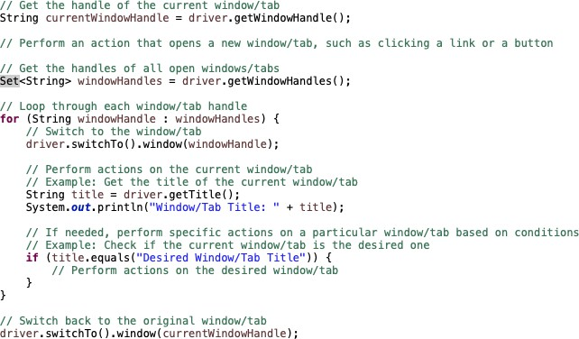

##### Browser Alert/Pop-Up

**Alerts** are popup boxes that ta**ke our focus away from the browser and forces us to read the alert message**. If we do not handle the alert, then we will not be able do any action on the webpage if present.

There are 3 types of web-based alerts

* 1. **Simple Alert**
  2. **Confirmation Alert**
  3. **Prompt Alert**

**To handle Alerts**, we need to **use Alert interface** which provides methods that allows us to deal with alerts.

* **accept()** □ to **accept** the alert
* **dismiss()** □ to **dismiss** the alert
* **getText()** □ to **get the text** of the alert
* **sendKeys()** □ to **write some text** to the alert

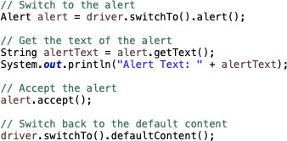

##### Desktop Alert/Pop-Up

Handling desktop alerts or popups with Selenium is not directly supported because Selenium is primarily designed for web browser automation. However, we can use the Robot class to handle basic desktop alerts.

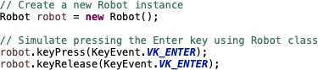

##### Actions Class

The Action class in Selenium is used to perform advanced user interactions such as mouse movements, keyboard events, and other complex actions on web elements. it can perform multiple actions at the same time

1. Right Click



1. Double Click



1. Drag & Drop

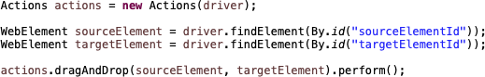

1. Mouse Hover



##### Upload File

Uploading files in WebDriver is done by simply using the **sendKeys()** method on the file-select input field to enter the path to the file to be uploaded.



##### Download File

We can handle file downloading by locating the download link and clicking on it, after that we wait for some time until the file is downloaded, then we check for the existence of the file in the specified download directory. After verifying that the file is downloaded, we can apply different actions like reading the content depending on the type of file we are interacting with.

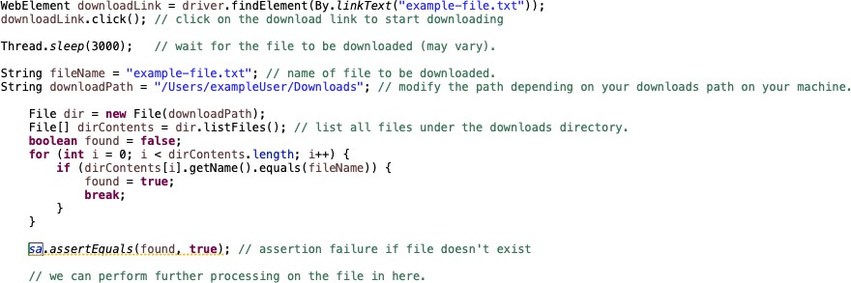

##### Robot Class

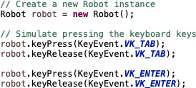The **Robot** class in Selenium provides a way to **simulate user interactions with the operating system's keyboard and mouse**. This class can be useful in scenarios where direct WebDriver interaction is not possible, such as handling operating system dialogs, interacting with native applications.

##### JavaScriptExecutor Interface

**JavaScriptExecutor** is an **interface** in Selenium WebDriver that **allows the execution of JavaScript code through Selenium.** It provides an another approach when regular Selenium locators are unable to perform the operation on a web element. We can use JavaScriptExecutor, to execute custom JavaScript code to interact with elements

1. Enter Text

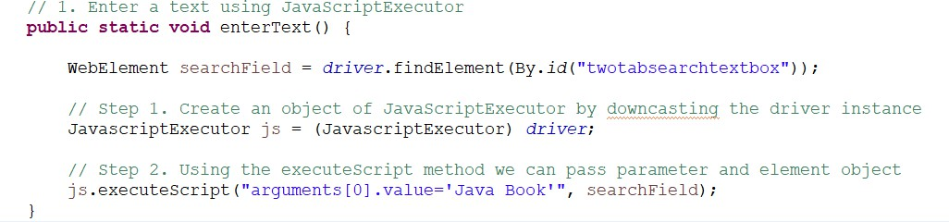

1. Click the button.

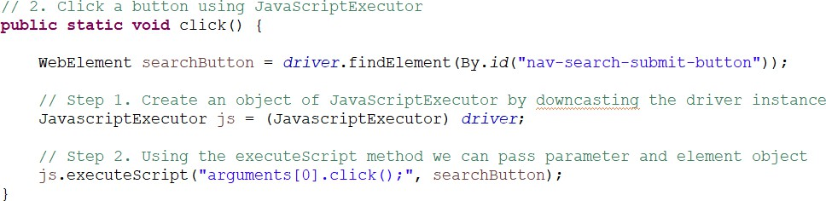

1. Retrieve Page Title

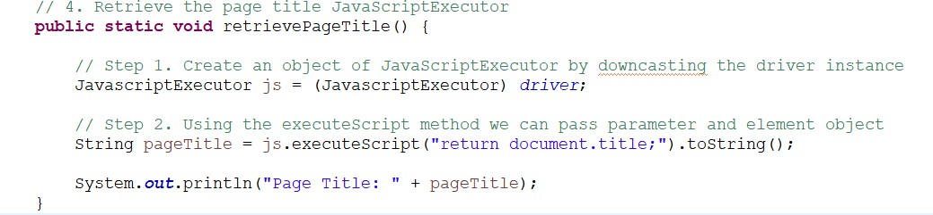

1. Retrieve the Text

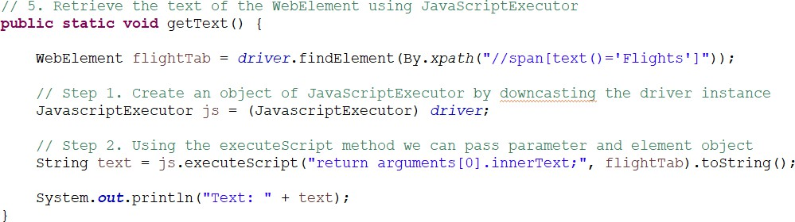

1. Refresh Page

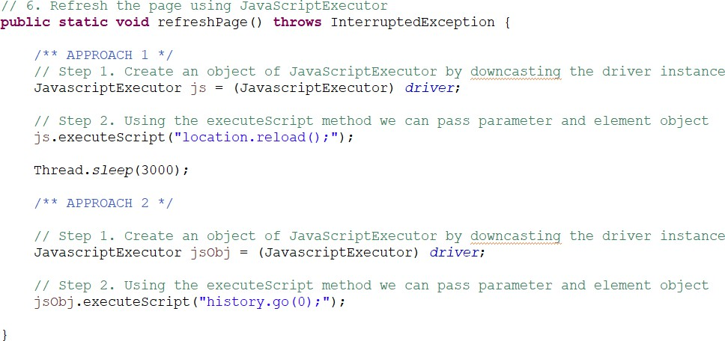

1. Navigate Back

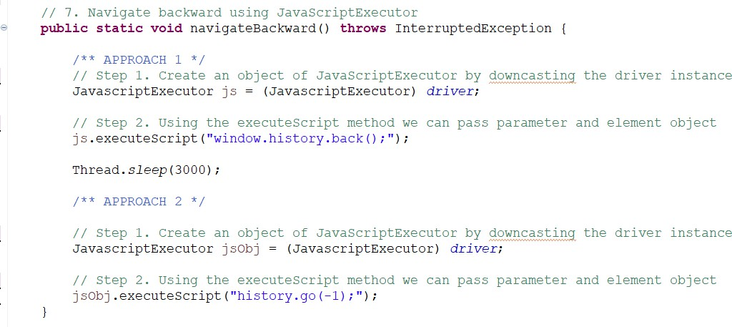

1. Navigate Forward

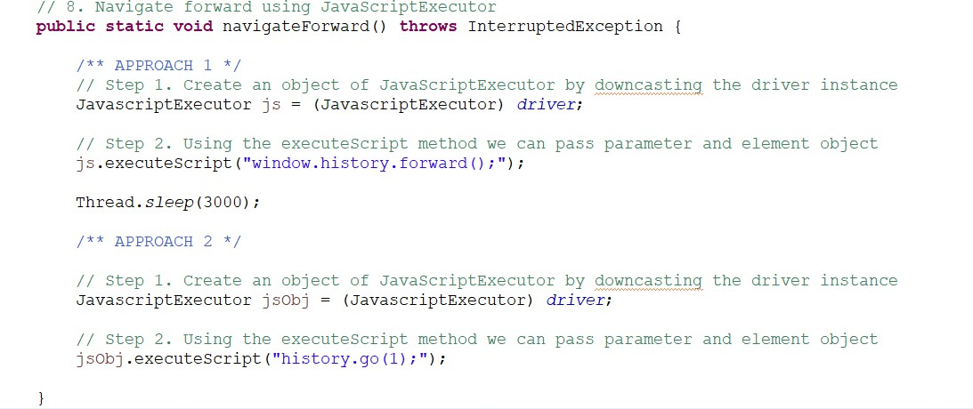

1. Interact with Hidden Element

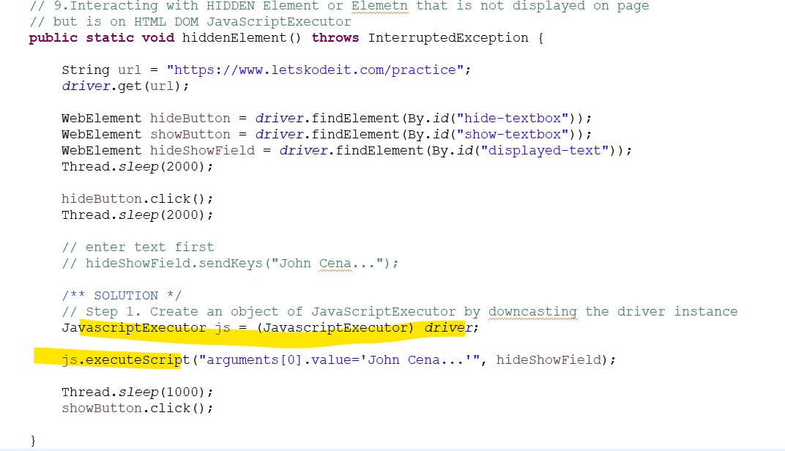

1. Scroll to the bottom of the page

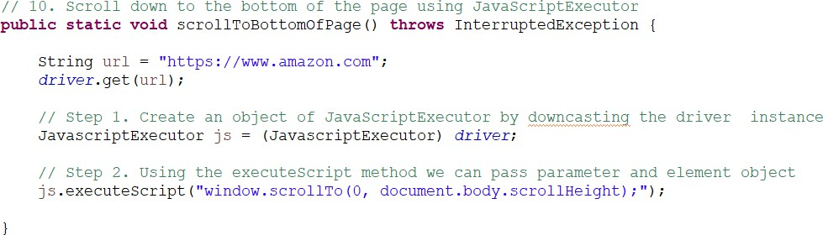

1. Scroll to the top of the page

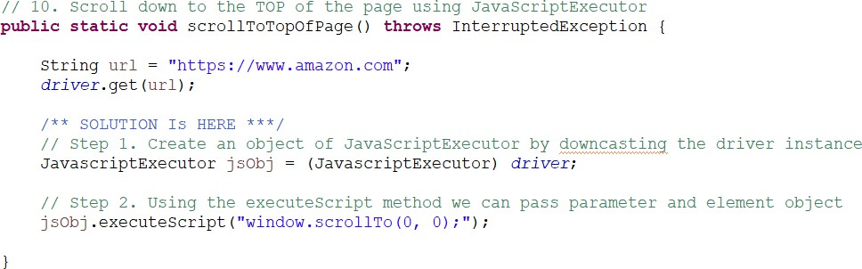

1. Scroll to the specific element on the page

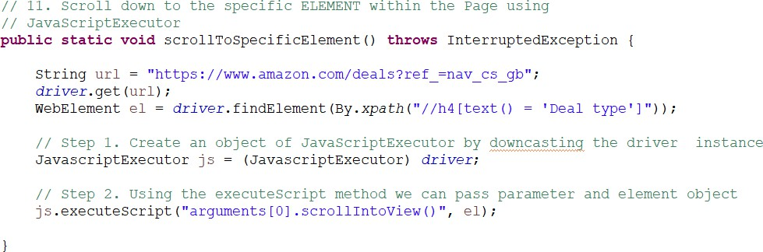

1. Scroll to the specific location/pixel

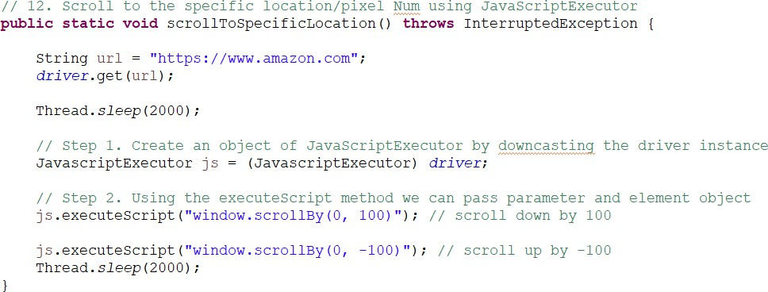

1. Horizontal Scroll

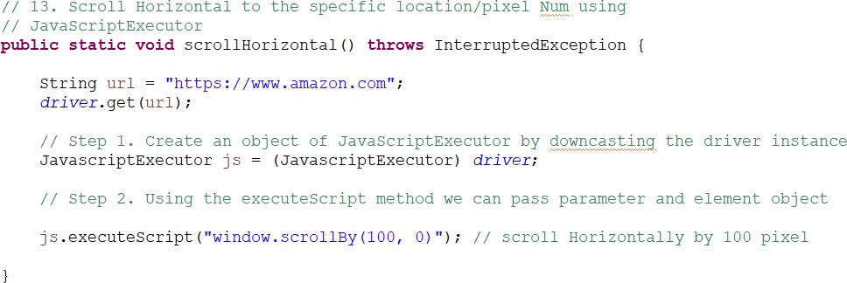

##### TakeScreenShot Interface

To take a screenshot with Selenium, we can use **getScreenshotAs()** from **TakesScreenshot** interface. So first, we have to **create an object** of TakesScreenshot by **downcasting** the **driver instance**

TakesScreenshot screenshot =(TakesScreenshot) *driver*;

Then we need to call the **getScreenshotAs()** and pass the **Output.FILE** as parameter and store inside the

**File Object**. In **java.io** package we have **File class** and we can set that equal to File.

File file = screenshot.getScreenshotAs(OutputType.***FILE***);

Once we take the screenshot, we need to **save the file somewhere in our project**. FileUtils.*copyFile*(file, **new** File("./src/test/resources/screenshot/xyz.png")); To s**ave the file**, we can use the **copyFile()** from **FileUtils class** and pass 2 parameters

* **Parameter1** will be the file object and
* **Parameter2** to location of the file where we want to store

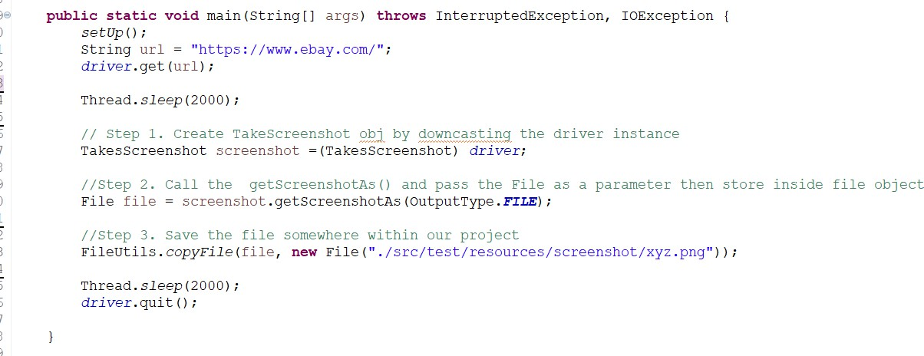

##### Handling Broken Link

To find out if the link is broken or not, first we need to capture all the links from the page. To retrieve all the links, we can use the tagName locator because all the links in HTML DOM will have <a> tag and the link for the <a> tag will be stored inside 'href' attribute.

Using findElements() we can locate, retrieve, and store inside List<WebElement>. Once we have all the links stored inside List<WebElement> then we need to loop through each link and retrieve the href attribute value

Then we can create a **URL** object and open a connection to the link's URL by sending a request. We can use **HttpURLConnection** and pass url to open a connection. Once the connection is established then we can retrieve the response status code.

If the **response status code is greater than or equal to 400 then it is a broken link.** Otherwise, it is considered a valid link.

* **4xx** HTTP status code refers to a **Client-Error,**
* **5xx** status code refers to a **Server-Error**

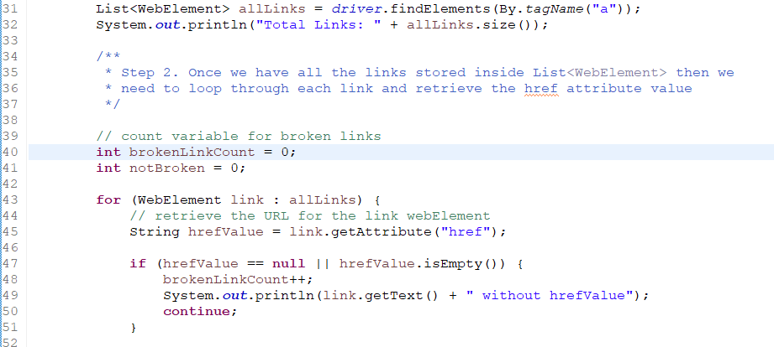

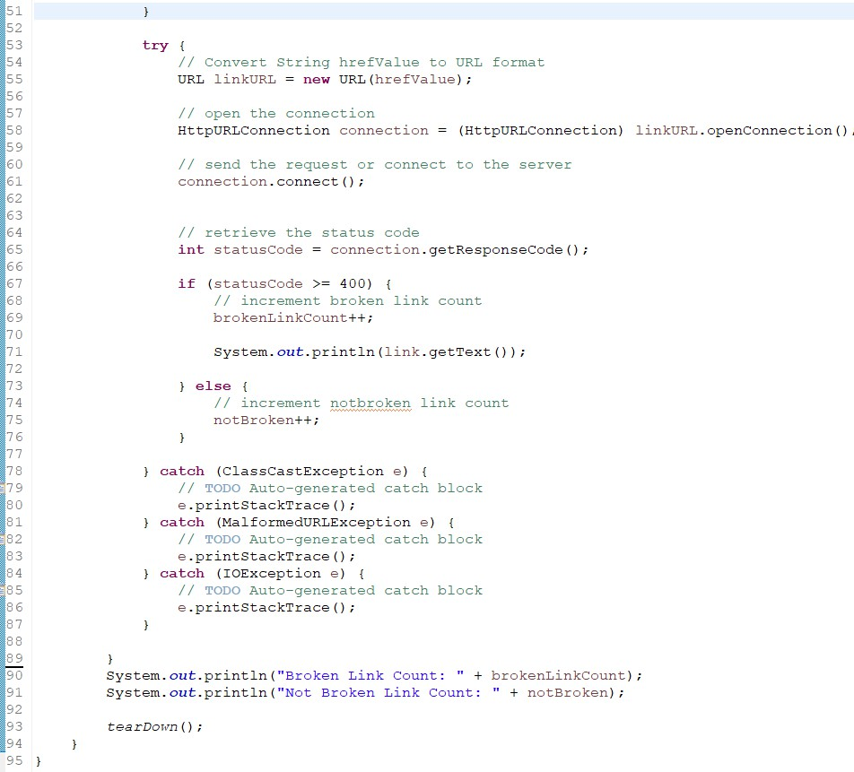

##### Page Object Model (POM)

**Page Object Model** is a **design pattern**, used in my automation framework **which creates Object Repository for web UI elements**.

Using page object model:

* It reduces code duplication,
* Makes code cleaner,
* Easy to understand,
* And improves test maintenance.

In **Page Object Model**, for each **web page in our application**, I have a corresponding **Page Java Class.** This page class will contain the **WebElements of the web page** and **contains Page Methods** which perform operations on those WebElements.

For example, to **implement Page Object Model**:

* 1. First, I have to **inspect the WebElement** of the page
  2. Second, using **@FindBy annotation** I have to store the in WebElement Object. **@FindBy**

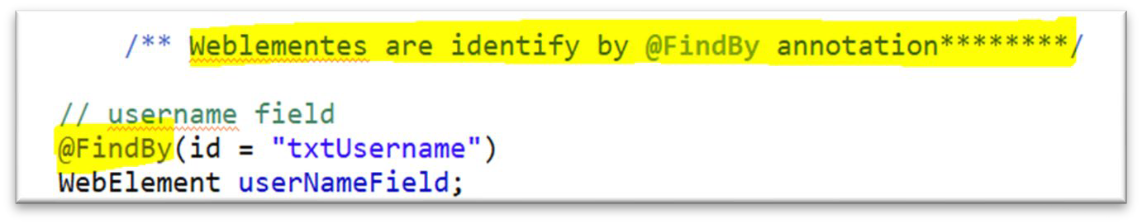

annotation is **used to find WebElement**.

* 1. Third, I have to create **Page Class Constructor,** and, in the constructor, **I need to call PageFactory.initElements method** by **passing the driver object and class reference**. **InitElements** method is **used to initialize web elements**.

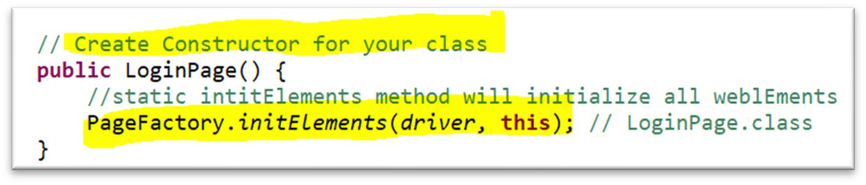

* 1. Lastly, I will be **creating page methods** which **performs operations on those WebElements.**

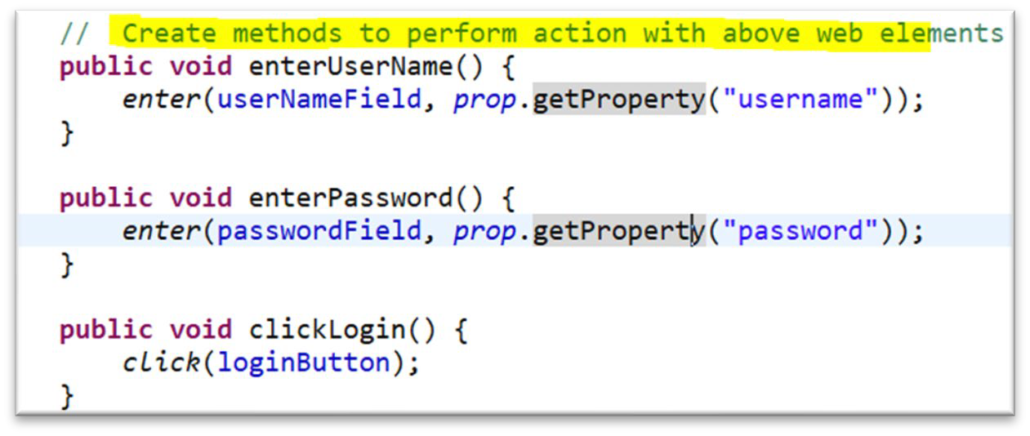

##### Different ways to enter value to text field.

With Selenium, to **enter a value** in textfield we can use **sendKeys()** or **JavaScriptExecutor**





##### WebTable

After locating a webTable element, we can iterate through its rows and columns, then we can perform different actions, that involves retrieving data, searching for a specific value, or interacting with table elements.

* **Locate the table element:**

WebElement table = driver.findElement(By.tagName("table"));

* **Retrieve all rows in the table:**

List<WebElement> rows = table.findElements(By.tagName("tr")**);**

* **iterate through the rows and retrieve data from each cell:**

for (WebElement row : rows) {

List<WebElement> cells = row.findElements(By.tagName("td"));

for (WebElement cell : cells) {

String cellText = cell.getText();

// Perform actions with the cell data

} }

* **Access specific cells using row and column indexes:**

WebElement specificRow = rows.get(rowIndex);

WebElement specificCell = specificRow.findElements(By.tagName("td")).get(columnIndex); String cellText = specificCell.getText();

// Perform actions with the specific cell data

##### WebDriverManager

WebDriver Manager is a tool that helps in managing the WebDriver executables, it removes the manual effort of downloading the executable files, setting the paths, and constantly checking the versions, which is time-consuming and inefficient.

**To use WebDriverManager**

* First, we need to include the **dependency** in our project.
* Then, we can configure the WebDriver Manager to **download the appropriate WebDriver executable** for our target browser.



* When we run our test, WebDriverManger **automatically checks for the latest version** of the WebDriver executable **and downloads it** if it is not already present.
* After downloading, WebDriver Manager **sets the necessary system properties** to ensure that the executable is detected and used by Selenium.
* Finally, we can create an instance of the WebDriver for the desired browser



**Selenium Grid (Completed)**

##### What is Selenium Grid and how does it work?

Selenium Grid is used to run tests on different machines against different browsers in parallel.

**We use Selenium Grid in the following scenarios:**

* + Execute your test on different operating systems
  + Execute your tests on different versions of the same browser
  + Execute your tests on multiple browsers
  + Execute your tests in parallel and multiple threads

**Here’s how Selenium Grid works:**

* + **Hub**: Hub is the central point of the entire GRID Architecture which receives all requests. There is only one hub in the selenium grid. Hub distributes the test cases across each node.
  + **Node**:
    - Node is a remote device that consists of a native OS and a remote WebDriver.
    - It receives requests from the **hub** in the form of JSON test commands and executes then using WebDriver.
    - There can be one or more nodes in a grid.
    - Nodes can be launched on multiple machines with different platforms and browsers.
* **Test Execution:**

The client (test script) communicates with the hub to request a specific test configuration. The hub determines an available node that matches the requested configuration and assigns the test execution to that node. The **test script is then executed on the assigned node.**

* **Result Reporting:**

After the test execution, the results are collected and reported back to the hub. The hub in turn provides a report to the client.

##### What are the advantages of using Selenium Grid?

* Selenium Grid gives the flexibility to distribute your test cases for execution.
* Reduces batch processing time.
* Can perform multi-browser testing.
* Can perform multi-OS testing.

##### How to set up a Selenium Grid?

* **Set up the Hub:**
  1. Launch a machine or server that will act as the hub.
  2. Download the Selenium Server (also known as Selenium Standalone Server) from the official Selenium website. It is a JAR file that contains the necessary components for running the hub and nodes.
  3. Start the hub by running the following command in the command line: java -jar selenium-server-standalone.jar -role hub

The hub will start and listen for incoming test requests on a specified port (default is 4444).

* **Set up the Nodes:**
  1. Configure the nodes. For example, different browser versions, operating systems, or device emulators.
  2. On each machine or virtual machine that will act as a node, download the Selenium Server JAR file. Start the node by running the following command in the command line:

java -jar selenium-server-standalone.jar -role node -hub http://<hub_address>:<hub_port>/grid/register

Replace **<hub_address>** and **<hub_port>** with the **actual address and port** of the hub.

0. The node will register itself with the hub and make its capabilities (browser, version, platform) available for test execution.

* **Verify the Grid Setup:**
  1. \;p\
  2. ‘k,.-[“pen a web browser and navigate to the hub's console by entering the hub URL in the address bar (e.g., http://<hub_address>:<hub_port>/grid/console).
  3. The console will display information about the connected nodes, their capabilities, and their availability for test execution.
* **Execute Tests on the Grid:**
  1. Modify your test scripts to use the hub's URL for remote WebDriver creation instead of the local WebDriver.
  2. Specify the desired capabilities for the test, such as browser type, version, and platform, to match the configurations available on the grid.
  3. Run your test scripts, and they will be distributed and executed across the nodes in the grid.

**API (Completed)**

##### API vs Webservice

* + Webservice is an API wrapped in HTTP Protocol and part of Internet
  + **All webservice are API, but APIs are not webservice** Because APIs can be tested in local systems as well without accessing the internet.
  + Web Service might not perform all the operations that an API would perform
  + A **web service needs a network** while an API does not need a network for its operation.

##### SOAP API vs RESTful API

**SOAP API:**

* + Simple Object Access Protocol.
  + It is used for message exchange between service and application in **XML format.**
  + Is a wrapper over HTTP protocol, internally **it used HTTP** protocol to transfer and receiver XML messages
  + **ONLY supports POST** Type Request

**RESTful API:**

* + Representational State Transfer.
  + RESTful APIs **commonly use JSON** (or sometimes XML) for message formatting, since it is a **simpler and more lightweight** data interchange format.
  + **Response** can be in format **HTML, XML, plain Text, JSON, PDF**, etc.
  + Data and functionality that a client can access from server called **Resource**
  + it uses standard **HTTP methods (GET, POST, PUT, DELETE)** to perform actions on resources
  + [

##### HTTP METHODS

I worked with different HTTP Method, we have GET, POST, PUT, PATCH, DELETE methods

* **GET** is used to retrieve existing resource
* **POST** is used to create new resource
* **PUT** is used to update existing resource
* **PATCH** is used to update partial and
* **DELETE** is use d to delete resource
  1. GET Request
* **GET** Method is used to **retrieve data from resource**.
* GET Method **does not modify data**.
* GET APIs should be idempotent(unchanged), which means that making multiple same requests must produce the same response from server until another HTTP Methods(POST or PUT) has changed the value of the resource on the server
* GET Method **does not contain body**. When sending GET Request we do not provide any method body
* For any given HTTP GET API, **if the resource is found on the server**, then it must return HTTP response code **200 (OK)** – along with the response body which is usually either ***XML or JSON content***
* In case **resource is NOT found on server** then it must return HTTP response code **404 (NOT FOUND)**
* If the **GET Request itself is not correctly formed**, then server will return HTTP response code

**400 (BAD REQUEST)**

* 1. POST Request

 POST Method is used to create a resource

* **If the resource has been created on the server**, the response SHOULD be HTTP response code **201(Created)** and contain an entity which describes the status of the request and refers to the new resource
* **Many times, the action performed** by the POST method might not result in a resource that can be identified by a URI. In this case, either HTTP response code **200 (OK) or 204 (No Content)** is the appropriate response status
* POST Method **requires a request body.**
* The data sent to the server with POST is stored in the request body of the HTTP request
  1. PUT Request
* PUT Method is primarily used to **update existing resource in a server**. If the resource does not exist, then PUT API may decide to create a new resource or not)
* If a **new resource has been created** by the PUT API, the server MUST inform the client via the HTTP response code **201 (Created)** response
* If **an existing resource is modified,** either the **200 (OK) or 204(No Content)** response code SHOULD be sent to indicate successful completion of the request
* PUT Method **requires a request body.**

**NOTE***: The difference between POST and PUT** is that PUT requests are idempotent. That is, calling the same **PUT request multiple times will always produce the same result**. In contrast, **calling a POST request repeatedly have side effects of creating the same resource multiple times**.

* 1. PATCH Request
* PATCH Methods are used to **make partial update on a resource**
* PUT requests also modify a resource entity so to make more clear - PATCH method is the correct choice for **partially updating an existing resource** and **PUT should only be used if you are replacing a resource in its entirety**
  1. DELETE Request
* DELETE Methods are used to **delete resources** (identified by the Request-URI)
* A successful response of DELETE requests SHOULD be HTTP response code **200 (OK)** if the response includes an entity(response body/message) describing the status
* 202 (Accepted) if the action has been queued
* 204 (No Content) if the action has been performed but the response does not include an entity (response does not have body/message)
* DELETE Operations are idempotent. If you DELETE a resource, it is removed from the collection of resources
* Repeatedly calling DELTE API on that same resource will not change the outcome- however calling DELTE on a resource a second time will return a **404(NOT FOUND)** since it was already removed
* DELTE Method does not require method body. We mention in the URI the resource information (id)
  1. HEAD Request
* HEAD Method is almost **identical to GET Method, but without the response body**
* In other words, when we perform GET Request the Server will return with response body, however when we perform HEAD Request the Server will not return response body
* HEAD requests are useful for checking what a GET request will return before actually making a GET request- like before downloading a large file or response body
  1. OPTION Request
* OPTIONS Method is used to **describe the communication options for the target resource**
* OPTIONS Method allows the client to determine the options and/or requirements associated with a resource, or the capabilities of a server, without implying a resource action or initiating a resource retrieval

##### Status Code

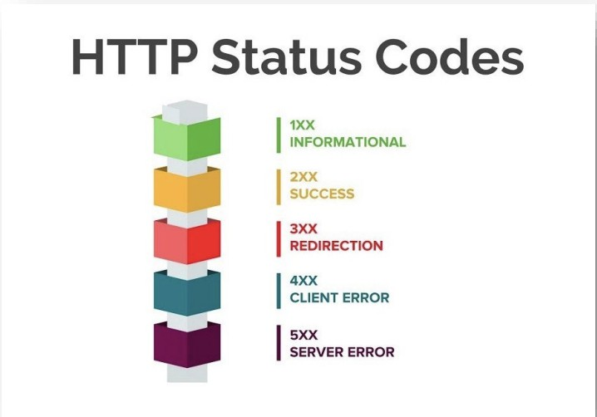

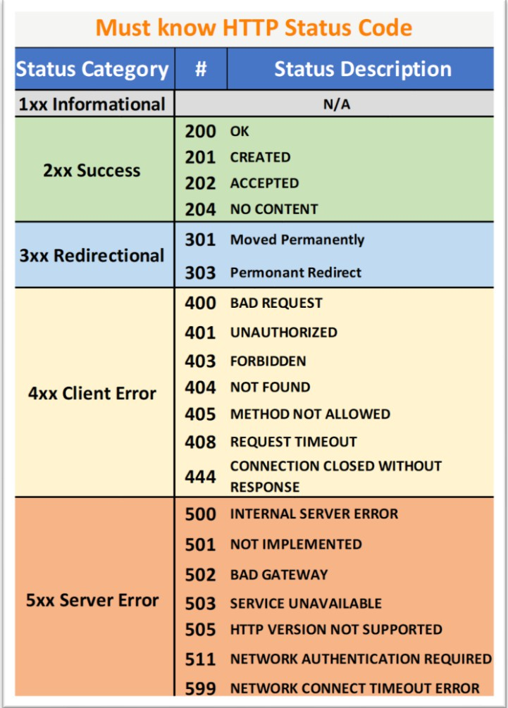

1. Authentication
2. What is Authentication?
   * Authentication is the process of **verifying the identity of the client** making a request to access or interact with an API.
   * It **ensures that only authorized users or applications can access the protected resources** or perform certain actions within the API.
   * Authentication is crucial for API security and helps **prevent unauthorized access.**
3. Types of Authentications
   * **Basic Authentication:**
     + The client sends **the username and password in base64-encoded** format with each request.
     + This method is simple but less secure as credentials are sent in each request.
   * **API Keys:**
     + Clients use **a unique API key,** typically provided by the API provider, to authenticate themselves.
     + The key is included in the request, either as a query parameter or in the headers.
   * **OAuth:**
     + OAuth is an authorization framework that allows users to **grant third-party applications limited access** to their resources **without sharing their credentials.**
     + It involves the exchange of access tokens after user authentication.
   * **JWT (JSON Web Tokens):**
     + JWT is a popular method for token-based authentication.
     + It uses **digitally signed tokens** to authenticated clients.
     + after successful authentication. Clients include the token in the request headers to authenticate themselves.
     + JWTs can contain information about the user or client.
4. Where do you add authentication?

We use the **"Authorization" header** field to include the authentication token. The value of the "Authorization" header typically follows a specific format based on the chosen authentication method.

For example:

**for Bearer Token**: **The value of the "Authorization" header** is **"Bearer {token}"**.

##### API Testing Process

In my current team, we do have both **UI and Web service User Stories**. When I am working with user story that is web service, I use different testing approach and tools in order to test.

All our webservice is RESTful API. In order to test:

1. First, **I need to understand the requirements**,
2. And need to make sure I **have all the information in order for me to make a request** to server.

For example, If I am **sending POST Request**:

1. **First**, I need to make sure I have the
   * **Endpoint**
   * **Headers if required**
   * **Query parameter if required**
   * **And Request body**
2. **Second**, using **SoapUI or Postman** I will do **manually webservice testing** to make sure I can send a request and get response for server
3. **Third**, once I send a request and server responds**, I need to validate if I am receiving correct status code**.
4. **Lastly**, after validating the status code, I will v**alidate the response body to make sure the expected and actual fields are matching.**

##### What do you validate from response?

When it comes to validation, depending on the requirements I will be performing different types of validation.

Initially I need to verify that the HTTP status code returned in the response is the same as the expected one. **For example**, a successful request typically returns a **200 OK** status code, while an error might result in a **400** or **500 Level** status code. We need to make sure that the status code aligns with the expected behavior of the API for the given request.

Then, I will validate the response body. When it comes to response body validation, it really depends on the requirement

* I might have to validate specific fields or required fields within the response body or
* I might have to validate everything in the response body or
* I might have to validate the structure of the response body or
* I might have to validate the response header and response time or
* I might have to validate the correctness of the data server responding by connecting to the application database and writing query to cross validate to ensure what the response body has aligned with the application database.

1. **RestAssured Library**: Example of how to perform API Testing with RestAssured Library

When automating APIs with **RestAssured Library**, I need to ensure that I have the required dependencies in my **pom.xml**.

In my automation framework I have **two important dependency** that allows me to automate and perform different types of validation depending on the requirement.

* + I have **RestAssured Library dependency** that will allow me to use the built-in feature to interact with the server and
  + I have **JsonPath dependency** that will allow me to extract data within the response body.

**Before making a request** I need to make sure I have

* + **Headers** if required
  + **Query Parameter** if required
  + **Authentication** if required
  + **RequestBody** if required

**Once I have all the information** to construct the request to server I will use built-in methods from RestAssured Library. The methods in **RestAssured Library** are **similar to Gherkin keywords** but in terms of **methods**.

In **Gherkin Language** we have **Given**, **When**, **Then**

* + **Given** is the **precondition**
  + **When** is the **action**
  + **Then** is the **outcome**

In **RestAssured** we have

* + **given()** method,
  + **when()** method,
  + **then()** method

**For example**, to make a **POST Request** using **RestAssured Library.**

* + First I will create **Response object**
  + Then I will set

**responseObj** = **given()**

.**headers()** and pass headers as argument

**.params()** and pass parameters as argument

**.body()** and pass the body as argument

**.when()**

**. post()** and pas the URL as argument

.**then()**

**.extract()**

**.response();**

**Depending on the requirement** I will be performing **different types of validation**. First I will **validate the response status code**. To get the status code. I will use **responseObject.getStatusCode()** method.

After the status code validation, I will be **validating the response body**.

For the **response body,** I am using **JsonPath dependency**. With **JsonPath dependency** I will be able to

**extract** the response body and **perform validation**. **To achieve that**, I will create **JsonPath Object**:

**JsonPath jsonPathObject** = **responseObject**.**jsonPath();**

Then I can pass the path of the **jsonObject** or **jsonArray** to **getString()** method from **JsonPath Class**. Once I am **done extracting** the **actual field values** from response body then I will be using **Assertions**

from **TestNG** to **check if the expected and actual values are matching**.

Within the **TestNG Assertions** we have **two different types**:

* + **Hard Assertions** and
  + **Soft Assertions**

All the methods in the **Hard Assertion Class** are **static**, so we don’t need to create a class object to access. We can simply say **Assert**.**assertEquals()**

The methods in the **SoftAssert Class** are **not static**, and we **need to create class object** then we will be able to use the methods.

The **main difference** between **Hard Assert** and **Soft Assert**.

* + In **Hard Assert**, when the **actual value** and **expected values does not match** then it will **throw exception** and **STOP the execution**
  + In **Soft Assert**, when the **actual value** and **expected values does not match** then it will **NOT throw exception immediately and the execution CONTINUES**.
    - In **Soft Assert**, **at the end of our script** we will use **assertAll()** method. This method will **collection the outcome of all assertions** whether **failed** or **passed**. If any of our **assertions failed** then **it will list out those and then throw an exception.**

##### **Karate API**: Example of how to perform API Testing with Karate API

For API automation I have used both RestAssrued and Karte APi

Currently I am using the Karate API and I can walk you through with one the scenarios I have automated

The structure of our framework is a bit different. For example, one of the API stories I have automated is to update existing record info.

So, what I have is JSON file where I can get the request body and the fields in the body are parameterized. I have a runner class which has the two annotations @RunWith and @KarateOptions.

And I have the feature file, in my scenario what I am doing is reading the request body from json file using the read method by passing the classpath of the file and store the result inside an object variable.

To create an object, I will use DEF objectName.

Then using the SET method, I will be replacing the values that I passed in my example table. Once I am done replacing the data, I set up the headers, query parameters, the path and making a PUT request to the server.

Once I have a response then I verify the status code and some of the response fields.

If I am verifying specific field in response then I will use the JSON path, and match method to validate.

##### How do you handle when the server response status code is in the 500 level?

When we have status code that is in 500 Level, then it means something wrong with the server. I would log the details of the error, including the request and response information, to help with troubleshooting.

If the error was a one-time occurrence, I would retest the API to see if the error still occurs. It's possible that the error was caused by a temporary issue on the server side.

If the error is consistent and occurs multiple times, I would report it to the development team. I would create defect and include the details of the error, along with any relevant logs or screenshots, to help the development team troubleshoot and fix the issue.

I would also validate other functionality related to the API to ensure that the error hasn't caused any unexpected side effects.

##### How do you handle when the server response status code is in the 400 level?

When we have status code that is in 400 Level, then it means something wrong with client side. I would first check the request data to ensure that it is correctly formatted and contains all the required parameters.

I would validate the response body and headers to see if they contain any additional information about the error (for example: authentication failure).

I would verify the API documentation to ensure that I am using the correct endpoint, parameters, and HTTP method.

If possible, I would try to reproduce the issue using the same request data in a tool such as Postman.

If the issue is reproducible or persistent, I would report it to the development team along with the details of the request and response. I would also provide any relevant logs or screenshots to help the development team troubleshoot and fix the issue.

1. **RestAssured Library:** How do you validate the response body, which dependency do you use?

**Depending on the requirement** I will be performing **different types of validation**. First I will **validate the response status code**. To get the status code. I will use **responseObject.getStatusCode()** method.

After the status code validation, I will be **validating the response body**.

For the **response body,** I am using **JsonPath dependency**. With **JsonPath dependency** I will be able to

**extract** the response body and **perform validation**. **To achieve that**, I will create **JsonPath Object**:

**JsonPath jsonPathObject** = **responseObject**.**jsonPath();**

Then I can pass the path of the **jsonObject** or **jsonArray** to **getString()** method from **JsonPath Class**. Once I am **done extracting** the **actual field values** from response body then I will be using **Assertions**

from **TestNG** to **check if the expected and actual values are matching**.

Within the **TestNG Assertions** we have **two different types**:

* **Hard Assertions** and
* **Soft Assertions**

All the methods in the **Hard Assertion Class** are **static**, so we don’t need to create a class object to access. We can simply say **Assert**.**assertEquals()**

The methods in the **SoftAssert Class** are **not static**, and we **need to create class object** then we will be able to use the methods.

The **main difference** between **Hard Assert** and **Soft Assert**.

* In **Hard Assert**, when the **actual value** and **expected values does not match** then it will **throw exception** and **STOP the execution**
* In **Soft Assert**, when the **actual value** and **expected values does not match** then it will **NOT throw exception immediately and the execution CONTINUES**.

In **Soft Assert**, **at the end of our script** we will use **assertAll()** method. This method will **collection the outcome of all assertions** whether **failed** or **passed**. If any of our **assertions failed** then **it will list out those and then throw an exception.**

Cucumber(Completed)

##### What is Cucumber?

**Cucumber** is a tool that supports **behavior driven development(BDD)** which is used to write acceptance tests for the application. It allows automation of test case in simple readable format called **Gherkin**

##### Advantages of Cucumber

There are many advantages of use Cucumber within our Framework. It is very easy to share our test scenarios with **non-technical team members**, **ability to generate user friendly cucumber report** and most importantly it is very easy to write the test scenarios using **Gherkin** format.

During our Sprint demo, when demoing user stories with the Stakeholders and Team, I am sharing the scenarios from the Feature file which reduces miscommunication.

##### Disadvantages of Cucumber

Based on my experience writing test scenarios and automating, one thing that **Cucumber does not have is the OOP Concepts**. For example, we are writing a lot of **repetitive Steps** in each Feature file, instead of having the capability to call another step or reuse steps from one Feature file to another Feature file.

It would be very helpful if we could re-use some of the steps instead of re-writing in a different Feature file.

But overall, **Cucumber has a lot of advantages and most importantly it reduces the gap between technical and non-technical team members.**

##### Cucumber Components

READ

The main components of Cucumber are **Feature File, Runner Class** and **Step Definition**. In my BDD Framework, the process of automating the User Story starts with writing the Scenario in Gherkin Format in the feature file.

**Each step in the Feature File** has the associate java method which is stored in the **Step Definition Class.**

**Runner Class** is where I am executing the Feature File and it links-up the Feature File and Step Definition. In Runner Class we have two important annotations **@RunWith** and **@CucumberOptions**

**@RunWith** annotation allows us to execute class as Cucumber Test and

**@CucumberOptions** allows us to specify different properties that will be applied to our test such as

**Feature**, **Glue**, **Tag**, **plugin**

**Feature property** where we provide the path of the feature file

**Glue property** where we provide the path of the step definition.

##### Runner Class

In Runner Class we have two important annotations **@RunWith** and **@CucumberOptions @RunWith** annotation allows us to execute class as **Cucumber Test** and

**@CucumberOptions** allows us to specify different properties that will be applied to our test such as

**Feature**, **Glue**, **Tag**, **plugin**

**Feature property** where we provide the path of the feature file

**Glue property** where we provide the path of the step definition.

##### Step Definition Class

**Step Definition** is a java class that **contains steps methods which are linked to a scenario step** in the **Feature file**. When Cucumber executes Scenario steps, it will look for a matching Step Definition method to execute.

##### Feature File

**Feature file** consists of different types of Keywords, including **Feature**, **Background**, **Scenario**, **Scenario Outline**, **Given**, **When**, **Then**, **And**, **Examples**.

Some of the keywords are mandatory when writing scenarios in feature file. For example,

**Feature** Keyword must be specified on top of each Feature file.

**Background** Keyword is used **when we have common step between different scenarios** in the Feature file.

**Given** is the **pre-condition**

**When** is the **action** we are performing

**Then** is the **outcome**

##### Scenario vs Scenario Outline vs DataTable

**Scenario** represents single testcase or scenario.

**Scenario Outline** is used to **execute the same scenario with different dataset**. When using **Scenario Outline**, we need to use the **Examples** Keyword and provide the different set data.

**DataTable** allows us to pass tabular data as an argument to a step in a scenario or scenario outline.

##### Background Keyword

**Background** Keyword is **used for common steps between all the scenarios** in the Feature file.

For instance, in my automation shakeout suite I have 5 different scenarios that are configured in the Jenkins. For each scenario we must be logged in and landed in the application dashboard page so those steps will be under **Background** keyword in feature file **which will be shared among all the scenarios.**

##### Hooks Class

**Cucumber Hooks** are the **@Before** & **@After** annotations that **run before and after each scenario in Feature file**. By using Cucumber Hooks, it **allows us to better manage the execution flow and reduce code redundancies**.

**TestNG(Completed)**

##### TestNG Annotations

|  |  |
| --- | --- |
| **Annotations** | **Description** |
| **@BeforeSuite** | Runs only once before all @Test annotation methods in the Test Suite |
| **@BeforeTest** | Runs before each @Test annotation method with <test> tag in xml file |
| **@BeforeClass** | Runs before @Test annotation method in current class |
| **@BeforeMethod** | Runs before each @Test annotation method |
| **@Test** | Method contains the test case |
| **@AfterMethod** | Runs after each @Test annotation method |

|  |  |
| --- | --- |
| **@AfterClass** | Runs after last @Test annotation method in current class |
| **@AfterTest** | Runs after each @Test annotation method with <test> tag in xml file |
| **@AfterSuite** | Runs only once after all @Test annotation methods in the Test Suite |

1. How do you handle data-driven testing in TestNG

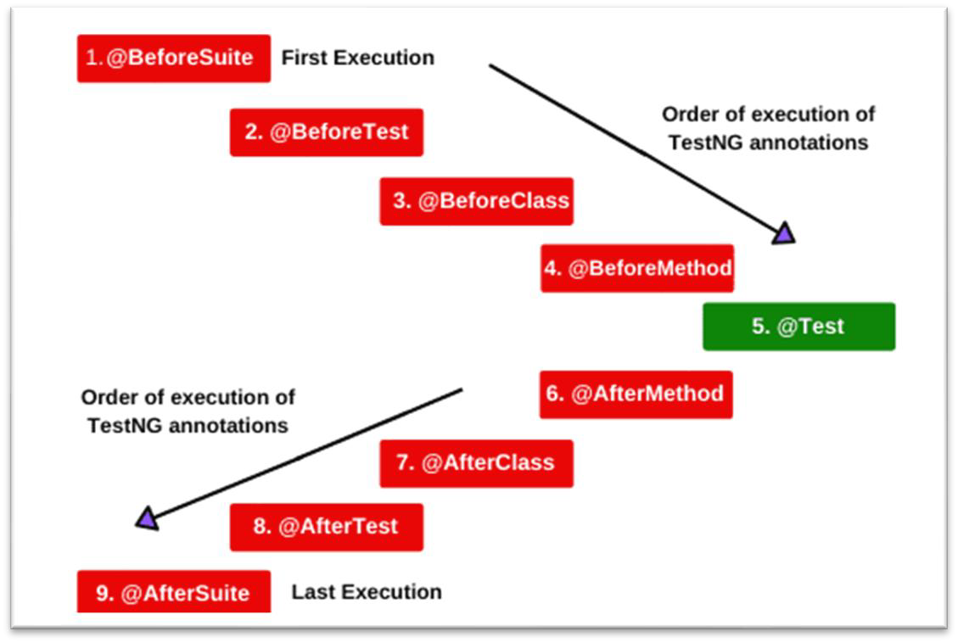

To achieve **data-driven** testing in TestNG, we can the “**@DataProvider**” **annotation. To implement data driven testing in TestNG**,

* + **First**, I will create the **TestData Provider Method** that will contain the **test data**.
    - This method will have **@DataProvider annotation** and
    - 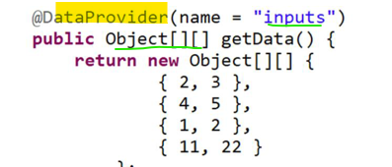**return** a **two-dimensional array of objects**.
  + **Secondly**, in my **@Test method**
    - I will **specify the data provider name** using **the dataProvider attribute.**
      * and **set that equal to my data provider name**.
    - The **test method parameters** need to be matched to the **test data provided** parameters.

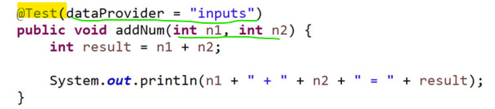

* + Then I will **configure** the **TestNG XML File,** and in my **TestNG XML** file
    - I will **mention the class** that contains the **test method and the data provider method.**

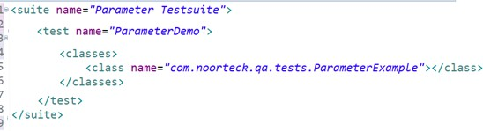

* Lastly I will execute the **xml file**. **TestNG** then will **automatically invoke** the **test method for each data provided by the data provider method.**

##### TestNG Assertions

Within the **TestNG Assertions** we have **two different types**:

* **Hard Assertions** and
* **Soft Assertions**

All the methods in the **Hard Assertion Class** are **static**, so we don’t need to create a class object to access. We can simply say **Assert**.**assertEquals()**

The methods in the **SoftAssert Class** are **not static**, and we **need to create class object** then we will be able to use the methods.

The **main difference** between **Hard Assert** and **Soft Assert**.

* In **Hard Assert**, when the **actual value** and **expected values does not match** then it will **throw exception** and **STOP the execution**
* In **Soft Assert**, when the **actual value** and **expected values does not match** then it will **NOT throw exception immediately and the execution CONTINUES**.
  + In **Soft Assert**, **at the end of our script** we will use **assertAll()** method. This method will **collection the outcome of all assertions** whether **failed** or **passed**. If any of our **assertions failed** then **it will list out those and then throw an exception.**

##### How to PARAMETERIZE

**TestNG Parameters** are the arguments that we pass to the test methods.

There are two ways through which we can pass the parameters to the test methods

* **TestNG Parameters**
* **TestNG DataProviders**

For example, we **want to pass the environment related information** like **URL, username or password**

from file.

* In TestNG XML file we will have **<parameter> tag** with **name** and **value attributes**.
* Then in our **TestNG class**, **above the method declaration we can use @Parameters annotation**

and **pass the attribute name.**

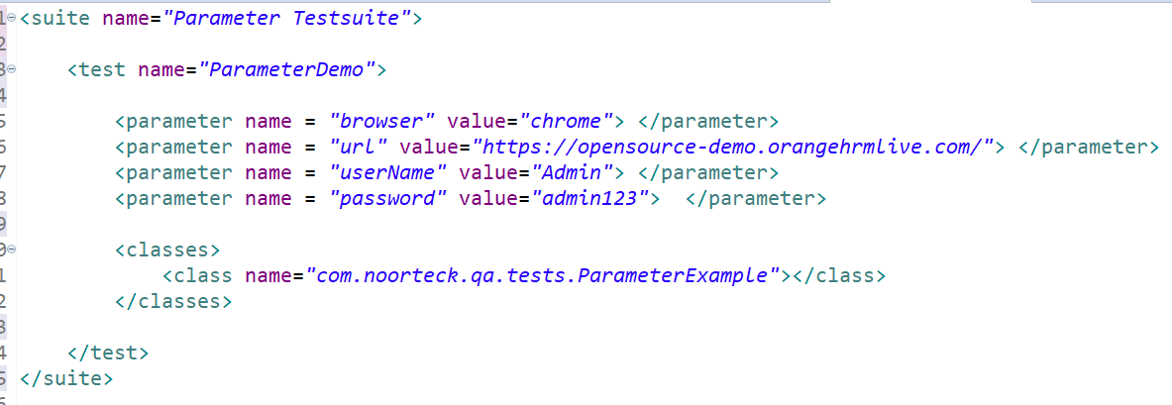

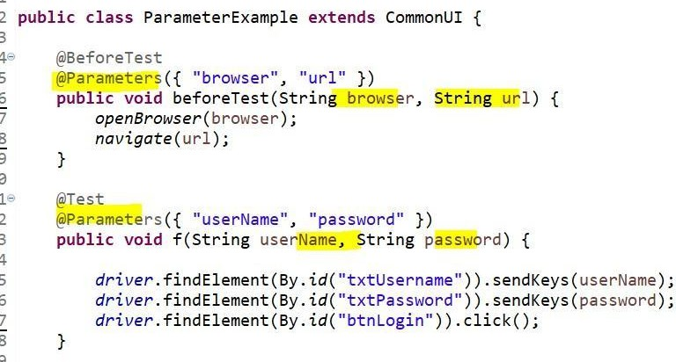

##### How to PRIORITIZE Testcase

Testcase in TestNG executed in **alphabetical order. Prioritization** is one of the features of TestNG that allows us to **provide a sequence to the test methods.**

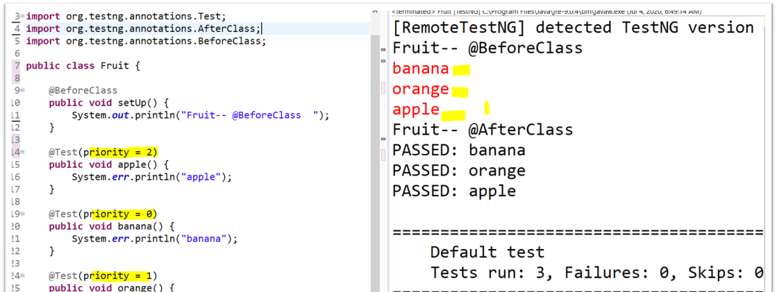The **default value** for the testcase **priority is zero**. If we **do not mention the priority** for the testcase it will take all the testcase as **priority = 0 and execute in alphabetical order.**

##### How to GROUP Testcase

**Grouping** is another important feature of TestNG, that allows us to **group test methods or classes into one or more groups. Grouping** is similar to **tagging** the testcase in **Cucumber Feature File**

We can group testcase by **regionName, releaseNumber or sprintNumber or by moduloName To achieve Grouping:**

* First in our test classes, we can assign groups using **groups attribute in test methods.**
* Then, in **TestNG XML File** we need to have **group tag** and **include tag.**

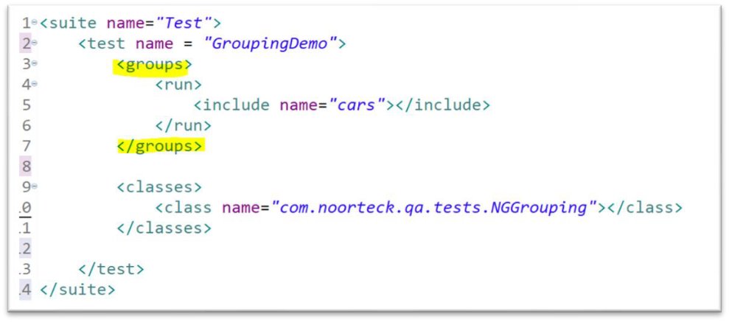

##### How to perform PARALLEL Testing with TestNG

TODO…

##### How to perform CROSS-BROWSER Testing with TestNG

TODO…

**JUnit(Complete)**

##### JUnit Annotations

With in my current automation framework, I am using **JUnit 4** and some of Junit annotations are:

**@BeforeClass**

* + Method with **@BeforeClass** annotation will run once before any of test methods in the current class.

**@Before**

* + Method with **@Before** annotation will run before each @Test method.

**@Test**

* + Method with **@Test** annotation is the test method to run.

**@After**

* + Method with **@After** annotation will run after each @Test method.

**@AfterClass**

* + Method with **@AfterClass** annotation will run once after all the test in the class have run in the current class.

**@Ignore**

* + Method with **@Ignore** annotation will not be executed. It will be ignored.

**Testing Types(Completed)**

##### Functional Testing vs Non-Functional Testing

**Functional Testing** and **Non-Functional Testing** are **two different types of software testing** which focus on different parts of application quality.

* + **Functional Testing** focuses on **verifying the functionality of the application against the requirements**. It makes sure the functionalities that were built by dev team meets the requirements.
  + **Non-Functional Testing** focuses on **testing the non-functional aspects of the application**

including the **performance**, **reliability**, **usability**, and **security**.

* + When performing the Non-functional Testing, we are testing the behavior of the **system under**

**different conditions.**

**An example of Functional Testing** are

* + - **Unit Testing,**
    - **Regression Testing,**
    - **Smoke Testing or**
    - **End to End Testing**

**An example of Non-Functional Testing** are

* + - **Load Testing,**
    - **Usability Testing,**
    - **Stress Testing, or**
    - **Accessibility Testing**

**In my project,** I have focused mainly on performing the **Functionality Testing**. I am very comfortable performing **UI Testing, API Testing** and **DB Testing** for data validation.

I have **not done** any **Non-Functional Testing** including **Performance Testing** or **Security Testing** because we have separate team that handled.

##### Verification vs Validation

**Verification**

* + Is the **process of checking** the requirement document, design and technical document to make sure the software has been built according to the requirements.
  + It focuses on the **early stage of Software Development Lifecycle.**
  + The **main purpos**e of the verification to make sure the requirements are defined correctly.

**Example of Verification activities can be**

* + **Requirement review:** By checking the requirement documentations to check if they are clear, complete, and consistent.
  + **Code review:** By checking the source code to make sure there are no bugs or errors.
  + **Design document review:** By checking the software design to make sure it is aligned with requirements.

**Validation**

* + Is the **process of testing and validating** the **actual product against the requirement.**
  + Once the Dev team finishes the implementations and delivers to the QA team then we as a QA **perform different types of testing** to ensure the application functionality is aligned towards the requirements.

**Example of Validation activities can be:**

* + **Performing Functional Testing:** Testing the functionality against the requirements
  + **Performing Non-Functional Testing:** Testing the performance, or security testing
  + **Performing Usability Testing :** Testing the user friendliness and easy use of the application

##### Functional Testing Types

1. Unit Testing

**Unit Testing** is a type of testing where individual units or components of software tested.

**For my team,** the **Unit Testing** is done by the **Dev Team.** Before the **Dev Team** deploys the code to test environment the code review needs to be done internally within the Developers then the **Unit Test Job** should be executed.

**One of the rules we have within our organization**, prior the **Testing Team** kicks of the Testing activity, the **Unit Test Job must be executed by the Developer** and the **pass percentage** should be **85 % or above**.

If the **Unit Test pass percentage below 85 %** then

* **Dev Team will not be able to deploy** and
* **Testing activity won’t start** until the **Unit Test failures are fixed.**

For my **automation scripts**, I do write **Unit Test** to ensure the code I have written is working properly. For Unit Testing, I have used **JUnit** and **TestNG**.

I have **not done Unit Test for developers code** but if it is something I have to do, I don’t mind doing as long as I have quick walks or code review with developer, so I have understanding about the requirement and source code.

1. Integration Testing

**Integration Testing** is a type of testing where **individual units are combined and tested as a group**. It focuses combining different components of the application and making sure it works correctly together and behaves as expected.

With my current application, I had to perform **Integration Testing** for the **Search Functionality**. The **Search Functionality** for our application consists of multiple components including.

* **search input field,**
* **search algorithm and**
* **search result display.**

The **Integration Testing,** I performed focused on making sure the **correct integration and behavior of different components**.

I had to:

* Verify that the search input field correctly handles different inputs.
* Validate that search algorithm interacts correctly with the search input and returns accurate results.
* Verify the search results are properly displayed and relevant information is presented.
* Validate the handling of errors related to search functionality.

1. Smoke Testing

**Smoke Testing** is a type of testing which is performed to check whether the **Critical Functionality** of the

**application is working correctly**, and **the environment is stable enough**.

1. Explain your Smoke Suite

**One of my responsibilities** is to ensure we perform the daily **Smoke Testing** first thing in the morning and provide execution result update to the team prior daily stand up. **Initially when I joined the team**, the **Smoke Testing** was performed **manually** by our Functional Tester.

Once I had access to the tools and application, I was able to automate the Smoke Testcases and configure **Jenkins Job** to kick of **Monday – Friday 6AM**.

Currently, in our **Smoke Suite** we have **5 testcases** that focus on the main functionality of the application, and it kicks of daily by **Jenkins**. The execution takes about 2-3 minutes.

If any of the **testcases fails**, I usually **take a step back**, **refer to the logs** and **figure out the root cause** of the **failure**. Sometimes **failure** can be because of the

* **Test Data issue**
* **Or Environment related issue**
* **Or Test Script issue**
* **Or an application defect.**

Depending on the **failure type**, I usually take necessary steps and provide updates to the team during our **daily stand up**.

* If it is **Test Data issue**, or **Test Script issue**, I will **ensure to apply necessary fix** to the script then push to the remote and **re-execute the Smoke Job**.
* If it is an **Environment Related issue**, I will **document my observation** and put a word document file with screenshots and explanation **then reach out to the Environment Team** and let them know about the issue.
* If it is **Application Defect**, I will **cross validate against the requirement**, **double check to make sure I can reproduce**, then **check other environments to see if the defect exists in other regions**.
  + Once I am **done with my analysis and verification part** then I will put a **document together** and **provide steps to reproduce along with screenshots** and any additional

information that will be helpful for our developer.

* + **Once I have put together the document**, then I will **create a defect in Jira and attach the file** then **bring it up during the stand-up meeting**, so the rest of the team is aware of the issue.

1. Sanity Testing

**Sanity Testing** is a type of testing performed to check whether the **critical and commonly used functionalities** of an application are working as expected **after minor code changes or bug fixes** by the dev team.

**Sanity Testing** focuses on **validating that the recent changes or fixes** have **not introduced new bugs or issues to the application.**

We can also consider **Sanity Testing** as a **subset of the Regression Testing** because it **focuses testing specific features** which have been **affected** by **recent changes**, instead of testing all features of application.

1. Smoke Test vs Sanity Test

**Smoke Testing** is performed to check whether the **Critical Functionality** of the **application is working correctly**, and **the environment is stable enough**.

**Sanity Testing** is performed to **check that the recent changes or bug fixes by Dev team** have not introduced any major issues to the application.

1. Regression Testing

**Regression Testing** is a type of testing that focuses on verifying the **bug fixes or changes that were made to application code** by Dev team **didn’t introduce new defects or caused previously working functionalities to fail.**

**Regression Testing** makes sure the **existing features and functionalities** of the application **continue to work as expected after code change or bug fix.**

1. Explain your Regression Suite

In my **Regression Suite**, I have about **185 Testcases.**

* Out of 185 Testcases, about **100 Testcases** are **UI related testcase.**
* and **85 API Testcases.**

It takes about **6 hours** to **execute the entire Regression Suite.**

We execute **Regression Suit every Friday at the end of the day before we log off.** We have **Jenkins Job** that is configured and prior logging off, one of the QA members will manually Build via Jenkins Dashboard.

1. Re-Testing Testing

**Retesting** is a type of testing that focuses on verifying that the **defect or issues reported in a previous testing cycle** have been **fixed correctly.**

**For example**, when I am **testing a functionality,** I found that the functionality is **not behaving according to the requirement**.

Then I will **take step back** and

* Try to **reproduce**,
* Double check the **requirement**,
* Find out the **type of issue** and then document everything then create a defect log on Jira.

When the **dev team fixes the defect** I reported, then I will **re-test by running the same testcase** to make sure the issue is fixed.

1. UAT Testing

**UAT (User Acceptance Testing)** is a type of testing performed **from an end user’s perspective** to make sure the **application meets** the **user requirements, expectations**, and **it does what it is supposed to do**.

**UAT Testing** is usually the **final phase of testing before it goes to production.**

**UAT** involves **real world scenarios** and **is usually conducted** by the **end users or stakeholders** who will be using the application.

The main **goal of UAT Testing** is to validate the application **functionality**, **usability**, and **overall user satisfaction.**

1. End-To-End Testing

**End-to-end** testing is a type of testing performed to make sure **the application functionality, data flow, user experience and different parts of the application layer** works as expected and meets the user expectations form **start to finish.**

For example,

In our application we have **Retrieval Page** where we can search by the **account number.**

When we search by account number then it will display the member information which the account belongs in web table format

After **verifying the search result** then I have to go back to the **application database** and **cross validate by writing query** with same account number and **making sure the resultset will have same output as what UI have displayed.**

##### Non-Functional Testing Types

1. Performance Testing

**Performance Testing** focuses on testing the **speed**, **responsiveness**, **stability**, **scalability** of an application under **different workloads**.

In our organization we have **Performance Testing Team**, that focuses on performing different types of testing including **Load Testing, Stress Testing, Volume Testing or Scalability Testing**.

I have **not done** Performance Testing, mainly focused on **Functional Testing**.

I am aware that our **Performance Team** uses **JMeter** which is **Java based library** and **I have strong Java background picking new tool wont be challenging.**

1. Load Testing

**Load Testing** focuses on testing the **behavior and performance of the application under normal and peak load conditions**. It simulates realistic workloads and measures the application response time and behavior.

1. Stress Testing

**Stress Testing** focuses on testing the **behavior, stability and reliability** of the application **under extremely heavy load conditions.** It evaluates how software behaves under extreme condition and find out application breaking points.

1. Volume Testing

**Volume Testing** focuses on testing the **behavior and performance of an application** when **exposed to a large volume of data.** It evaluates how **software performance behaves** when the **volume of data increased** in the database.

1. Usability Testing

**Usability Testing** focuses on testing the **user friendliness** and **ease of use** of an application.

1. Compatibility Testing

**Compatibility Testing** focuses on testing the **application is compatible with different environments**, **operating system, browser or devices**.

The main goal of **Compatibility Testing** is to make sure the **application functions correctly and consistently** across different **platform, browser, and devices.**

1. Security Testing

**Security Testing** is a type of **Non-Functional Testing** that focuses on **finding the weaknesses**, **vulnerabilities,** and **potential security risks** within an application.

**Security Testing makes sure that the application is able to protect**

* The **sensitive data**,
* Maintain **confidentiality**, and
* **Defend** against any unauthorized access virus attacks.

1. Accessibility Testing

**Accessibility Testing** is a type of testing that **ensures the application being tested and is usable by individuals with disabilities** like hearing, color blindness etc.

1. Reliability Testing

**Reliability Testing** is a process of checking an application’s ability to perform its **intended functions without failures or errors** over **a specific period of time.**

1. Scalability Testing

**Scalability Testing** focuses on testing the performance of the application **when the number of users increases**. It makes sure the **application can handle** when **increase in user traffic and data volume**

1. Configuration Testing

**Configuration Testing** focuses on testing the **behavior and functionality** of an application across different configurations or settings.

**Testing Technique(Completed)**

##### Black Box Testing

**Black-Box Testing** is a **technique** in which the **tester does not have access or knowledge of the source code**. The **functionality of the application** is tested **without looking at the code.**

I pretty much perform **Black-Box Testing** when testing the **User Stories that are assigned to me**.

When **testing the functionality**, I will be testing **against the requirement** to ensure the functionality performs as per **requirements expectations.**

##### White Box Testing

**White-Box Testing** is a **technique** in which is performed by **Developer**. In this case the person that is performing the testing **has knowledge of the source code**. **Unit Testing** is an example of **White Box Testing.**

##### Equivalence Partitioning

**Equivalence Partitioning** is a testing technique used to **design test cases** in which **input data is divided into partitions** of **valid and invalid values** and makes sure all partitions have the **same behavior.**

* + If a condition of one partition is true then the condition of another equal partition must also be true.
  + If a condition of one partition is false then the condition of another equal partition must also be false.

It **helps to reduce the number of test cases** and make sures we have **maximum test coverage**.

##### Boundary Value Analysis

**Boundary Value Analysis** is a testing technique used to **test boundary values** because the **input values near the boundary have a higher chance of error.**

##### Decision Table Testing

**Decision Table Testing** is a testing technique used to **test the behavior of the application** based on

**different combinations of their respective behavior** which is captured in a table format.

##### Error Guessing

**Error Guessing Testing** is an **informal testing technique** where we t**est the functionality based on our experience and knowledge to find defects.**

While using this technique, I usually put myself in **User Shoes** and **try different ways of testing to catch potential errors or defects.**

**Testing Approach(Completed)**

##### Positive Testing

**Positive Testing** is a testing approach in which we **verify the application behaves as expected when provided with valid input.**

##### Negative Testing

**Negative Testing** is a testing approach in which we **verify the application behavior when provided with invalid, or unexpected inputs**. It focuses on testing how the **application handles when invalid input** is provided by user.

##### Exploratory Testing

**Exploratory Testing** is an approach in which we **explore the system and test the functionality** without having all the requirements or set plan.

While we **play around with different functionality of the application**, we will **learn more about the application** and come up with proper testcase.

##### Ad Hoc Testing

**Ad-Hoc Testing** is an **informal and unplanned testing that involves exploring** and testing the application

**without following any testcases or documentation.**

Main purpose of **Ad-Hoc Testing** to find defects by randomly testing and not follow any documentation.

##### Monkey Testing

**Monkey Testing** is a testing technique in **which we enter any random inputs into the application** to find

**unexpected behavior, crashes or errors.**

**Defect (Completed)**

##### What do you do when you find a defect?

Once I find a defect, I usually take a **step back and perform a different set of checklists** before reporting to the team.

* + First I will try to **reproduce the defect**.
    - I will **note down the steps I took that led to the defect** as well as a**ny error messages or unexpected behavior I observed.**
    - I will also **try checking with different browsers** and in **different regions** to ensure that issue does not exist in other regions.
    - I will also **double check the requirement** to make sure I didn’t miss anything from the requirement standpoint.
  + Once, **I was able to reproduce**, then I will **document the defect**.
    - I usually **create word document fill** and provide detailed report **describing the defect.**

**In this file I will include information including**

* + - * The **Environment** which the defect found,
      * The **expected behavior** and the **actual behavior**.
      * **Steps to reproduce the defect,**
      * I will also include **screenshots along with the logs that generated.**

For **Defect Reporting** we use **Jira**, once the **word document with defect description** is **ready** then I will create defect from **Jira** and attach the file.

After creating a defect on **Jira**,

* + I will **communicate** with my team and let the developer know about the defect.
  + Usually, **we connect via Teams**, and I will walk them through the defect report and will answer if they have any questions.

Once the **developer fixes the defect and re-deploy** I will **follow up and re-test**, **to make sure the issue is resolved.**

* + **If the issue is resolved** I will **update Jira with test results**, **update the team** and **close the defect**
  + **If the issue is not resolved**, then **I will re-assign back to developer** and **let them know.**

##### What does the Defect Report Consists of?

For **defect**, we use **Jira** and **when creating a defect report** there are **different fields** we have to provide including:

* + **Defect Title:** which describes the defect title.
  + **Defect Description:** usually for **defect description I prepare word document file** which includes
    - **Detailed descriptions** about the defect,
    - **Steps to reproduce**,
    - **Expected outcome and actual outcome,**
    - **Screenshots** and any **error messages** or **unexpected behavior.**
  + **Defect Severity:** which will **describe the impact of the defect** to the application.
  + **Defect Priority:** which will **describe the importance or urgency of fixing** the defect.
  + **Defect Environment:** in which environment the defect was detected.
  + **Sprint number:** Which **sprint the defect** was detected.
  + **Linked Issued:** which **links the defect to the user story** that might be blocked.
  + **Defect assignee:** which will be **someone from the team that will be responsible** for fixing the defect.

##### Severity vs Priority

**Defect Severity** refers to the **impact of a defect on the functionality and performance** of the application. It is a **measure of how sever or critical a defect is and how much it affects the application**

**There are 4 levels of Defect Severity: Critical, High, Medium** and **Low Critical:**

* + Is a **critical issue that causes a significant impact** to the application
  + **Example:** Application crashed, Unable to login

**High:**

* + The **main functionality is not working**, **business workflow is broken**, or **performance issues.**
  + **Example:** Retrieving member info not working

**Medium:**

* + Is an **issue that affects the functionality, but does not cause a major impact** on the application
  + **Example:** After adding new job title there is no success message

**Low:**

* + Is an issue that has **minimal impact on the applicatoin and may not require immediate attention**
  + **Example:** spelling mistake, alignments, look and feel issues

##### What do you developer do not agree with a defect?

There were many times when the **developer did not accept the defect that I created**. I am very positive and get along with all my team members.

When **they do not agree**

* I usually **take a step back and try to understand from their point of view** and **go back to the requirement and see if there is something I missed or misunderstood.**

**After doing my analyses**,

* if **I still disagree** with the **developers point of view**, then I will **set up a meeting** and include the

**PO, BA, Dev**, and other **QA** in my team.

Basically, **during this meeting**

* I will **walk them through the scenario** and **go over my point of view** and let the **developer go over their point of view**.
* And then **gather feedback from the rest of the team.**

**o Based on the teams feedback and comments** we **will try to come to a common understanding and conclusion.**

As a QA and Developer,

* We might have **completely different points of view,** and this is **good for the project success and quality**.
* Sharing each other’s point of view and **choosing the one that benefits the project the most** is the **most important part during this process.**

##### After checking the regression execution report, we have test case failures, walk me through how you would fix the failed test cases.

In my current project,

* + We run the **regression suite** at the end of the day before we log off every Friday.
  + One of my main tasks every Monday when we are back is to refer to the Regression execution report results.
    - If we have failures then it is my responsibility to find out the cause of the failure.

What I usually do when going over the **regression failures**, is

* + **First take a step back and go over the execution report**.
  + I will **scan through** and **categorize the testcases that failed.**
    - Then I will **prioritize the failures by categorizing** the **failed testcases based on severity or impact**. I will focus on critical functionalities first.

**Once it is categorized**, then I will start **debugging the failures** by **going over the logs and stack trace** to find out the failure reason. Sometimes failure can be because of the

* **Test data issue**
* Or it can be **script issue.**
* Or it can be an **Environment issue.**
* Or it can be an actual **application defect**.

**Once I know the cause of the failure then I will take necessary action**

* If it is a **test data issue**, I will **come up with a new set of test data** and try to re-run and make sure it is working.
* If it is **script issue**, then I will i**mplement necessary changes to the code** to make sure we are handling the unexpected, scripted failure issue.
* If it is an **environment issue** then I will **create a document and put necessary information with screenshots and logs** then **touch base with the Environment Team and work closely with them** to resolve the issue and see how we can come up with a solution, so we do not run into similar issues in future.
* If it’s an **actual application defect**, then I will **follow the defect life cycle process** and **double check the requirement**, **try to reproduce and verify against different environment**, then create a document by providing steps to reproduce, screenshots and logs that will be helpful to the dev team. Then create a **defect on Jira and assign to the dev team.**

Once I am done with **Regression failure fixes**,

* I will **document and report the root causes of the failures** and provide a description of what fixes I have applied to fix the failures.

Lastly, we **usually re-group internally with QA Team** and **discuss the failures and the fixes** we have applied and **how we can avoid future execution to reduce the downtime.**

##### For instance, 2 days before release day you found a defect in the application, what do you do as a tester?

As a QA, if I found a **defect 2 days before the release.**

First of all, I will take a **step back and before creating panic to my team,**

* + I will **double & triple check the requirement**,
  + Try to reproduce,
  + Check other regions and try testing with different browser to make sure this an actual defect.

**And if it is an actual defect,**

* + I will create the **defect document** by
    - Providing steps to reproduce,
    - Environment related information,
    - Expected outcome and actual outcome,
    - Include the screenshots and logs that will be helpful to the team.

**Once I have put together the document**

* + I will **report** the **defect to the team IMMEDIATELY**. I will have quick meetings with the dev and PO and **walk them through the issue I have discovered.**

**Once the team is aware of the issue,**

* + Then I will **prioritize the defect**, by clearly communicating with the team the severity and impact of the defect to the application.

Meantime, if any other functionality that we think was impacted, we will try to run the **regression suite**

and make sure other parts of the application were not impacted.

I will also ensure my **manager is aware** of the defect and severity to the application.

**Once the management and leads are aware of the issue,**

* + We will come up with **plan action** and I will **work closely with development team** to **determine the feasibly of fixing the defect within the limited time frame** before release and how **QA team can test** and ensure it didn’t affect other parts of the application.

If needed **I will stay after work hours or spend weekends continuing the testing activity** and **check with QA manager** to see if we can receive help from other QA teams with testing activities.

##### How do you handle the production defect that was reported?

When a **production defect is reported**,

* + First I will take a **step back and go over the defect report and try to understand how to reproduce it.**

Once I have a clear picture of the issue,

* + Then I will **prioritize the defect based** on its severity and impact to the application.

I will **analyze** the defect and work closely with the dev team to go over the logs and **pinpoint the root cause of the defect.**

**During my analyses process,**

* I will try to **find the User Story that is related to the defect** and **go over the testcase we have done** while testing this functionality and **make note on how we missed** to test this specific scenario.

**By reproducing and identifying the root cause**,

* I will **gain more knowledge about functionality** and will work closely with the dev team on resolving the issue.

**Once the Dev starts working on fixing the issue**

* I will **monitor closely s**o when they f**inish with fixes and deploy to the testing environment**, I

will r**etest the functionality** and make sure the issue is resolved.

**And once I finished with retesting**,

* I will kick off the **Regression Suite** to make sure the code changes **didn’t affect other parts of the application**.

**After fixing the issue,**

* It will be good practice to **regroup** with the team and go over what we can **improve so we can avoid similar types of issues in future.**

**Exceptions(Completed)**

##### How do you handle exceptions

To handle Exception in my automation script,

I use try-catch blocks to catch exceptions that may occur during test execution.

By encapsulating the code that might throw an exception within a try block, I can catch and handle the exception in the catch block.

In some cases, instead of using the try-catch block, we might use the throws keyword which we can define in the method definition that will indicate the exception might occur.

In my automation framework, whenever an exception occurs, I log the details of the exception using Log4J. Logging the unexpected exception is usually very helpful for troubleshooting and debugging to find the root cause of the exception.

##### Error vs Exception

Error usually refers to severe or critical which we cannot recover, and it is beyond the control of the application. It can be because of out of Memory error or stack overflow error. Usually, OutOfMemoryError or StackOerflowError we generally don’t handle programmatically.

Exception usually refers to problems that occurred within the application code and something we can handle programmatically.

In Java we have 2 types of Exceptions:

* + Checked Exception and
  + Unchecked Exception

Checked Exceptions are checked at Compile Time while Unchecked Exception checked during the Runtime.

##### Advantage of handling exceptions

When an exception occurs during the automation script execution, and if we didn’t handle properly then the execution will terminate and it can cause down times.

The advantages of handling exceptions are that we can avoid the script termination if one of our assertions failed, instead it can continue executing and report the result towards the end of the execution.

We can also generate proper error messages instead of system generated errors which will make the troubleshooting and debugging process much easier.

##### Types of Exceptions

In Java we have 2 types of Exceptions:

* + Checked Exception and
  + Unchecked Exception

|  |  |
| --- | --- |
| **Checked Exception** | **Unchecked Exception** |
| Checked Exceptions are checked and handled at Compile Time | Unchecked Exceptions are not checked or handled at Compile Time, instead it occurs at the time of the Execution which is also referred to Runtime Exception. |
| We cannot ignore Checked Exception, it must be handled before executing | We can ignore Unchecked Exception during the compilation time |
| Usually Checked Exception occurs when the  chance of failure is too high | Unchecked Exception typically occurs due to  programming mistakes |

|  |  |
| --- | --- |
| Example of some of common Checked Exception I have encountered are:   * ClassNoFoundException * SQLException * IllegalAccessException | Example of some of the common Unchecked Exception I have encountered are:   * NullPointerException * IndexOutOfBoundException * NoSuchElementException |

##### Try-catch-finally block

Try-catch-finally block is used for exception handling. During the automation script execution, if any exception occurs we can use try-catch-finally block to perform necessary action based on the exception.

Try block will contain a set of statements where an exception may occur. Usually in our automation script, if we think that certain statements in a program might throw an exception, then we can enclose them in try block and then handle the exception in catch block

Catch block follows the try block and used to catch and handle specific exception. We can have multiple catch block, each handling a specific type of exception. When an exception is caught, the program flow continues with the first catch block that matches the thrown exception type

Finally, block is optional and follows the catch block. In finally block we have code that is always executed, regardless of whether an exception occurred or not occurred. In my automation, I have used finally block for cases where I am dealing with database of files, we need to ensure the file that are opened and used by automation script is closed and database connection is closed.

##### Throw vs Throws Keyword

Throw keyword

The throw keyword is used to explicitly throw an exception from a method. In our automation script, if it does not matches the business requirement and if we need to throw the exception then we can use throw keyword. By using throw keyword followed by an instance of an exception class .

The throws keyword is used in the method signature to declare that a particular method may throw an exception. Using throws keyword, we can declare multiple exceptions at a time.

##### Java Exceptions Examples

**NullPointerException:**

Occurs when we try to access or perform an operation on a null reference.

**ArithmeticException:**

Occurs when we try divide number by zero.

**ArrayIndexOutOfBoundsException:**

Occurs when we try to access an array element with an invalid index.

**FileNotFoundException:**

Occur when we try to access a file that does not exist or cannot be found.

**IOException:**

Occurs usually when we are trying to read or write in a file.

**IllegalARgumentException:**

Occurs when an invalid argument is passed to a method or constructor.

##### Selenium Exceptions Examples

**NoSuchElementException:**

Occurs when an element we are trying to locate or interact with is not found on the web page.

**TimeoutException:**

Occurs when a certain condition, such as element visibility or presence, is not met within the specified time limit.

**StaleElementReferenceException:**

Occurs when the element we are interacted no longer exists in the HTML DOM.

**ElementNotInteractableException:**

Occurs when an element is present in the DOM but cannot be interacted with, like clicking or typing into it.

**NoSuchWindowException:**

Occurs when we try to switch to a window that does not exist.

**ElementClickInterceptedException:**

Occurs when an element is present on the page but is not clickable or intercepts the click action.

**UnexpectedAlertPresentException:**

Occurs when an unexpected alert appears on the web page and our script not handling.

**ElementNotSelectableException**

Occurs when we are trying to interact with an element that should be selectable but is not selectable.

**NoSuchSessionException**

Occurs when we are trying to interact with a WebDriver session that no longer exists.

**ElementNotVisibleException**

Occurs when the WebDriver tries to find an element that is hidden or invisible.

##### StaleElementReferenceException

When we have **StaleElementReferenceException**, it means that the **element we are trying to interact with is no longer attached to the HTML DOM**. It can happen if the DOM has been **refreshed or modified after the element was located.**

**To handle this exception,**

* + We can **re-locate the element**. If the element becomes stale because of DOM changes, we can refresh or re-locate the element before interacting with it.
  + We can use **explicit wait** to wait for elements to become available again.

##### Rest Assured Library Exceptions Examples

**InvalidStatusCodeException:**

Occurs when the response status code received from the API call does not match the expected status code.

**JsonPathException:**

Occurs when there is an issue with parsing or accessing data using JSONPath expressions. It can occur if the JSON response structure does not match the expected format or if the JSONPath expression is incorrect.

**SSLException:**

Occurs when there is an issue with SSL handshake during an HTTPS connection. It can occur if the server certificate is not trusted, expired, or does not match the requested hostname.

**RequestSpecificationException:**

Occurs when there is an issue with the request specification, such as missing or invalid headers, query parameters, or body content.

##### Database Exceptions Examples

**SQLException:**

Occur due to issues such as invalid SQL syntax, connection problems, or violations of database constraints.

**ClassNotFoundException:**

Occurs when the JDBC driver class for a specific database is not found. It typically occurs when the required database driver is not included in the classpath or is misspelled.

**SQLTimeoutException:**

Occurs when a database operation exceeds the specified timeout period. It occurs when the execution time of a query or transaction exceeds the timeout value set.

##### Karate API Exceptions Examples

**KarateException:**

Occur because of invalid feature file syntax, incorrect test configuration, or unexpected errors encountered during test execution.

**AssertionError:**

Occurs when an assertion in a Karate test fails. It occurs when the expected result does not match the actual result or when a condition specified in the test script is not met.

**HttpException:**

Occurs when there is an HTTP error status code returned by the API call. It occurs when the response status code is not in the expected range (e.g., 4xx or 5xx status codes).

**ValidationException:**

Occurs when there is an issue with data validation or schema validation in Karate. It occurs when the data or schema validation rules defined in the feature file are not satisfied.

**ConfigException:**

Occurs when there is an issue with the test configuration in Karate. It can occur if there are missing, or invalid configuration settings specified in the **karate-config.js** file.

**Challenges(Completed)**

##### Non-Technical Challenge 1

In my current project as an Automation Tester one of the major challenges that I faced is that every time I found a defect, the developer did not agree with me and he would not accept it as a defect.

We had to check with our BA for clarification most of the time. Then I realized the requirements itself was not specific enough, so I understood the requirements differently than the developer.

In the sprint retrospective meeting I mentioned we should spend more time on the requirement clarification because that is the key for the project success.

The entire team agreed on my feedback and as a team we did overcome this challenge and the issue was resolved. I think the issue was the misunderstanding and lack of communication. If we come together as a team and discuss then there is nothing, we cannot resolve.

##### Non-Technical Challenge 2

One of the biggest challenges my team faced was working under time constraint. When the Development Team didn’t deploy the code on time to our region then Testing Team didn’t have enough time for completing the testing activities.

And when the upper management kept asking us about the testing status, some of our team members simply focused on completing the task instead of testing thoroughly, focusing on quality testing or higher test coverage.

So, during the Sprint Retro, I suggested that we should work very closely with the development team and make sure that we are communicating on daily bases.

This insured that our testing team and the development team prioritize the important tasks and work on them first. Any user stories left, would be pushed to the next sprint since it’s not as important as the other ones.

##### Non-Technical Challenge 3

Another non-technical challenge I faced when Covid-19 came to existence and we started working remotely. I've been with the team almost a year by then, and we used to love attending meetings together.

Besides our ceremonies we had a brown bag session where developers and testers from different scrum teams joined together and shared their thoughts on new technologies, and so on. so after the covid we attended our meeting remotely and the engagement level was not as it used to be.

To overcome this challenge, I proposed during our sprint retro is to mandatory webcam on during each or our meetings. This helped us to keep focused and have an active engagement during our sessions. Now it doesn't even matter whether we are having our session online or in person, it has the same impact.

##### Technical Challenge 1

One of the technical challenges I have faced with my current project was during the development process of UI. development team didn’t provide id’s or names.

I discussed with developers and brought up during the Sprint Retro meeting about the challenge I was facing and requested them to start adding unique value to the elements so it will make the automation process a lot smoother.

Once I shared the difference between having the id vs me creating unique xpath and the amount of time I spent automating test cases, it added a lot of efforts. The development team agreed and started adding unique element values for our web application.

##### Technical Challenge 2

As an automation tester, I faced many challenges over the years, one of the most major challenges I had faced working on one of the applications I automated.

In the application my selenium script is supposed to locate an element on the webpage, but due to multiple factors selenium always gave Element Not Clickable Exception , and without clicking on that element the rest of script would fail, and it would be blocked, there was multiple factors to the reason why the element was not clickable, one is that there a pop-up frame that showed up every time and blocked the button,

so selenium wouldn't be able to locate it and I corrected that by having selenium scroll down the page, and there was a defect in the application that after the frame shows and you scroll down , the element I was looking for, would be un clickable which is a bug in the application, so

I corrected that but with a combination of explicit wait times, switching to the frame closing it and switching back to the default content , and then the original element I was looking for would be visible and clickable

##### Technical Challenge 3

One of the challenges that I faced was the StaleElementException. Our application is dynamic and sometimes we have to navigate back and forth between pages within our application.

Some of the elements, were throwing the StaleElemenentException because it happens when the element is no longer attached to the DOM, or element has been deleted when a part of the page refreshes.

Stale element is basically an element which is not present anymore. In order to handle that exception, we can either refresh the page and try again, or implement the retry method

##### Technical Challenge 4

During my automation testing using Selenium, I faced a challenge related to timeouts and waits. There were scenarios where certain web elements took longer than expected to appear on the page or become interactive. This was particularly challenging when dealing with dynamic web applications or slower network conditions.

To overcome this challenge, I tried different techniques. First, I applied implicit and explicit waits provided by Selenium to pause the script execution and wait for specific conditions to be met.

Explicit waits allowed me to define custom conditions, such as element visibility or availability, and set a timeout for waiting.

This made sure that the automation script didn't proceed until the element was ready to be interacted with.

##### API Testing Challenges

In API testing, I encountered a situation where I needed to test an endpoint that required a complex authentication mechanism. The API used OAuth2 for authentication, and obtaining the access token was a multi-step process involving several API calls. To solve this challenge, I employed the RestAssured framework, which provides excellent support for handling authentication. I implemented a custom authentication flow using RestAssured's authentication mechanism and successfully obtained the access token. I then included the token in subsequent API requests by adding it to the request headers. This approach allowed me to automate the testing of the authenticated API endpoints effectively.

##### UI Testing Challenges

One of the technical challenges I have faced with my current project is working with

dynamic elements. It is when the web element is constantly changing its html path and I cannot use regular locators to locate such elements because they will simply not work.

In order to handle dynamic or complex web elements, I will use CSS SELECTOR (appending classes, WildCards), or XPATH (absolute, relative).

Absolute path is represented by a single slash / and starts all the way up from the root of the DOM to reach the desired element. But if during the development process any changes were made in the path, then the path expression will fail.

Sothat's why the Relative path is more appropriate to use between the two - it starts with a double slash I/ and it searches for the webelement anywhere in the DOM structure, so it's much shorter.

So both CSS SELECTOR and XPATH are good options to handle dynamic elements, but if I have to choose one of the two - I would go for the CSS SELECTOR simply because it is faster than xpath.

##### Manual Testing Challenges

When conducting API testing, I frequently encountered the challenge of dealing with large data sets. where some api endpoints require a lot of data in the body part, and they also often return a significant amount of data, and it is crucial to validate the correctness, completeness, and integrity of the returned data.

So, generating test data and validating responses manually was taking me so much time and was error prone since the responses contain a lot of data and nested objects and arrays.

To address this challenge I created test data generation scripts or used data mocking tools to simulate different scenarios.

I also developed techniques to handle validating responses using **json path** where I can access complex objects in the response and validate them, ensuring that the API responses were validated against the expected results.

##### Team Member Challenges

One of the challenges that I have faced with a team member , is with a developer **rejecting** the defects that I have found. When this happens what I like to do is set up a **meeting** that includes **myself, the developer, and the BA**.

In this meeting we **review the requirement** together and more often than not, the issue is that the requirement wasn’t specific enough. So I have interpreted the requirement differently than the developer.

In the **sprint retrospective meeting** I mentioned we should spend more time on the requirement **clarification** because that is the key for the project success. The entire team agreed on my feedback and as a team we did overcome this challenge and the issue was resolved.

**Testcase(Completed)**

##### How do you write an effective testcase?

To write an effective testcase, first of all it is important that I **understand the Requirements**. When **reviewing the requirements**,

* + I will try to put myself in **user shoes and think from QA standpoint** and
  + If there are any ambiguities or not clear then I will ask questions to get clarification.

Usually, PO walks us through during the **Sprint Planning** and I will be asking questions to ensure we are aligned from a **testing point of view.**

Once I **understand the requirement**,

* Then I will put **myself in user shoes** and come up with a **testing objective** on **how I will be testing the specific functionality.**
* By putting myself in the **users shoe** and **thinking outside box** I will be able to visualize on come up with different ways of testing.

**When coming up with Test cases,**

* I will design my testcase in such a way where each testcase is **independent** and **each test case focuses on testing a specific scenario**.

**Depending on the requirements**

* I will also be using different **testing approach and techniques** including
  + Positive testing, Negative testing,
  + Boundary analysis or
  + Equivalence partitioning technique.

I may also **prepare different test data** in order to test certain features.

For test data, we usually use the **test repository** and retrieve from there by **writing SQL Query** and in case if we do not have the test data then I will prepare from my end.

In our project, we write our **testcase in Gherkin format**. For **Testcase management** we use **Xray Plugin** which is part of the **Jira**. Once I am done writing in feature file, then I will move those testcase in Xray Repository.

Once I am done **writing my testcase**, I will set up **testcase review meeting** internally with my QA Team and have their feedback.

##### What are some common testcase design techniques/approaches do you use?

The common testcase **design techniques or approaches** I have used are

* + Equivalence Partitioning Technique
  + Boundary Value Analysis Technique
  + Positive & Negative Testing approach
  + Ad Hoc and Monkey Testing approaches

**Equivalence Partitioning**

Is a technique which is used to **design test cases** in which **input data is divided into partitions** of **valid and invalid values** and makes sure all partitions have the **same behavior.** It **helps to reduce the number of test cases** and make sures we have **maximum test coverage**.

**Boundary Value Analysis**

Is a technique used to **test boundary values** because the **input values near the boundary have a higher chance of error.**

**Error Guessing Testing**

Is **a technique** where we t**est the functionality based on our experience and knowledge to find defects.**

**Positive Testing**

Is a testing approach in which we **verify the application behaves as expected when provided with valid input.**

**Negative Testing**

Is a testing approach in which we **verify the application behavior when provided with invalid, or unexpected inputs**. It focuses on testing how the **application handles when invalid input** is provided by the user.

**Ad-Hoc Testing**

Is an **unplanned testing that involves exploring** and testing the application **without following any testcases or documentation.**

**Monkey Testing**

Is a technique in **which we enter any random inputs into the application** to find **unexpected behavior, crashes, or errors.**

##### How do you ensure that the testcase cover all possible scenarios?

To ensure that my test cases cover all possible scenarios. Firstly, I make sure that I **understand the requirement clearly** so I can identify **different use cases, workflows, and scenarios** that needs to be covered based on the requirement.

When **coming up with test cases**, I usually **put myself in user shoes**, **think outside box** and **use different testing techniques and approaches** that best suit for the specific requirement, including

* + Equivalence Partitioning Technique
  + Boundary Value Analysis Technique
  + Positive & Negative Testing approach
  + Ad Hoc and Monkey Testing approaches

**By using these techniques**, I will be able **come up with different scenarios and quality test cases.**

For instance, **Negative testing approach** is crucial when testing the functionality, because we want to

**ensure the application can handle the error** and **behaves as expected when invalid input provided**.

When it comes to **edge cases and boundary conditions**. We can **reduce the number of testcase** and design test cases that cover **values just below, just above, and exactly at the boundaries of input ranges,** so we can still provide maximum coverage with less number of testcases.

Another effective approach we can incorporate is having the **testcase review session internally with other QA Team members**. Incase if I miss any scenario, my team members can catch and provide.

##### How do you manage and track test cases?

In my current team, we use **Jira** as our project management tool, and for test management we integrated it with **Xray**. **Xray** is plugin allows us to manage and track test cases throughout the testing process.

We can **create test cases directly** in **Xray** within the **Jira**. When creating a testcase we use regular templates that include fields such as

* **Test Case ID,**
* **Test Case Description,**
* **Test Steps,**
* **Expected Results, Actual Results, and**
* **Status.**

In **Xray**, we can create custom test issue types including

* **Testcase,**
* **Test Plan,**
* **Test Set, or**
* **Test Execution.**

We also have **Test Repository** in **Xray** which is used to **organize test cases.** We can create repositories based on **features**, **release** or **modulo**.

Within each **Test Repository**,

* We can create **individual test cases**,
* Create **parent-child relationship** between testcases if needed it,
* **Categorize** testcase based on **functionality**, or **priority level.**
* We can also **group** related testcases based on the **release** or **specific sprint.**

**Xray** also supports the **traceability of testcase to requirement**,

* We can **link the testcase to the respective user story in Jira** which will make our life match easier to track and see which requirements have testcases and which ones do not have testcase.

In case if we **found any defect during the testcase execution**, we can **create a defect and link defect to the corresponding testcase in Jira.**

One of the helpful features **Xray** offers is the **metrics and reporting features**,

* It allows us to **generate metrics and report** on **test case execution, coverage, and progress** so the management can refer to the progress we made.

##### How do you handle test cases that fail, and what do you do to resolve them?

When we have failed testcase what I usually do when going over the **failures**, is

* + **First take a step back and go over the execution report**.
  + I will **scan through** and **categorize the testcases that failed.**
    - Then I will **prioritize the failures by categorizing** the **failed testcases based on severity or impact**. I will focus on critical functionalities first.

**Once it is categorized**, then I will start **debugging the failures** by **going over the logs and stack trace** to find out the failure reason. Sometimes failure can be because of the

* **Test data issue**
* Or it can be **script issue.**
* Or it can be an **Environment issue.**
* Or it can be an actual **application defect**.

**Once I know the cause of the failure then I will take necessary action**

* If it is a **test data issue**, I will **come up with a new set of test data** and try to re-run and make sure it is working.
* If it is **script issue**, then I will i**mplement necessary changes to the code** to make sure we are handling the unexpected, scripted failure issue.
* If it is an **environment issue** then I will **create a document and put necessary information with screenshots and logs** then **touch base with the Environment Team and work closely with them** to resolve the issue and see how we can come up with a solution, so we do not run into similar issues in future.
* If it’s an **actual application defect**, then I will **follow the defect life cycle process** and **double check the requirement**, **try to reproduce and verify against different environment**, then create a document by providing steps to reproduce, screenshots and logs that will be helpful to the dev team. Then create a **defect on Jira and assign to the dev team.**

Once I am done with **testcase failure fixes**,

* I will **document and report the root causes of the failures** and provide a description of what fixes I have applied to fix the failures.

##### How do you identify test cases for regression testing?

With my current project, in our regression suite we have around 185 test cases and we usually execute end of the day before we log off every Friday.

We conduct regression test to verify the **bug fixes or changes that were made to application code** by Dev team **didn’t introduce new defects or caused previously working functionalities to fail.**

**Regression Testing** makes sure the **existing features and functionalities** of the application **continue to work as expected after code change or bug fix.**

When selecting test cases for regression testing, it is important to focus on effective and manageable test case selection.

* + I will concentrate on test cases related to recent code or functional changes. These areas are more likely to encounter issues.
  + Make sure the critical functionality of the application has testcases that cover different scenarios.
  + Include test cases in areas where there are frequent defects.
  + Include test cases that cover areas visible to the user, even if the issues are low in severity but have high priority from the user's perspective.
  + Include all integration test cases to check for any issues that may arise when combining software modules.

##### What are testing metrics?

**Testing Metrics** are the way to measure and monitor the testing activity. It gives insights about testing progress.

Usually when we are discussing about the test metric, it usually answers questions like

* + Total number of test cases, how many passed/failed.
  + How many bugs found were fixed, closed, deferred, or reopened?
  + How long will it take to test?
  + Number of testcase automated vs not automated

**There are different types of metrics. We can have.**

**Test Case Execution Metric:**

Which measures the progress and efficiency of test case execution, including the number of test cases executed, passed, failed, blocked, or deferred.

**Test Coverage Metric:**

Which measures the percentage of requirements, or functionalities covered by the executed test cases.

**Defect Metrics:**

Which track the number of defects, severity and status of defects found during testing.

**Test Automation Metrics:**

Which tracks test automation coverage, execution time, number of testcase automated vs not automated.

##### Type of testcases to automate.

In my current team, we perform **in-sprint automation**, pretty much **majority of the user stories** we are testing needs to be **automated with in the same sprint**. There are some of testcase that may or may not qualify.

When it comes to **deciding which test case to automate**. We usually automate:

* + Test cases that are **executed repeatedly**. By automating repetitive testcase we can save a lot of time.
  + Test cases that **involve complex or repetitive steps.** With automation we can handle more efficiently and accurately compared to manual execution, which can reduce the chance of human errors.
  + If test cases **involve large data set or data driven scenario**, then we can generate random fake data based on the business requirement from script and use it our test case. Preparing test data manually will consume a lot of time.
  + Test cases that **focus on core functionality of the application**
  + Test cases with **long execution time**
  + Test cases that **require compatibility testing**. Where we test same scenario with different browser, device, or operating system.

##### Type of testcases not to automate.

When it comes to **deciding which test case to not automate**. We usually do not automate:

* + Testcases that **focus on the user experience**, **usability** or **visual aspect** of the application because with this testcase its challenging to automate.
  + Whenever we are **performing Exploratory Testing or Ad-Hoc Testing**. Because usually we test the application without any predefined testcases or requirement.
  + If the functionality of an application is **unstable or frequent changes** applied by dev team then we do not automate.

**SDLC(completed)**

##### Describe SDLC Phase

**SDLC** is an approach to software development that involves a series of **phases** and

**activities.** The main phases of **SDLC** are:

* + **Planning, Analysis**
  + **Design**
  + **Development**
  + **Testing**
  + **Deployment, and**
  + **Maintenance**

Each phase has its own **set of activities and deliverables**, which help to ensure the software is developed to the highest standards.

###### SDLC Phase Summary

* **Planning:** involves determining the scope of the project, identifying requirements, and developing a project plan.
* **Analysis:** involves analyzing the requirements and designing a solution to meet those requirements.
* **Design:** involves creating a detailed design of the solution that was developed in the analysis phase.
* **Implementation:** involves coding, testing, and integrating the solution into the system.
* **Testing:** involves testing the solution to ensure it meets the requirements and functions correctly.
* **Deployment:** involves of production environment and making it available to end-users.
* **Maintenance:** involves ongoing support and maintenance of the application to ensure it continues to function correctly and meet the changing needs of the business.

**STLC (completed)**

##### 1) Describe STLC Phase

**STLC i**s the **process of testing software** to make sure that the software meets the requirements. It helps to identify and resolve issues early in the software development process.

In STLC we have different phases, and each phase focuses on the different testing activities. Phase of STLC includes of:

* **Requirement Analysis**
* **Test Planning**
* **Test Case Development**
* **Test Environment Setup**
* **Test Execution**
* **Test Cycle Closure STLC Phase Summary**
* **Requirement Analysis:** involves gathering and analyzing requirements from stakeholders to determine what needs to be tested and how it will be tested.
* **Test Planning:** In this phase, the test plan is developed, which includes identifying test objectives, defining the scope of testing, and identifying the testing environment and resources needed.
* **Test Case Design:** In this phase, test cases are developed based on the requirements and the test plan. This includes identifying test scenarios, test data, and expected results.
* **Test Environment Setup:** In this phase, the test environment is set up to replicate the production environment.
* **Test Execution:** The test cases are executed, and the results are recorded. This involves running tests, reporting defects, and retesting until all defects are resolved.
* **Test Closure:** In this phase, the testing process is completed, and the results are analyzed. This includes generating reports, reviewing the testing process, and identifying areas for improvement in future testing.

1. **Introduction:** Tell me about yourself?

Refer to google driver, we have file about tell me about yourself and pick 1 of the versions.

[*https://drive.google.com/drive/folders/10YUW_kGKU3kadeHoacsfHqQX8QUk8B-D*](https://drive.google.com/drive/folders/10YUW_kGKU3kadeHoacsfHqQX8QUk8B-D)

1. **Project:** Tell me about your project?

TODO- Fahim will send separately.

1. **Framework:** Tell me about your framework?

Currently, the framework I am using is **Hybrid Framework.** It is a combination of **data driven, keyword driven** and **behavior driven frameworks**. It supports **UI Automation, API Automation,** and **data validation**.

Upon joining my current organization, they didn’t have automation framework in place and were in the initial stage of framework creation and I was **heavily involved** with the development process.

To build the framework, we utilized different tools including **Selenium WebDriver, Selenium Grid, Cucumber, JUnit, Maven, Karate API, GitHub, Jenkins, JDBC and Java for Programming Language**

For any **User Stories** that is related **Front End** we are using **Selenium**.

* + We follow **SOME** of Page Object Model Design Pattern Concepts. Any business logic or validation for the specific class are kept in the specific Page Class.
  + Instead of storing the web element objects in the Page class or creating object repository in page

class, **we are actually keeping in Property File.**

* + All of our application web element objects are stored in the property file and accessed during runtime to retrieve the locator information.

For any **User Stories** that is related to **API** we use **Karate API.**

* + Karate API is built on top of cucumber in which we do not have step definition class.
  + Usually with cucumber we have feature file which contains scenario steps and step definition class that has the java methods for each step-in feature file.
  + With Karate API we do not need the step definition class because everything is done in feature file.
  + With Karate API, we can also call Java methods, connect to database perform assertions, call one scenario from another scenario and perform parallel execution

For **data validation**,

* + We use JDBC when interacting either with test repository or application database in SQL Server.
  + For both API and UI User Stories we cross validate against the database to make sure the data that is displayed on UI or retrieved from Server is matching the data stored in application database.

In terms of **test data**, we can **pass the test data** from **different sources.**

* + We can connect to database using **JDBC** and retrieve the data then use in our test scenario.
  + We can also use to store the test data in **external file** like **Excel, JSON, XML or Property File** then use in our test scenarios
  + Third way we pass the test data **directly in feature file** with **scenario outline or data tables.**

In terms of **Reporting**,

* + We are using **Logger**, **TestNG Assertions** and we have built **TestResultTrackerUtility Class** which

**keeps track of execution results.**

* + Pretty much **every testcase we are running** will have some **type of validation,**
    - it can be **field validation,**
    - **data validation**
    - or **error message validation,**

Whenever we are **doing validation** we will update the **Execution_Detail** Table in **Test Repository** in **SQL Server** and then **generates 2 types of report,**

* + **Cucumber Report** and
  + **Extent Report.** The Extent Report will have everything, including a screenshot, logs and **graphical representation** which is **very useful and easy to share** with management and the rest of the team.

For **Version control**,

* + We use **GitHub**, we follow common practices among teams by stashing, pulling or pushing when interacting with GitHub.

For **CI,** we use **Jenkins**.

* + We have scheduled automated jobs that run on a daily basis and jobs that trigger automatically when new build comes to our environment. Both Smoke Suite and Regression Suite are executed on Jenkins Server

1. **Role & Responsibility:** Tell me about your role & responsibilities?

Refer to google driver, we have file about Role & Responsibility and pick 1 of the versions. <https://drive.google.com/drive/folders/10YUW_kGKU3kadeHoacsfHqQX8QUk8B-D>

1. **Day-2-Day Activities:** Tell me about your day-2-day activities?

Refer to google driver, we have file about Day-2-day and pick 1 of the versions. <https://drive.google.com/drive/folders/10YUW_kGKU3kadeHoacsfHqQX8QUk8B-D>

**Team(Complete)**

1. **Scrum Team:** Tell me about your scrum team, sprint duration?

We follow **agile methodology**, specifically **scrum**. My **Scrum Team** consists of **11 members.**

We have:

* + **5 Developers**
  + **3 Testers ( 1 Functional Tester and 2 Automation Tester)**
  + **1 BA**
  + **Scrum Master**
  + **And Product Owner**

Our **Sprint iteration** is **3 weeks**, and we perform **IN-SPRINT AUTOMATION**,

* + So pretty much all the **User Stories** need to be **automated within the same sprint in order for PO to accept or mark the User Story as complete.**

I am one of the **Automation Engineer**

* + And I perform both **manual** and **automation testing**,
  + Participate in different **agile ceremonies**.
  + And make sure the testing activities are taken care of for my project.

I have a **very close relationship** with my team and **work closely with them**.

* + Depending on the **User Stories**, I **team up with different Developer** each Sprint.
    - And **work closely with them** to make sure the **requirements are tested and automated.**

I also communicate with my **internal QA team.**

* We have **internal review sessions** for testcase and automation script.
* And I **provide support** if they need support with automation or manual testing activities.

##### **Scrum Meetings:** Explain each scrum ceremonies and your contribution as SDET in each meeting?

**Stand Up**

The stand-up meeting for my current team **happens daily first thing in the morning at 9:00am**. Typically, our stand up lasts for **15-30 mins.** During this meeting each team member provides **status updates**.

When providing updates, we pretty much talk about:

* + **What we did the previous day,**
  + **What we are planning to work on today,**
  + **And bring up if we are facing any blockers.**

**Our stand up is divided up into 2 parts:**

* + The **1st – 15 mins** we go in circle and provide status update.
  + The **last 15 mins** we discuss about the **blockers**, **issues**, **challenges**, or **any updates related to Project.**

**Sprint Grooming**

We have **2-3 Sprint Grooming meetings each Sprint**, which typically happens **every Tuesday around 1PM**.

During this meeting we are focused on **grooming the User Stories** by **go over the Requirements** and

**provide input to PO**.

We need to make sure the **User Story is groomed** and the **input from QA & Dev team also included before going to the Sprint Planning Meeting**.

**One of the rules** we have when going to the **Sprint Planning meeting**,

* + The **User Story must be groomed** then we can go over **otherwise** we **will not consider as part of upcoming Sprint.**

**Sprint Planning**

Our **Sprint Planning** happens on the **first day of the Sprint** and during this meeting we **actually have our webcam on** and takes **almost half of the day, starts at 10AM and goes up to 2PM**.

**During the meeting,**

* PO goes over the list of User Stories in Product Backlog
* And we as a team discuss, ask questions and provide story point from QA and Dev standpoint.

**The goal of the Sprint Planning**,

* Is to set the Sprint Goal for the next 3 weeks.
* It is important we plan out properly.
  + And go over any dependencies, challenges we might encounter and find out team capacity.

During this meeting, I am **pretty active and try to understand the requirement** from the **testing standpoint** and ask follow up questions if anything unclear.

**Sprint Review**

Our **Sprint Review meeting** usually is on the **last of the sprint and it usually takes about hour.** This is one of the formal meetings which we p**resent our progress to management and stakeholders.**

The **meeting is divided into different parts,** our **PO kicks** with **introduction and going over the slides**

which contains **summary and status for the sprint tasks team worked**.

We have **different slides that summarizes**

* List of User Stories **team completed.**
* List of User Stories **team couldn’t complete and reason.**
* **Defects and any challenges we have faced.**

**Once PO is done then**

* **QA Team takes over and does demo on User Stories** we have developed and tested.
* I usually do **demos on the User stories that I have tested**
  + And sometimes fill in other team members part **in case if they are not able due demo.**

Once we are done with the demo, the last part of the meeting, we usually **gather feedback from stakeholders and management** and answer any questions that come up.

**Sprint Retrospective**

**Sprint Retro** is the **last meeting** which **follows right after our Sprint Review meetin**g. It lasts anywhere from 30-60 mins **depending on how our sprint went.**

In **Retro meeting** We **usually take a step back as a team**

* And **go over the progress,**
* **Challenges** we faced during the Sprint.
* And **discuss any improvements** or **changes** we need to focus on as a team to improve the process.

This is **important from a team standpoint** to have an opportunity to **celebrate what we did well** and

**determine how to carry** on those successes into our next sprint.

#### User Story Process

Once the **User story is assigned to me during** the **Sprint Planning meeting**, I usually **spend some time understanding the requirement** and **plan out on how I will be working** on the User Story in order to provide the quality testing and deliver the User story by the due date.

After reviewing the User Story, depending on the requirements I usually **split the User Story in multiple Sub-Tasks and assign to myself on JIRA board.**

The **sub-task I will be creating are**:

* Prepare Test Cases
* Prepare Test Data
* Test Case review
* Prepare automation script
* Execute manually
* Execute via automation script
* Demo to PO

Our **sprint iteration is 3 weeks**, while the **developers are working on the User story to develop the functionality**, in **parallel I will be working on the subtasks**. Basically, I will be preparing test cases, test data, automation script and have the test case review internally with the other testers in my team.

**Once the developers finish and deliver the build in scrum region**, I will continue working with the remaining subtasks. **Perform the manual testing first** then **execute the automation script** to make sure the expected and actual results are matching.

**Once I am done with testing** the user story and if there are no issues found then **last step I have to demo to my PO** and she has to approve otherwise provide feedback in case if I miss something from the requirement.

##### **Story Point:** Explain how many US you work each Sprint and how do you estimate story points?

The number of **User Stories** that I work on during each sprint can vary depending on their

* + **complexity,**
  + **size, and**
  + **the capacity of the testing team**.

When **estimating story points**, we use the **Fibonacci Sequence**. During the estimation process, we

**consider several factors such as the**

* + **Effort required to Develop & Test User Story**
  + **Complexity of the User Story,**
  + **Risks, and**
  + **Any dependencies associated with each User Story.**

In our **Estimation Process**,

* + Each **User Story** is assigned a **story point value from the Fibonacci Sequence**, typically ranging from **1, 2, 3, 5, 8, 13, 21**, and so on.
  + The **larger the story point value,** the **more effort and complex** the **User Story** is.

During the **Sprint Planning meeting**,

* + Once our **PO goes over the requirement**, as a team we **together discuss and evaluate each User Story.**
  + We **compare the new User Stories with previously completed** ones to have an idea for estimation.
  + We consider the **similarities and differences** in terms of **complexity and effort required**.

During this **collaborative discussion,**

* + We try to come up with a **story point estimate** for each User Story.
  + By going through the estimation process it helps us as a team **pick the appropriate number of User Stories** based **each members availability during the sprint and overall teams capacity.**

Typically, **each sprint** I work with a range of **9-10 story points**. However, the **number of user stories that make up this total can be different on their individual story point values.**

1. **Definition Of Done:** What is the definition of Done for your project?

The **Definition of Done (DoD)** for our project outlines the criteria that a **User Story must meet in order to be considered complete and ready for release.**

It is pretty much d**efined by the PO** and agreed by the **Development Team including BA, QA and Dev**. This helps our team work together and establish a shared understanding of the criteria that **User story must meet in order to be considered complete.**

**For our Project Definition of Done includes of:**

**Code Review and Unit Testing needs to be done by Dev Team:**

* Once the **User Story functionality has been implemented** by the developer then Dev Team must have **internal code review** and **perform Unit Testing**.
* **Unit Test passing percentage must be 85% or above** before they deploy to the **Test Environment.**

**Functional Testing needs to be done by QA team:**

* The User Story should be tested including manual and automation by the QA Team

**Test Case Review and Test script Review needs to be done by QA Team:**

* QA Team should have internal review session to ensure we have proper test cases and

**And Performance Testing needs to be done by Performance Team**

* Once we deploy in higher region, Performance Testing Team responsible running different type of testing to ensure the performance of application is stable and aligned towards the expectations.

1. **Not Complete US:** What happens when the US is not completed by the end of Sprint?

When a **User Story** is **not completed by the end of a sprint**,

* + we usually **take a step back and as a team**
    - **review the incomplete User Story** and
    - **analyze the reasons why it is not completed.**

Once we know the reason behind it, which could be

* **unexpected problems,**
* **dependency or**
* **any other challenges that caused not complete.**

During our **Sprint Review meeting**,

* We pretty much do **demo to the stakeholders and to the management** on the **overall status of the sprint.**
* For any **User Stories** that we **couldn’t complete,** we will **provide status updates and explain the reasons for non-completion.**

Usually, our **Sprint Retro meeting** is right after the **Sprint Review.**

During the Retro meeting

* We will discuss about the **incomplete User Story** and the **factors that lead to its non-completion**.
* During this meeting we will try to discuss and **focus on how we can improve** and prevent running into similar situations in future sprints.

As a team we will determine which part of the **requirements were completed** and **which ones were not completed** and adjust the story point and the requirement scope if need it.

**Then we will carry over to the NEXT SPRINT**.

##### **Late Deploy:** What happens when the dev team deploys the code late or on last day of the sprint?

**In initial stage of our project,**

* + This was common things for our team, we used to get the **code from dev team 1 or 2 days before end of the sprint.**
  + Which put **QA team in pressure position** because as soon it was deployed then our **PO or management would ask about the testing status update.**
  + Sometimes, we had to stay **off business hours to continue with the testing activities**, even **login over the weekend** to make sure we **tested thoroughly before sprint ends.**

Although we as QA Team overcame and ensured that we tested thoroughly **before signing off,** it was **not the correct process** which could **impact the quality of the application and testing activity**.

First of all, when we **run into this type of situation,**

* I am very flexible, and I will make myself available to make sure we complete the testing before the sprint ends.
* I will ensure to communicate with the team,
  + If required, I don’t mind working additional hours, reprioritize tasks.
  + And **keep the QA manager in loop** in case if we need assistance from other team members to ensure we test thoroughly.

Incase if we **could not finish the testing activity** or we **found the defect,**

* Then **we won’t be able to sign off** and **mark the user story as incomplete** then **carry over to the next sprint**.

If we were **able to finish the testing activity**

* Then that will be **good accomplishment** for us to overcome the challenge and work as a team to deliver.

**On last of the Sprint,** We have a retro meeting, and

* I will definitely **bring up about the challenge** we run into **due to late deploy from dev team.**
* I will go over **how the late deployment can impact the testing activity** and as a team discuss how **we can improve the deployment process.**

It is important **QA and Dev Team works together and communicate** to improve the development and testing process.

1. **What to Automate:** How do you determine which user stories require automation testing?

In my current team, we perform **in-sprint automation**, pretty much **majority of the user stories** we are testing needs to be **automated with in the same sprint**. There are some of testcase that may or may not qualify.

When it comes to **deciding which test case to automate**. We usually automate:

* Test cases that are **executed repeatedly**. By automating repetitive testcase we can save a lot of time.
* Test cases that **involve complex or repetitive steps.** With automation we can handle more efficiently and accurately compared to manual execution, which can reduce the chance of human errors.
* If test cases **involve large data set or data driven scenario**, then we can generate random fake data based on the business requirement from script and use it our test case. Preparing test data manually will consume a lot of time.
* Test cases that **focus on core functionality of the application**
* Test cases with **long execution time**
* Test cases that **require compatibility testing**. Where we test same scenario with different browser, device, or operating system.

1. **Estimate Testing Efforts:** How do you estimate the amount of testing effort required for a US during the Sprint Planning?

When **estimating the amount of testing effort required** for a **User Story during Sprint Planning**,

* + I **usually take a step back** and try to **understand the Requirement.**

**Before coming to the Sprint Planning Meeting,**

* + I usually allocate sometime to **review the User Stories**
    - By going over the **Acceptance Criteria** and
    - Any **relevant documentation** that is attached or available on **confluence page** and **make notes.**

**During the Sprint Planning Meeting** when **PO goes over the requirement.**

* + I will **try understanding** and **see from testing point of view**
    - Then a**sk my follow up questions** if unclear about the requirement.

**Once the requirement is clear**,

* + I will try to **break down the User Story into smaller sub tasks** and
  + Think about the **level of effort for each part of task** based on my knowledge and experience.

The **sub-task I will be considering are**:

* Test case preparation
* Test data preparation
* Automation Script development
* Manual Testing effort

**I will also keep in mind**

* + About the **complexity of the User Story**,
  + The **number of testcases** we have to come up,
  + Do we **have test data that we can reuse**, or **we have to create** which sometimes can be very

time consuming.

* + Do we **have automation scripts that we can re-use or have to build new functionalities?**
  + Allocate time for **testcase review**, for **defects**, **reporting** and **retesting**.

I will also try to **pinpoint the requirements for one of the similar previous User Stories** we have completed. And most importantly, **discuss with other QA members** about the challenges and dependencies that might encounter.

By following these important points, I can **provide correct and proper estimation for testing efforts.**

##### **Estimate for not enough Requirement:** Can you describe a time when you had to estimate the testing effort for a user story during Sprint Planning when there were not enough requirements or dependencies available? How did you approach this situation?

One of the User Stories that I had to test few sprints back had to do with the

* + Retrieval Page in our application which has a **search functionality that allows users to retrieve specific member information** based on **different type of searching criteria** like **member number, date range and or by name.**

During the **Sprint Planning Meeting,** when **PO was going over the Acceptance Criteria,**

* + Different number of questions raised to me **from testing point of view**
    - And realized the **requirements were incomplete**
    - And **missing some of the important points** about the functionality we were planning to develop and test.

**The Search Criteria Validation was not provided.**

* We have different validation rules and error handling within our application and for this specific story the validation rules and error handling were missing.
* For example, if I search by **member id that does not exist** vs **data range which does not contain data what should system display.**

**Sorting and Filtering capability for the search result were not provided**.

* It was **unclear whether the result** should be **sorted by date, or membered or by other columns.**

I usually take **notes and pay attention** until PO finishes going over the requirement,

* Once She finished, then I had opportunity to ask follow up questions

**o** And **bring up my observations to get clarification on the missing parts of the requirements.**

Once I brought up about the **error handling** and **sorting & filtering capabilities**, somehow **PO missed discussing this part of the requirement with stakeholders.**

We **couldn’t move forward with this story** because PO had to reconnect with stakeholders and verify the options.

**Project (Completed)**

1. **Project:** Tell me about your project

##### **Technology & Architecture:** What technology development team using to build the application. Explain High Level Architecture of your application (UI -API-Data – Layer)

**SUMMARY**

The **current application** I am working on is a **web-based application** and our **development team** uses different technology stack to build each layer.

First of all, the application consists of

* + **Presentation Layer,**
  + **Business Logic Layer,**
  + **Data Layer and**
  + **Middleware Layer**

The **Presentation Layer** utilizes **HTML**, **CSS**, and **JavaScript** for creating the user interface. **Dev Team** uses

* + **JavaScript frameworks** like **React**
  + And **CSS frameworks** such as **Bootstrap** and **Materialize**,
  + And **JavaScript libraries** like **jQuery** and **AJAX**.

The **Business Logic Layer** uses **Java** with **Spring** and **Hibernate** as a **Java-based web framework**. **It implements**

* + **REST APIs** for communication,
  + **JSON** as the data format,
  + and **SQL** for database querying.

The **Data Layer** uses different relational databases including

* + **SQL Server Management** and **Oracle DB** for **data storage.**
  + **JDBC** is used for **database connectivity.**

The **Middleware Layer** includes

* + **Apache Tomcat** and **Jetty** as application servers,
  + **Apache** as a web server,
  + And **Amazon Web Services (AWS)** for **hosting**, and **deployment**.

1. **Technology & Architecture:** REFERENCE NOTES

**NOTE:** Q2 &Q3 is same, Q2 has the summary we can use during the interview Q3 is for you to gain more knowledge

**What technology is used to build the application by the dev team?**

1. **Presentation Layer (Front-End/UI)**
   1. HTML, CSS, JavaScript
   2. React, Angular ( JavaScript Frameworks)
   3. Bootstrap, Materialize (CSS framework)
   4. JQuery, AJAX (JavaScript Libraries)
2. **Business Logic Layer( Back-End/API)**
   1. Java, Spring, Hibernate (java-based web framework)
   2. Rest API (API protocol)
   3. JSON (data format)
   4. SQL ( database query language)
3. **Data Layer (database)**
   1. MySQL, Oracle DB, SQL Server (Relational Database)
   2. JDBC ( java database connectivity)
4. **Middleware Layer**
   1. Apache Tomcat, Jetty(Application Server)
   2. Apache ( web server)
   3. Amazon Webservice (Cloud services)

**REFERENCE FOR YOU:**

* The **Presentation Layer** is responsible for creating the user interface of the application and displaying data to the user. The front-end technologies listed above are used to create the visual and interactive components of the application.
* The **Business Logic Layer** is responsible for processing data and executing business logic, and uses the back-end technologies listed above to do so. This layer handles tasks such as data validation, database management, and API design.
* The **Data Layer** is responsible for managing the application's data, and uses database technologies such as MySQL, PostgreSQL, or Oracle to store and retrieve data.
* The **Middleware Layer** is responsible for connecting the various components of the application together and facilitating communication between them. It uses technologies such as Apache Tomcat or Jetty as application servers to run the application, and Apache as a web server to serve the application to the user. Amazon Web Services is a cloud service that can be used for hosting and deployment of the application.

##### **Environment:** How many Environments do you have and what is the process?

We have so many **different environments**. We have

* + **Dev Environment**
  + **Scrum Environment**
  + **Sit Environment**
  + **Performance Environment**
  + **Stage Environment**
  + **And Production Environment**

**Dev & Scrum Environment** considered **Lower Environment**

* + And **the Dev Team works in dev environment** to implement the requirements.
  + Once **Dev Team finishes** with implementation, they will deploy to the **Scrum Environment for QA Team to perform the testing.**

**During the 3 weeks of Sprint Iteration,**

* + There will be **many deployments and fixes** that will happen **between dev & scrum region.**
  + And **towards the end of the sprint** once everything is tested in scrum environment
    - Then it will be **deployed to the Sit Environment**

**Sit Environment** is considered Higher Environment

* And it is always **1 Sprint behind.**
* We have **SIT Tester**, pretty much he **re-tests the features we have tested in Scrum Environment**

and makes sure it didn’t affect other part of application code.

Once the **testing is completed in SIT environment**

* Then it will be deployed to the **Performance Environment**
* And the Performance Team takes over and performs the performance testing.

Once the **Performance Testing is completed** then code is **deployed in Stage Environment** and from there it **goes to the Production.**

##### **Release:** What is the release cycle? How often the project goes to release?

Within our organization we have **3 different types of release**, We have

* + **Quarterly Release,**
  + **Minor Release and**
  + **Emergency Releases**

**Quarterly Release**

* + Is a **planned release** that is **scheduled once every 3 months.**
  + Mainly in our **Quarterly Release we include a**
    - **set of new functionalities,**
    - **enhancements,**
    - **and any bug fixes for our application.**

**Minor Release**

* Are **more frequent** compared to the **Quarterly Release**
* And depending on **circumstance and urgency**
  + If we have an **urgent request or demand from the stakeholder**
  + Or we have **critical bug fixes** that **cannot wait until the next Quarterly Release** then our application will go under Minor Release.

**Emergency Release**

* Are **unscheduled and outside the regular release cycle.**
* Incase if we have **critical issues**, **security vulnerabilities** or **performance issue** that is causing

**major impact for our end users**

* + Then we will **apply necessary solutions to fix** and go through the **Emergency Release** to ensure our end users **do not have to much down time.**

1. **Type of Testing:** What type of testing do you perform?

As an **Automation Engineer** working in Scrum Team, I perform **different types of testing**. The current application I am working on is a **web-based application.**

We have the **UI Layer**, **API Layer** and **DB Layer.**

* About **60%** of our **User Stories** are focused on the **UI Layer**
* And **40%** of the **User Stories** are focused on the **API Layer.**

I also interact with **Database Layer** a lot for **data validation.**

* To ensure the **data flows correctly,**
* And the **application database is reflecting** and **aligned** whenever we **remove**, **add**, **update** or

**create new entry to our application.**

In terms of the **type of testing** I perform,

* I mainly focused on the **Functional Testing aspect**,
  + To ensure the **functionality** of the application is **aligned with the requirements**.

I am very comfortable performing **Functional Testing** including

* **Smoke Testing,**
* **Regression Testing,**
* **End to End Testing,**
* **Component Level Testing,**
* **And Sanity Testing.**

I am comfortable with **UI Testing**, **API Testing** and **data validation** with **database** both **manual** and

**automation.**

##### **Smoke Test Suite:** What is Smoke Test, how many test case do you have in your Smoke Suite, how often do you execute and how do you execute?

**One of my responsibilities** is to ensure we perform the daily **Smoke Testing** first thing in the morning and provide execution result update to the team prior daily stand up. **Initially when I joined the team**, the **Smoke Testing** was performed **manually** by our Functional Tester.

Once I had access to the tools and application, I was able to automate the Smoke Testcases and configure **Jenkins Job** to kick of **Monday – Friday 6AM**.

Currently, in our **Smoke Suite** we have **5 testcases** that focus on the main functionality of the application, and it kicks of daily by **Jenkins**. The execution takes about 2-3 minutes.

If any of the **testcases fails**, I usually **take a step back**, **refer to the logs** and **figure out the root cause** of the **failure**. Sometimes **failure** can be because of the

* + **Test Data issue**
  + **Or Environment related issue**
  + **Or Test Script issue**
  + **Or an application defect.**

Depending on the **failure type**, I usually take necessary steps and provide updates to the team during our **daily stand up**.

* + If it is **Test Data issue**, or **Test Script issue**, I will **ensure to apply necessary fix** to the script then push to the remote and **re-execute the Smoke Job**.
  + If it is an **Environment Related issue**, I will **document my observation** and put a word document file with screenshots and explanation **then reach out to the Environment Team** and let them know about the issue.
  + If it is **Application Defect**, I will **cross validate against the requirement**, **double check to make sure I can reproduce**, then **check other environments to see if the defect exists in other regions**.
    - Once I am **done with my analysis and verification part** then I will put a **document together** and **provide steps to reproduce along with screenshots** and any additional information that will be helpful for our developer.
    - **Once I have put together the document**, then I will **create a defect in Jira and attach the file** then **bring it up during the stand-up meeting**, so the rest of the team is aware of the issue.

**Automation Framework(Completed)**

1. **Create Framework from Scratch:** What is the process of creating framework from scratch?

GOOOREAD

In order to **create framework from scratch,**

* + First of all, I need to **understand the requirements**, learn more about the **project** and the

**domain**.

* + I also need to learn more about the **technology stacks** that are used to **build the application by the dev team**.

From there, it is important for me to also know about the **testing activities**.

* + What **type of testing we are performing,**
  + How we are **reporting the test case results,**
  + How are we **generating the test data** and **managing** the testcases.

Once I have gathered all this information I will take a **step back**, then categorize and come up with a plan. When building framework, it will be important for us to keep in mind about **design, reusability, maintainability and flexibility.**

For instance, if we are performing **UI automation**

* + We can leverage **Selenium WebDriver, Grid.** It allows us to automate different browsers and operating systems.
  + Along with **Selenium**, we can integrate **Maven** for **build management,**
  + **Cucumber** to write our testcase,
  + **TestNG** for assertions and we can use **Extent Report** to generate report

If we are performing **API testing,**

* + We can continue building on top of UI automation by integrating the **Karate API.**

We also have to **consider the test data,** how we will be passing the test data to the testcases. To achieve that

* + We can use **Test Repository by connecting to database** and grabbing from there based on the requirement then using in our test scenario,
  + Or we can have **external file like JSON, EXCEL** where we can store large data set and read from there,
  + Or we can **directly pass in feature file** and use in our scenario
  + Or we can use **javafaker library to generate random testdata** based on our requirement and use that during the execution.

In terms of **version control and CI tools**,

* + If the organization already has in placed and used by the dev team we can also use that by creating our repository in GitHub or Bitbucket and then we will have **capability to create Jobs** that will **kick off automatically** using **Jenkins or any other CI Tool.**

Once we have all this placed, what **I can do is pick 1-2 Requirements and automate**, then **demo to the team and gather their feedback.**

Then we can go from there by putting a **road map and start the implementation process.**

1. **Framework Enhancements:** Provide an example of which part of framework you enhanced.

###### Enhancement 1: ObjectMap Class

One of the Utility Classes I have implemented to enhance the framework is the **ObjectMap Class and use Property File to create Object Repository.** Initially we decided to use the Page Object Model Design Pattern with PageFactory Class. Our application has many pages, and we end up creating java class for each page and in each page class we created Object Repository by adding all the web elements.

From maintenance standpoint it was too much and time consuming, and we had many duplicate codes because when using PageFactory with Page Object Model, we had created WebElement Object for each element in the page then provided method to perform action.

First, I created **ObjectRepository Property File** and in there I came up with structure which we can keep the element name, locator type and locator value.

Then, I created **ObjectMap class** which we pass the Property file as argument in constructor and the ObjectMap class reads and loads the application property.

I also implemented **getLocator()** method that takes the name of the property or web element then it retrieves the locator type and locator value. Once the locator information is retrieved then method returns By object for locating element on web page and use it in our **findElement()** to locate the element.

By using this approach, we have **Single Object Repository** for entire project, and we don’t have to write duplicate methods for each WebElements, instead re-use the generic methods we have implemented in our CommonUI class.

###### Enhancement 2: WebDriverManager

For our **Regression Test**, we use **Virtual Machines** for the executions. The Regression Job is kicked from **Jenkins**, but the **execution actually happens** in **Virtual Machines** instead of **Jenkins Server**. Because our Regression Suite takes almost 7 – 8 hours to finish and the DevOps team does not want us to occupy Jenkins Server for a long period of time. My team has **2 dedicated Virtual Machines**, and we use **Selenium Grid** to redirect the execution from Jenkins Server to Virtual Machines.

The **challenge we faced with Virtual Machines** was because Virtual Machine controlled by the **Security Team,** and they **usually release new updates** which would cause our **Regression Testcases fail**. For example, if the browser version updated over the weekend and our Regression Suite Running then it will automatically fail because we do not have correct browser driver.

I initially brought this challenge to management and tried to touch base with the Security Team if there is a way for QA Team to be in loop whenever new updates are released.

The Security Team agreed and kept us in the loop for a few weeks but then we started running into the same issue again. I had to take a step back and wanted to find a solution where we don’t have dependencies towards the security team.

To overcome this challenge, I spent my weekend researching and ran into **WebDriverManager API** which we can add to our framework. WebDriverManager removes the manual part, and we no longer depend on the Security Team.

With **WebDriverManager**, we no longer need to download and add to project the driver executable file because it takes care for us. When we kick of execution, WebDriverManager first checks our browser version then checks if we have the correct driver executable, if we have then it will use that, if not then it will download automatically and use it.

By adding this enhancement, we didn’t have to worry about failures because of browser version or depending on Security Team.

1. **Framework Contribution:** Provide an example of which part of the framework you developed.

Upon joining my current organization, they **didn’t have a stable framework** and they were in the initial stage of framework development process. I wa**s part of the framework creation and implementation process from the initial stage.**

While building the framework, there were **many Utility Classes** which I was responsible for developing the script. In our utility package we have many Utility Classes:

###### Utility Class Development 1: DBUtil Class

I implemented the **DBUtil Class**. In **DBUtil Class** we have all the **generic methods** that allows us to

**interact with database** and **perform different Operations** including

* + Retrieving the ResultSet,
  + Updating existing record values in Table
  + Inserting new record in Table
  + Deleting record from table
  + Handling store procedures

Along **DBUtil Class**, I also came up with **Json file** where we will keep the **environment related information**. We have many environments, and **each environment has it is own database.** To keep all the environment information, I kept in Json File and loaded the data based on the region we are executing the test.

###### Utility Class Development 2: Reporting

One of the important features our framework was missing initially was the **reporting and keeping track of validation points.**

We built all the good capabilities that run all our UI and API testcases, but it was **hard to showcase** to **management** or **stakeholders** because showing the execution was not enough. We had to come up with metrics and reports that can summarize what was executed and what validation performed for specific testcase.

To build this future I used different libraries including Logger, TestNG Assertions and develop

**TestResultTrackerUtility Class** which **keeps track of execution results.**

Pretty much **every testcase we are running** will have some **type of validation,**

* + it can be **field validation,**
  + **data validation**
  + or **error message validation,**

Whenever we are **doing validation** we are using **TestNG Assertions** and **store the outcome** in the

**TestResultTrackerUtility Class.**

At the **end of the execution** based on the assertions if everything is passed we are marking passed otherwise failed and capture the reason.

For **reporting**, once we capture everything,

* + we will update the **Execution_Detail** Table in **Test Repository** by providing **high level information**

about the **testcase**, like

* + - **Sprint number,**
    - **User story number,**
    - **Testcase name,**
    - **Execution status,**
    - **Region executed,**
    - **And if failed then the reason.**

Once the Test Repository updated framework **generates 2 types of report,**

* + **Cucumber Report** and
  + **Extent Report.**
    - The Extent Report will have everything, including a screenshot, logs and **graphical representation** which is **very useful and easy to share** with management and the rest of the team.

##### **Test Data Handling:** How do you handle test data and what are the different ways you pass the test data

Within my automation framework, we have the **capability to pass the test data** from **different sources.**

* + First of all, we have **Test Repository** within our team where we can **write SQL query and retrieve the data** then use in our test scenario.
    - It is very helpful to **re-use the existing data instead of creating new ones** which might

take time.

* + - In our framework we have functionality where we can **connect to database using JDBC**, **pass our query, retrieve the resultset** and use that in our **scenario dynamically.**
* Incase if the **test data is not in database**, we build **Utility classes** that we can **read & write from external files** like **Excel, JSON, XML or Property File.**
  + For some of our API scenarios we use **JSON file** where we **dynamically generate the testdata using javafaker library** based on our requirement then **store in the JSON File** and use that in our request body before sending request to server.
* Third way we pass the test data **directly in feature file** with **scenario outline or data tables.**

##### **OOP Concepts:** Explain how you applied each OOP concept in your framework.

Java is Object Oriented Programming Language. The main concepts of Object-Oriented Programming are Inheritance, Encapsulation, Polymorphism and Abstraction. In my test automation framework, to improve the code readability and reusability I have applied these concepts.

###### Inheritance

**Inheritance** allows us to create **Parent-Child Relationship** between two classes using the **extends**

keyword.

In my **framework,** I have used it in many cases, for instance

* + We have a **Constants Class** which consists of global objects that is shared among different classes,
  + And we have **ObjectInitialize Class** which **inherits** the **Constants Class.**
  + By creating relationships, it allows us to have the direct access and we are able to initialize the global objects that is used between different classes

###### Encapsulation

**Encapsulation** is the process of **hiding the implementation details of a class** from the user by binding the variable and methods together.

We can **achieve Encapsulation**

* + by **declaring the variables or objects PRIVATE**
  + And provide **PUBLIC getters** and **setters method** to access indirectly.

In my framework, I have used it in many of the **Utility Classes**. For instance

* + In our **DBUtil class** we have all the generic methods that allow us to connect and interact with databases. The **Connection Object** in **DBUtil class** is declared with **Private Access Modifier** and we provide **getter** method for other classes to access
  + Another class I have applied is the **PropertyReaderUtil Class**, in which the **Property Object** is declared with **Private Access Modifier,** and we provide **getters** and **setters** method to access outside the class.

###### Polymorphism

**Polymorphism** is the **ability of an object to take many forms**. We have **two types** of **Polymorphism**.

* **Compile Time Polymorphism**
* **And Runtime Polymorphism**

**Method Overloading** is an example of **Compile Time Polymorphism**. This is where in the same class we have 2 or more methods with the same method name but different in parameters.

When it comes to parameter,

* It can be different in number of parameters,
* Or it the data type of parameter can be different
* Or the sequence of parameter data type can be different.

**Method Overriding** is an example of **Runtime Polymorphism.** This is where we have **IS-A Relationship**

between two classes and the child class wants overrides the parent class method. To achieve method overriding

* First we must have IS-Relationship
* Second, child class must have same method name as parent
* And the parameters in child class method must be same as parent class method.

In my framework, I have **TestResultTrackerUtil class** which is used to **keep track of validation details**

including **expectedData**, **actualData**.

In this class I have **addTestResult()** method which uses the **Method Overloading** or **Compile Time Polymorphism**.

I have **6 different AddTestResult() methods**, the method name is same, but the data type of parameters is different for expectedData and actualData.

For UI automation,

We have **CommonUI class** which consists of all the **generic methods** that are used by PageClass. Some of the methods including **entering a value to field** or **handling the dropdown** is

**overridden** by the **Child Classes** which is an example of **Runtime Polymorphism.**

###### Abstraction

**Abstraction** is the process of **hiding the implementation details from the user** and showing only functionality to the user. We can achieve abstraction by **Abstract Class** and **Interface**.

In my framework, I **cannot recall creating abstract class or interface**, but I have used **Abstract Class** or

**Interfaces**. I used **List**, **Map**, and **Set interface** a lot within my automation.

Also, we use **WebDriver instance** pretty much all the time when performing **UI Automation. WebDriver**

in Selenium is an **Interface** which the **implementations are provided by the Child Classes.**

1. **Report Generation:** How do you report the execution result and type of reports do you generate

In my automation framework, during the execution, we are using **Logger**, **TestNG Assertions** and we have built **TestResultTrackerUtility Class** which **keeps track of execution results.**

Pretty much **every testcase we are running** will have some **type of validation,**

* + it can be **field validation,**
  + **data validation**
  + or **error message validation,**

Whenever we are **doing validation** we are using **TestNG Assertions** and **store the outcome** in the

**TestResultTrackerUtility Class.**

At the **end of the execution** based on the assertions if everything is passed we are marking passed otherwise failed and capture the reason.

For **reporting**, once we capture everything,

* + we will update the **Execution_Detail** Table in **Test Repository** by providing **high level information**

about the **testcase**, like

* + - **Sprint number,**
    - **User story number,**
    - **Testcase name,**
    - **Execution status,**
    - **Region executed,**
    - **And if failed then the reason.**

Once the Test Repository updated framework **generates 2 types of report,**

* + **Cucumber Report** and
  + **Extent Report.**
    - The Extent Report will have everything, including a screenshot, logs and **graphical representation** which is **very useful and easy to share** with management and the rest of the team.

1. **Collection Framework:** Explain how you applied Collection Framework in your framework.

###### LIST Example 1

One of the scenarios which I have recently automated required me to retrieve **all the values from the drop-down** and I had to test each option with different test data to make sure that the functionality of the application is behaving as expected based on the drop-down value selected.

In order to deal with dropdowns, first of all, I had to **create an Object of Select class** and using the **getOptions()** method, I would **store all the values of dropdown in the List** because the **return type of getOptions() method is List of WebElement**.

Then I would **iterate through the list of options** and choose the applicable value from the list based on my requirements and test data that I am passing

By using the **List interface**, I was **able to test the drop down with different test data** to make sure **functionality behaves as expected** based on the value, I select from the drop-down.



###### SET Example 1

One of the user stories which I automated in the previous sprint was to **verify the Member Details Page displays the correct information.** To make sure that **back-end** (database) and the **front-end**(UI) of our application are aligned and **consist of the same information**.

One of the ways we can retrieve the member information in my application is to look up with member ID from the search page. Once I provide the member ID and search, the application will provide the output in the result section.

To validate the member information, I need to click member from the result table, then

**it will direct me to the Details page in a new window.**

To handle multiple windows, I needed to **keep track of each window and switch between each** in my automation script. Selenium provides **two useful methods** that will **allow us to switch between different windows**. It **assigns a unique ID for each window** opened by the script.

Using the **getWindowHandle()** method we can **retrieve the current window ID** and using the **getWindowHandles()** method we can **retrieve the Set of all window ID**. Since each window contains a unique ID, we can use the **Set Interface.**

Then I would iterate through the **Set of windows** and **switch to the Details Page** to verify the member information.

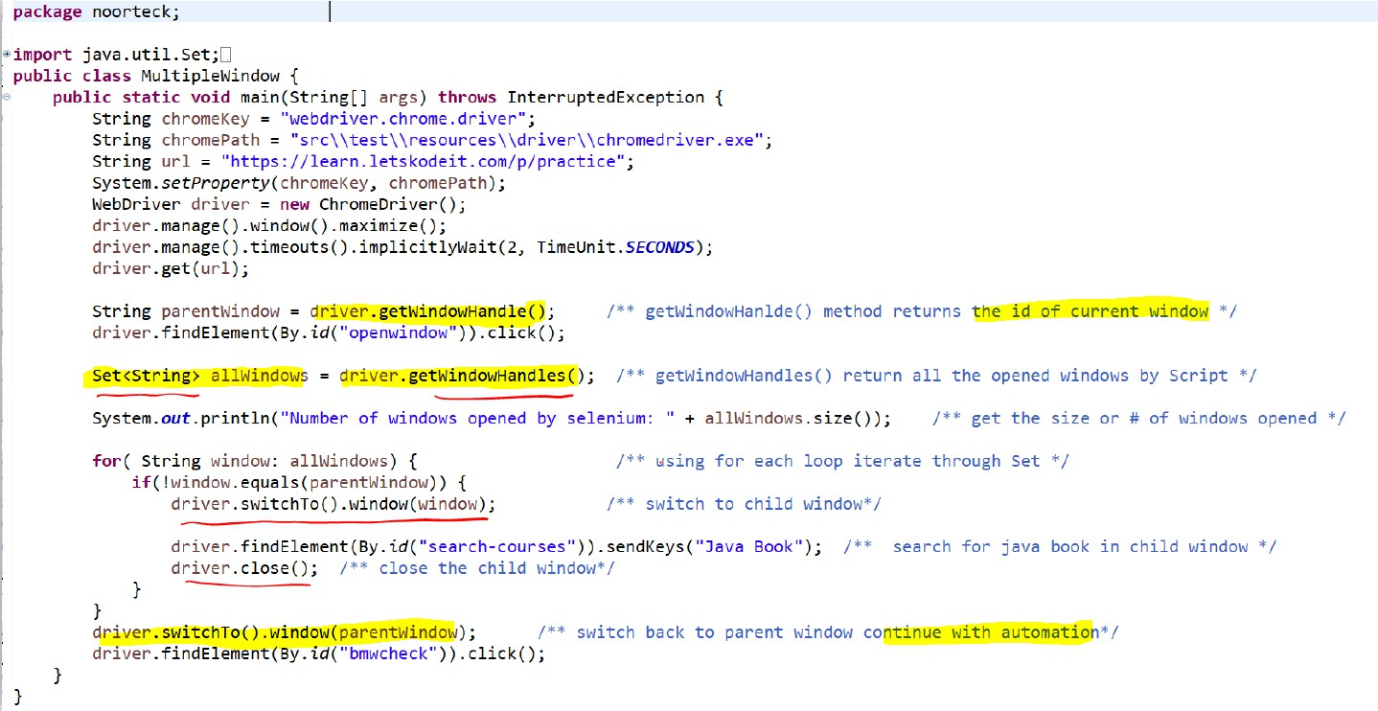

###### MAP Example 1

In some of my **scenarios in Feature File** I am using **Cucumber DataTable**. With **Cucumber DataTable** we can pass the **data in tabular format** which includes the **table header and table data.**

To handle the DataTable in our **step definition class** we can use **List of Maps**, where **each row in our DataTable will be treated as single Map** and this will be **stored in the List**.

Depending on the **requirement and logic**, I will be **accessing the Map to retrieve the key and value** then use it my automation.



##### **Excel File:** What is the process of reading/right Excel File?

Whenever I worked with a **large data set**, where I had to **pass the data into scenario** during the execution, instead of passing directly to feature file I used **excel file**.

In order to **read/write** the data from an Excel file, First I need to make sure that I have the **dependencies**

in my **pom.xml** file.

* + The dependencies I used to interact with Excel was **Apache POI library**, that has functionalities to read/write.

When **working with Excel file** it’s important we understand how excel files. In Excel file we can have

**different sheets** and in each sheet we can have data in **rows and columns format.**

###### Reading from Excel File

To **read an excel file** in java. First I need to make sure the **excel file** is stored somewhere within my project, we usually keep inside **src/test/resource** package.

Once I have the file, I need to **creating instance** of **FileInpustStream class** and pass the **location of the excel file as parameter**.

FileInputStream file = **new** FileInputStream(**new** File("excelFilepath"));

Then I will **create workbook instance** and **set that equal to by calling** the **create() method** from

**WorkbookFactory class** and **pass file as parameter**.

Workbook workbook = WorkbookFactory.*create*(file);

Once, workbook instance created, I will **create Sheet instance** and **set that equal to by calling** the

**getSheetAt() method**, **pass the sheetName or IndexNumber as parameter**

Sheet sheet = workbook.getSheetAt(0);

Once I have the sheet instance, I will use **2 loops**.

* + The **outer loop** will be iterating through the **rows**.
  + The **inner loop** will iterate through **each cell** in the row.

**for** (Row row : sheet) {

**for** (Cell cell : row) {

Inside **inner loop**, we can **read cell the value** by **getCellType()** and then **checking the type of cell value**,

* + If it is **String**, **Numeric**, **Boolean** or any other value.

CellType cellType = cell.getCellType();

**if** (cellType == CellType.***STRING***) {

} **else if** (cellType == CellType.***NUMERIC***) {

Based on the **requirement and logic**, I will be **capturing the value**s and applying them throughout my automation.

Once I am **done reading the excel file**, I will **close** the workbook and file

workbook.close(); file.close();



###### Writing to Excel File

To **write on excel file** from java. First I need to make sure we have the **Apache POI dependency** in my

**pom.xml** file.

Then, in order to write, I will **create workbook instance** and **set that equal to by calling** the **create() method** from **WorkbookFactory class** and **pass true as parameter**.

Workbook workbook = WorkbookFactory.*create*(**true**);

Once, workbook instance created, I will **create Sheet instance** and **set that equal to by calling** the

**createSheet() method**, **pass the sheetName parameter**

Sheet sheet = workbook.createSheet("Sheet1");

Once I have the sheet instance, I will **write a data in the sheet**.

* + Row 1 will be the headers and
  + Starting row 2 we will have the test data.

To create header row, we can use **createRow() method** and **pass the row number**

Row headerRow = sheet.createRow(0);

Then to for **data row** we can use **createCell() method** and **setCelValue() method** and pass the **row cell number** and **cell value** as parameter

headerRow.createCell(0).setCellValue("Name"); headerRow.createCell(1).setCellValue("Age");

Once the data is added to the sheet, then I have to **create an object of FileOutputStream class**. When creating an object of **FileOutputStream** class **I need to pass the path of the excel file in constructor as argument**.

FileOutputStream fileOut = **new** FileOutputStream(**new** File("excelFilePath"));

Then we can call the **write() method** and pass the **FileOutputStream object as parameter** to write on excel

workbook.write(fileOut);

Once I am **done writing to excel file**, I will **close** the workbook

workbook.close();



1. **Property File:** What is the process of reading/right Property File?

###### Reading from Property File

In order to **read a property** in Java, we can use the **Properties class** from **java.util** package.

* + **First** I have to **create an object of Properties class**

Properties prop = **new** Properties();

* + Then I have to **create an object of FileInputStream class**. When creating an object of **FileInputStream** class **I need to pass the path of the property file in constructor as argument**. Usually within our framework, we keep the property file in resource source package.

FileInputStream file = **new** FileInputStream(filePath);

* + Once FileInputStream object is created, then we have to **load the property file** by **using property object and passing the file object as argument** to **load()** method

prop.load(file);

* + To **retrieve the values from the property file** we can use **getProperty() method** and **pass the key as parameter**. In property file we keep the data in **key=value** format

String username = prop.getProperty("region"); String url = prop.getProperty("url");

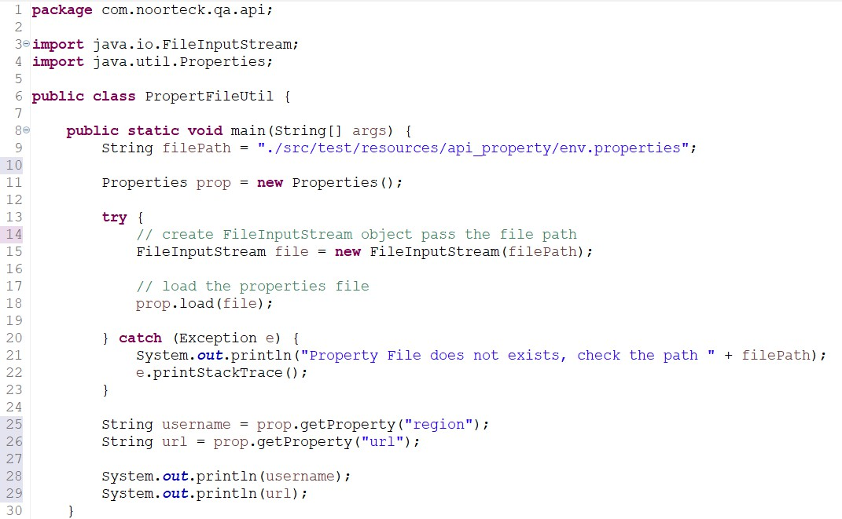

###### Writing to Property File

In order to **write into a property** in Java, we can use the **Properties class** from **java.util** package.

* + **First** I have to **create an object of Properties class**

Properties prop = **new** Properties();

* + Then, we can use **setProperty()** method to pass key-value pair data we want to write to the property file.

prop.setProperty("username", "admin"); prop.setProperty("region", "scrum");

* + Once the data is added to the property, then I have to **create an object of FileOutputStream class**. When creating an object of **FileOutputStream** class **I need to pass the path of the property file in constructor as argument**.

FileOutputStream file = **new** FileOutputStream(filePath);

* + Once **FileOutputStream** object is created, then we have to **store the property file** by **using property object and passing the file object as argument** to **store()** method

prop.store(file);



##### **Text File:** What is the process of reading/right Text File?

###### Reading from Text File

In order to **read a textfile** in Java, we can use the **FileReader & BufferedReader class**

* + **First** I have to **create an object of FileReader class and pass the filePath**

FileReader fileReader = **new** FileReader(filePath);

* + Then I have to **create an object of BufferedReader class** and pass the **fileReader object** as argument in constructor.

BufferedReader reader = **new** BufferedReader(fileReader);

* + Then I will create **while loop** to and **set the while loop condition to true**
  + And in the body I will use **reader object** and call the **readLine()** method to **retrieve the value of the line** and **store the value to String object.**
    - Then I will add **if condition to check if the value of String object** is **null** after retrieving

then it means **end of file** and **we can break out from loop.**

**while** (**true**) {

line = reader.readLine();

**if** (line == **null**) {

###### break;

}

System.***out***.println(line);

}

###### Writing to Text File

In order to **write a textfile** in Java, we can use the **FIleWriter & BufferedWriter class**

* + **First** I have to **create an object of FIleWriter class and pass the filePath**

FileWriter fileWriter = **new** FileWriter(filePath);

* + Then I have to **create an object of BufferedWriter class** and pass the **FIleWriter object** as argument in constructor.

BufferedWriter writer = **new** BufferedWriter(fileWriter);

* + Then to write any content to the file we can use the **write()** method. Along with **write()** method we can also use **newline()** to write the text from **new line.**

writer.write(“Tis is text”); writer.readLine();

* + Once we are done writing into file, **last step** we have to call the **flush()** method to make sure the

**content is written to the file.**

writer.flush();



#### BDD vs TDD vs Hybrid Framework

* + **TDD** is a Test-Driven Development, it is an approach we follow where we write the test first and make that test fail because the functionality does not exist yet. Then we go back and write the code to make the test pass. TDD approach is mostly used and practiced by the developers, where they write their unit test first, then go back and work on write the functionality.
  + **BDD** is a Behavior Driven Development, it is an approach that focuses on describing the behavior of the functionality from user’s standpoint. In BDD we use a common language that is understandable for technical and non-technical team members which is called Gherkin. Using different keywords like Given, When, Then we can describe the behavior of the system.
  + **Hybrid Framework** is a type of testing framework which can include a combination of

data-driven, keyword-driven, behavior driven framework. With Hybrid driven framework we can take a different framework type approach and combine it into one that suits the most for our automation and testing activities.

* + In **Data-driven framework** , the test logic or test script is designed to be generic and can be used with different test data. Usually, the test data is stored in external file like excel, or json, or xml file or database then during the execution we are accessing and executing same script with different data set.
  + In **Keyword Driven framework**, the script is written using predefined keywords that represent different actions or operation that needs to be performed. Each keyword will be associated with a specific functionality.

**Maven(Completed)**

#### What is maven?

**Maven** is a build management tool based on concept of **Project Object Model** (POM) that includes project information and configuration like

* + Directory structure
  + source directory
  + dependency
  + test source directory
  + Goals
  + plugins, etc.

#### How maven works?

**Maven** reads the **POM.XML** file and in the **POM.xml** file we have

* + **dependencies,**
  + **plugins and**
  + **properties.**

**When we execute Maven project,**

* + **First,** it checks the **LOCAL REPOSITORY** which is located in **.M2** folder, if the jar files for dependencies mentioned in our **POM.xml** file exist or not.
    - If the **LOCAL REPOSITORY does not have the dependency jar** files then it will go to

**CENTRAL REPOSITORY** and **download** into our **LOCAL REPOSITORY**

* + - If the **LOCAL REPOSITORY** has the dependency jar files then it **will not go** to the

**CENTRAL REPOSITORY**

* **Once we have the jar files** for dependencies mentioned in our **POM.xml** then we can **start using the classes, methods, interfaces** of that library.



#### Types of Maven Repository

1. **Maven Life Cycle?**

When we **build a maven project**, it executes a set of tasks based on how we configuration the project in

**pom.xml.**

There are mainly **3 phases** in **Maven Life Cycle**. We have the

* + **Clean Lifecycle**
  + **Default Lifecycle**
  + **Site Lifecycle**

The **Clean Lifecycle** phase will **remove any artifacts or files generated from previous build or execution.**

The **Default Lifecycle** phase **handles the entire build process**. It consists of **multiple sub-phases**

including validate, compile, test, package, verify, and deploy.

The **Site Lifecycle** phase **generates project documentation and reports**.



#### Where does the maven store all the dependency jar files?

All the **dependency jar files** are stored in **Local Repository .M2 folder.**

#### List of maven commands and purpose?



1. **Maven goal to execute runner class?**

**clean -Dtest=Runner test**

#### Maven goal to execute runner class with tag?

**clean** -**Dtest=Runner test -Dcucumber.filter.tags="@smoke"**

**clean -Dtest=Runner test -Dcucumber.filter.tags="@smoke or @release1_2"**

# Jenkins(Completed)

1. **Jenkins Process:** What is the process of setting up Jenkins Job?

The **process I have to follow** in order to set up a job, I need to make sure that I have the automation scenarios script ready which will be used part of the execution.

**When creating a job**, I need to make sure my **script is available on GitHub**:

* + **Then I need to provide**
    1. **the URL of my repository**,
    2. **Branch name;ٌَ﷼ \ﻣﯽ**
    3. **Maven goal** which contains the information on what to execute
    4. Lastly, I need to **configure the cucumber report** so it generates report after execution which will be available to all the team members.

###### There are 3 different ways I can set up job on Jenkins:

1. I can either **schedule the job to execut**e Monday through Friday to execute at certain time.
2. Or I can **trigger the job automatically whenever new build comes** to scrum region.

o **For example,** my shakeout **automatically kicks off when developer finishes developing User Story and deploys the code from Dev Region to Scrum Region**. If the **Build comes successfully** to scrum region then my **shakeout automatically kicks off** without my other team members interference.

1. Lastly, I can **create a job and manually Build** whenever I **need to do quick smoke testing**.
2. **Job vs Pipeline:** What is the difference between Jenkins job and Jenkins Pipeline?

A **Jenkins job** is like a single task or job that we define in Jenkins. We create separate jobs for each specific task in our building process. For example, we can have jobs named Smoke Job or Regression Job, where each job focuses on a particular part of the build or testing process.

A **Jenkins Pipeline** is like a combination of different jobs or tasks that we put together to form a complete workflow. In our project, we have a pipeline that includes several jobs. For instance, we have a pipeline that consists of the dev build, unit test job, and smoke job. These jobs are executed one after the other or even in parallel, depending on how we configure the pipeline.

# Git(Completed)

##### **Git Process:** Explain the process of how you interact with GitHub(Version Control)

We are currently using GitHub as our version control system for managing our framework, which is shared among multiple team members and teams. To ensure smooth collaboration and minimize conflicts and downtime, we follow a common practice.

* + When I work on automation, I perform all the scripting on my local workspace using the Dev Branch. This allows me to work independently without affecting the main codebase.
  + Once I have completed my scripting, I proceed by stashing my changes. Meanwhile, I also check our team's group chat or email to see if any team members have sent updates regarding their changes. If there are any, I pull the latest code from the remote repository to sync my local workspace.
  + Once my local workspace is up to date with the remote repository, I retrieve my stashed changes and apply them.
  + Next, I push my changes to the remote repository. As I use the Eclipse IDE, which includes a Git plugin, I utilize Git commands within Eclipse to perform the push operation.
  + After pushing the code to the remote repository, I create a pull request to merge my changes from the Dev Branch to the Stage Branch. To make sure code quality, I assign two of our team members as reviewers. They will review the code and, and once they approve they will merge it into the Stage Branch.
  + Finally, to keep everyone updated, I send a message to our group, informing my team that I have pushed my changes and remind them to pull the latest code to incorporate the updates into their own workspaces.

By following this process, we maintain a structured workflow, minimize conflicts, and ensure that our codebase remains up to date and accessible to all team members.

1. **Branching Strategy:** Explain the branching strategy your team follows.

The branching strategy that our team follows involves three main branches: dev, stage, and master.

* + **Dev Branch** serves as the main development branch where all coding and user story automation done.
  + **Stage Branch:** Once we finish the user story automation and push to remote dev branch. Then We will create pull request to merge the code from Dev Branch to Stage Branch. Upon creating Pull Request, we assign 2 reviewers.
  + **Master Branch:** Once the code is stable and reviewed thoroughly then we move from stage branch to Master branch. Master branch is the stable branch where all the Jenkins jobs are executed including smoke & regression jobs.

#### Git Conflicts

###### Explain how to handle Git Conflicts

Git conflicts occur when two or more team members make conflicting changes to the same file or lines of code. In order to handle Git Conflict:

* First, I will Pull the Latest Changes: Before making any changes, it's important to ensure that I have the most up-to-date version of the code. Use the command **git pull** to fetch and merge the latest changes from the remote repository into my local branch.
* Once I have to my local, then I will try to **Identify the Conflict**. When we have a conflict, **Git** will notify us which files have conflicts. We can identify the conflicting sections within the file by looking for **Git's conflict markers**, which usually appear as (multiple less than sign, multiple equal sign and multiple greater than sign) "<<<<<<<", "=======", and ">>>>>>>". These markers indicate the conflicting changes made by different contributors.
* Once I know which file has the conflict, then I will Open the conflicted file in Eclipse. Within the file, we will see the conflicting sections separated by the conflict markers.
* Then I will carefully review the conflicting sections to understand the changes made by each contributor. I will Identify which changes I want to keep and which to discard or modify. Sometimes I might have to discuss with the other team members to make sure we are keeping the right version.
* Once I am done with analyses and discussing with team member then I will Resolve the Conflict by Editing the conflicted file manually, removing the conflict markers and deciding how to combine the conflicting changes.
* After resolving the conflict, I will test the merged code to ensure it works as expected.
* Once I am done with the conflict resolution, I will stage the modified file(s) using the command

**git add <filename>** or **git add** . to stage all changes.

* Finally, I will commit the resolved conflict by running **git commit** with an appropriate commit message then push the changes to remote using git push command.

###### Explain how to AVOID Git Conflicts

To avoid Git conflicts, there are several practices my team follows.

* **Communication:** It is important we regularly communicate with the team members. By keeping each other informed about the files or sections of code we are working on, especially if we are frequently making changes. Whenever we make changes and push to remote, we send out email and message to team group chat to let them know that I have pushed my changes.
* **Follow Stash Process:** Before pushing or pulling we always stash our changes. To make sure we always pull the latest changes from the remote repository before pushing our changes.
* **Make Small and Frequent Commits:** Instead of pushing large commits, it is important we focus on small frequent commits, by breaking it down into smaller commits that will make the merging, and review process easier.
* **Make sure to Regularly Push and Pull:** It is important to regularly push our progress to the remote and pull updates from the remote repository regularly to stay in sync with the team’s changes. By doing this we can catch and resolve any conflicts or issues early.
* **Hold Code Review Sessions:** We hold once a week code review session with the team to go over the changes and new implementation to make sure everyone is up to date.

#### Git Commands Definition

###### git init

**“git init” command** creates a new Git repository in the current directory.

###### git clone

**“git clone” command** creates a copy of an existing Git repository, including all of its history, branches, and files. Initial stage whenever I join a team, I usually clone the existing repository to my local using **“git clone”** command.

###### git add

**“git add” command** adds changes in the working directory to the staging area. It allows to specify which files or directories to include before making the next commit.

###### git commit

**“git commit” command** records the changes in the staging area as a new commit in the Git repository. It creates a snapshot of the changes and permanently stores it in the repository's history. When making commit we usually provide commit message that describes the changes made in the commit.

###### git push

**“git push” command** pushes the committed changes from our local branch to a remote repository. It updates the remote repository with our local changes, making them accessible to other team members.

###### git pull

**“git pull” command** fetches the latest changes from a remote repository and automatically merges them into our local branch. It combines the **git fetch** and **git merge** commands to retrieve and apply the changes in one step.

###### git fetch

**“git fetch” command** retrieves the latest changes from a remote repository without merging them into our local branch. It allows us to view and review the changes before merging them manually using other Git commands.

###### git merge

**“git merge” command** integrates changes from one branch into another. It combines the changes from a **source branch** into the **current branch**, creating a new commit that includes both sets of changes.

###### git rebase

**“git rebase” command** reapplies commits from one branch onto another branch. It moves or combines commits to a new base commit, often used to incorporate changes from a feature branch into a main branch while maintaining a linear commit history.

###### git branch

**“git branch” command** lists, creates, or deletes branches in the Git repository. It shows a list of existing branches, allows us to create new branches based on the current branch, or delete branches that are no longer needed.

###### git checkout

**“git checkout” command** switches between different branches or commits in the Git repository. It allows us to navigate between branches, restore files from previous commits, or create new branches based on existing ones.

###### git status

**“git status” command** shows the current state of the Git repository. It displays information about modified files, untracked files, staged files, and the current branch. It helps us understand what changes have been made and which files are ready to be committed.

###### git log

**“git log” command** displays a log of the commit history in the repository. It shows information such as the commit message, author, date, and unique commit hash for each commit. It helps us track the history of changes and understand the chronological order of commits.

###### git tag

**“git tag” command** creates a named pointer to a specific commit in the Git repository. Tags are typically used to mark important points in the history, such as release versions or significant milestones. They provide a way to reference specific commits with a meaningful name.

###### git reset

**“git reset” command** resets the current branch to a specific commit, allowing us to undo changes or move the branch pointer to a different commit. It can be used to discard commits, unstage changes, or modify the commit history.

###### git stash

**“git stash” command** temporarily saves changes that are not ready to be committed yet. It allows us to switch branches or work on other tasks without committing incomplete changes.

###### git remote

**“git remote” command** shows the remote repositories associated with the local Git repository. It allows us to view the names and URLs of the remote repositories and manage their configurations.

###### Pull Request

A **Pull Request** is a way to propose changes from one branch to another branch. It provides a convenient method for code review, discussion, and collaboration. Within my

current team, once I am done with my scripting, I will push my changes to the remote then create Pull Request and assign 2 of my team members to review.

#### Git Command Comparisons

###### git pull vs git fetch

* + **“git pull”** combines the **“git fetch”** and **“git merge”** commands into one. It fetches the latest changes from the remote repository and automatically merges them into the current branch.
  + **“git fetch”** retrieves the latest changes from the remote repository but doesn't automatically merge them. It updates the remote-tracking branches, allowing you to review and manually merge the changes later.

###### git merge vs git rebase

* + **“git merge”** combines the changes from one branch into another branch. It creates a new commit that incorporates the changes from the source branch into the current branch.
  + **“git rebase”** moves or combines commits from one branch onto another branch. It modifies the commit history by replaying the commits on top of a different base commit. It results in a linear commit history and can be useful for maintaining a clean and organized history.

###### git reset vs git revert

* + **“git reset”** allows us to move the branch pointer to a specific commit, effectively discarding or undoing commits. It can be used to remove commits, unstage changes, or rewrite the commit history. It is a more destructive operation as it modifies the commit history.
  + **“git revert”** creates a new commit that undoes the changes made in a specific commit. It adds a new commit that negates the changes, effectively reverting the previous commit. It is a safer option as it leaves the commit history intact.

###### git clone vs git init

* + **“git clone”** creates a copy of an existing Git repository, including all branches, commit history, and files. It retrieves the entire repository from a remote location and sets it up on our local machine.
  + **“git init”** initializes a new Git repository in the current directory. It creates an empty repository with the necessary data structures to start tracking changes to files.

###### git diff vs git status

* + **“git diff”** shows the differences between the current state of the code and the previous commit or between different branches or commits. It provides a detailed view of

line-by-line changes in files.

* + **“git status”** displays the current state of the Git repository. It shows information about modified files, untracked files, and the status of files in the staging area. It provides a high-level overview of the repository's status.

###### git stage vs git unstage

* + **“git stage”** or **“git add”** adds changes in the working directory to the staging area. It prepares the changes to be committed by marking them for inclusion in the next commit.
  + **“git unstage”** or **“git reset HEAD”** removes changes from the staging area, undoing the previous git add command. It allows us to unstage files or changes that we no longer want to include in the next commit.

**SQL(Completed)**

#### How do you rate yourself in SQL?

I would rate myself 7/10 in SQL. I interact with database on daily bases and comfortable writing queries. There is always a room for improvement. In case if there are concepts or theories I don’t mind spending extra time learning and improving.

#### Do you write queries or dev team does for you?

In my current project and previous projects, database interaction was a huge part of the testing activities, automation framework and validation process. I am very comfortable writing complex queries and pretty much interact with the databases on a daily basis. Whether I am performing UI Testing or API Testing, I need to ensure the expected vs actual values matches. To perform data validation, I have to cross validate against the database. In my current project, we have application database as well as the QA Test Repository which we use to retrieve the test data for the automation scenarios.

### JDBC

###### JDBC Process: How do you connect from your automation framework

**In order to connect to database from my automation framework:**

* 1. First, I need to have the **database jar file in my project or database dependencies in my pom.xml file**.
  2. Second, in my scrip I need to **load the JDBC driver** by stating

## Class.*forName*("com.mysql.cj.jdbc.Driver");

* 1. Third, I need to **connect to database by creating Connection** object and using **getConnection() method** from **DriverManger** class. In **getConnection() method**, I will be providing the **URL** of the database, the **Username**, and the **Password**

## Connection con = DriverManager.*getConnection*(url, username, password);

* 1. Forth, then I will **create statement object**. This will allow us to perform database operations such as INSERT, SELECT, UPDATE , or DELETE

## Statement stm = con.createStatement();

* 1. Fifth, using statement object, I will be calling **executeQuery()** or **executeUpdate()**

method to **executing SQL query**.

* + 1. When I am **retrieving** data from database then I will be using **executeQuery()**

method and **storing** the returned data from database to **ResultSet** object

## ResultSet rs = stm.executeQuery(myQuery);

* + 1. When I am **update** or **inserting** test execution result to **database** then I will be using

**executeUpdate()** method.

## stm.executeUpdate(myQuery);

* 1. Sixth during automation execution I will be **accessing ResultSet object to get the data**, **use the data** for input fields and **compare** the expected results with actual results
  2. Seventh, after finishing using the database, then I will **close the databases connection.**

## con.close();

1. During the test script execution when do you access the database and why?

Mainly the database connection is established during the initial stage of the execution in our

**hooks class.**

We have **@Before** cucumber annotation for **setup()** method and in there we are setting up the environment and establishing the connection then connecting database.

Throughout the test execution we are accessing different tables to retrieve the data or to perform certain validation against the application database to ensure the data within the different layers of application is processing as expected.

#### DDL vs DML vs DCL vs TCL

SQL commands are mainly **categorized** into four categories

* 1. **Data Definition Language** (**DDL**)
  2. **Data Manipulation Language** (**DML**)
  3. **Transaction Control Language** (**TCL**)
  4. **Data Control Language** (**DCL**)

#### Data Definition Language (DDL)

1. **CREATE**
2. **ALTER**
3. **DROP**
4. **TRUNCATE**

**DDL** is used to **define the database structure and descriptions**, of how the data should reside in the database. DDL **allows to add, modify, delete the logical structures** which contain the data, or which allow users to access or maintain the data.

* + **CREATE**: to create a database and its objects like (table, index, views, store procedure)
  + **ALTER**: Modifies the structure of the existing database
  + **DROP**: Deletes objects from the database
  + **TRUNCATE**: Remove all records from a table and resets tables identify to initial value

#### Data Manipulation Language (DML)

1. **SELECT**
2. **INSERT**
3. **UPDATE**
4. **DELETE**

**DML deals with data manipulation** and it is used to retrieve, store, modify, delete, insert, and update data in database.



* **SELECT**: Retrieves data from a table
  + **INSERT**: Inserts data into a table
  + **UPDATE**: Updates existing data into a table
  + **DELETE**: Deletes all records from a table

#### Data Control Language (DCL)

1. **GRANT**
2. **REVOKE**

**DCL** is **used to create roles, permissions, and control access** to database by securing it. DCL **authorizes user to access and manipulate data** in the database.

* + **GRANT**: Allow users access privileges
  + **REVOKE**: Withdraw users access privileges given by suing the GRANT command

#### Transaction Control Language (TCL)

1. **COMMIT**
2. **ROLLBACK**
3. **SAVEPOINT**
4. **SET TRANSACTION**

**TCL** is **used to manage the changes made by DML statements**. It allows statements to be grouped together into logical transactions.

* + **COMMIT**: Save work done in transactions
  + **ROLLBACK**: Restore database to original state since the last COMMIT command
  + **SAVEPOINT**: Identify a point in a transaction to which you can later roll back
  + **SET TRANSACTION**: Specify the characteristics of the transactions

### ALTER TABLE :DDL

**ALTER** is a **Data Definition Language(DDL)** statement **used to add, delete, or modify columns in an existing table.**

* **ALTER TABLE** – **ADD** □ **Add a column** to an existing table.
* **ALTER TABLE** – **DROP COLUMN** □ **Delete a column** from a table.
* **ALTER TABLE** – **MODIFY COLUMN** □ **Modify the data type** of a column.
* **ALTER TABLE** – **CHANGE** □ **Change the column** name in a table.

### INSERT

**INSERT** is a **Data Manipulation Language(DML)** statement **used to insert data into a table.**

### UPDATE



**UPDATE** is a **Data Manipulation Language(DML)** statement **used modify the records** in

the table.

**Syntax** to **UPDATE** table

* The query will update **Major** column value to ‘**Computer Science**’ for student that has studentID value **1234**

#### TRUNCATE vs DROP vs DELETE

Truncate, Drop, & Delete are mainly used to remove data from a table, however they have different meaning.

* **TRUNCATE** is **used to delete all the records from the table, but not the table itself.** Only the data will be deleted. Truncate command used to quickly remove all rows from table and reset the table to initial state. With Truncate Operation we **cannot roll back and the deleted data cannot be recovered**
* **DROP** is **used to delete the records and the table from the database.** It deletes both the table structure and the data it contains. When we drop a table all the associated indexes, constraints and triggers are also removed. Dropping table cannot be recovered UNLESS we have a backup
* **DELETE** is used **remove specific rows from a tables based on a given condition**. With Delete command we can specify condition in our where clause. Deleted data can be rolled back.

#### SQL Constraints

**Constraints** are used to **specify rules for the data in a table to maintain consistency and correctness of data**. It enforces rules on the table whenever **data inserted, updated, or deleted from the table.**

**Constraints** can be defined at **table level** or **column level**

* We can create constraint **during creation of table** using **CREATE TABLE**
* Or we can create constraint **after creating a table** using **ALTER TABLE**



###### Not Null Constraint



**NOT Null** constraint **restricts a column from havin**g a **NULL** value. Once **NOT Null**

constraints is applied to a column, **you cannot pass** a **NULL** value to that column. It enforces to contain a proper value. **Not NULL** constraint **cannot be defined at table level**, only column level

**Example** of using **NOT Null** Constraint

* + The below query will declare the **ID** field of Student table **NOT NULL** which will

###### not take NULL values



1. **Unique Constraint**

**UNIQUE** constraint **ensures that a column will only have unique values**. **Unique** Constraint **column will not have duplicate value**. This constraint **can be applied** at **column level or table level.** Unique constraint **allows NULL value**

**Example** of using **UNIQUE Constraint**

* + The below query will declare the **ID** field of employee table **UNIQUE** which will



###### only have unique values and will not take NULL values

1. **Default Constraint**

**DEFAULT** constraint is used to **provide a default value for a column**. The **default value will be added** to all new records **if no other value is specified during insertion data into the table**

**Example** of using **DEFAULT** Constraint

* The below query will declare the **SchoolName** field of School table with

**DEFAULT** constraint which contains **‘NoorTeck’** as default value

* When **user inserts record and does not provide a value** for **SchoolName** field then it will add **‘NoorTeck’** for **SchoolName** column for that specific record



###### Check Constraint



**CHECK** constraint is used to **restrict the values of a column between a range**. It

performs **check on the values**, **before storing them into the database**. It is like condition checking before saving data into a column

**Example** of using **CHECK** Constraint

* + The below query will declare the **Age** field of Vote table with **CHECK** constraint



which Age column value must be greater than or equal to 18

###### Primary Key vs Foreign Key Constraints

**PRIMARY KEY** and a **FOREIGN KEY** are two different constraints in SQL and it is used to establish **relationship between tables.**

* **PRIMARY KEY** is a column or a set of columns in table that **uniquely identifies each record in the table**. It serves as a unique identifier for each row and makes sure that there are no duplicate records.
  + **Each value in the primary key column must be unique.**
  + **Primary key values cannot be null.**
* **FOREIGN KEY** is a column or a set of columns in **one table that refers to the primary key in another table**. It **establishes a relationship between two tables as a parent-child relationship**. The foreign key represents a link between the records in the child table to the corresponding records in the parent table

### DISTINCT

**DISTINCT** keyword is used to eliminate duplicate rows from the result set of a SELECT query. It filters out identical rows, so only unique values are returned.

### ORDER BY

The **ORDER BY** clause is used to sort the **resultset** of a **SELECT query** based on one or more columns. It allows us to specify the order in which the rows should be displayed.

The **ORDER BY** clause by default sorts the data in **ascending order**. To sort the data in descending order we can use DESC keyword.

**Syntax** for **ORDER BY** clause

* The query will return the result in **descending order of the firstName**

### LIKE

The **LIKE** clause is used to perform **pattern matching** in a SELECT statement. It allows us to search for **specific patterns** or substrings within a column's values.

The **LIKE** clause uses wildcard characters to represent unknown or variable parts of the pattern. There are two wildcard operators that we can use in LIKE clause

**%** □ The **percent sign** represents **zero, one, or multiple character**

**_** □ The **underscore sign** represents a **single character**



#### Aggregate Functions

1. **COUNT()**
2. **SUM()**
3. **AVG()**
4. **MIN()**
5. **MAX()**

**Aggregate functions** are used to perform calculations on a set of rows and return a **single value**.

Aggregate functions operate on columns or expressions within a **SELECT statement** and are commonly used with the **GROUP BY** clause to perform calculations on grouped data.

* 1. **COUNT(): Counts the number of rows or non-null values in a column.**
     1. Example: SELECT **COUNT(*)** FROM Employees;
  2. **SUM(): Calculates the sum of values in a column.**
     1. Example: SELECT **SUM(Salary)** FROM Employees;
  3. **AVG(): Calculates the average of values in a column.**
     1. Example: SELECT **AVG(Salary)** FROM Employees;
  4. **MIN(): Retrieves the minimum value from a column.**
     1. Example: SELECT **MIN(Salary)** FROM Employees;
  5. **MAX(): Retrieves the maximum value from a column.**
     1. Example: SELECT **MAX(Salary)** FROM Employees;

Along with **Aggregate Function** we can also use **GROUP BY** clause to perform calculations on subset of data. The **GROUP BY** clause **divides the rows into groups based** on the specified columns and applies the aggregate function to each group separately.

And if we need to **apply filte**r or condition to the **grouped aggregate function** sets then we can use **HAVING clause.**

1. **GROUP BY**

**GROUP BY** clause is used with **aggregate functions** to **divide the rows of a table into groups based on one or more columns**. It allows us to perform aggregate calculations on each group separately.

1. **HAVING**

**HAVING** clause is used to **filter the results of a GROUP BY query based on a condition applied**

to the result of an aggregate function.

It is similar to the **WHERE clause**, but while the

* **WHERE** clause filters individual rows before grouping,
* **HAVING** clause filters groups after the grouping has been performed.





#### Having vs WHERE

**HAVING** clause and the **WHERE** clause is to filter data based on specific conditions. However, they are used in different contexts:

* **WHERE clause:**
  + The **WHERE clause** is used in SELECT, UPDATE, DELETE, and some other SQL statements to **filter individual rows from a table before any grouping** or aggregation occurs.
  + It is typically used with **non-aggregated columns** or expressions.
* **HAVING clause:**
  + The **HAVING clause** is used in **combining with the GROUP BY clause** in SELECT statements to **filter the result set based on conditions applied to the aggregated values**.
  + It is used to **filter groups of rows after the aggregation** has occurred.

### JOINS

**JOIN** operation is used to combine rows from two or more tables based on a related column between them.



1. **INNER JOIN**

The **JOIN/INNER JOIN** returns records that have matching values in both tables

 

1. **LEFT JOIN**

The **LEFT JOIN/LEFT OUTER JOIN** returns **all records from the left table and the matched record from the right table.** The **result is NULL** from the **right table** when there is **no match**



1. **RIGHT JOIN**

The **RIGHT JOIN/RIGHT OUTER JOIN** returns **all records from the right table and the matched record from the left table.** The **result is NULL** from the **left table** when there is **no match**



1. **FULL JOIN**

****The **FULL JOIN/FULL OUTER JOIN** returns all records when there is a **match in left table OR right table records**



### SET OPERATORS

**Set** Operators are **used to join the results of two or more SELECT statements.** Set Operators are mainly used to **combine the same type of data from two or more tables.**

**RULES** on **Set Operations**

* Each **SELECT** statement **must have the same number of columns**

The **column must also have similar data types**

 The **columns** in each **SELECT** statement **must also be in the same order**

###### Union vs Union ALL

**UNION** is used to **combine the results** of two or more SELECT statements and removes

**the duplicate records.**

**UNION ALL** is used to **combine the results** of two more SELECT statements and DOESNOT **remove duplicate records.**

###### Intersect

**INTERSECT** is used to **combine the results** of two or more SELECT statements, but it ONLY **returns the records which are common from both SELECT statement**

###### Minus/Except

**MINUS/EXCEPT** is used to **combine the results** of two or more SELECT statements and

**returns only the result, which belongs to the first set of the result**

### IEW

**View** is a **virtual table** based on resultset of a SQL statement. It is a **set of saved SELECT queries**.

If we want to execute the **same query multiple times**, we can either save in a file or save the query in the database by creating a view



### INDEX

* **Index** is used to retrieve data from the database to **improve the performance**
* Without indexes, DBMS has to **go through all the records in the table** to retrieve the desired results. If we create index, the database **goes to that index first** and then retrieves the corresponding **table records directly.**
* Indexes **increases performance** for **SELECT** and **WHERE** clauses, but it **slows down** data input with the **UPDATE** and **INSERT** clauses.
* The **PRIMARY KEY** constraint **automatically creates a clustered index.**
* We can have **only one clustered index** in a table but **can have multiple**



**non-clustered indexes** in the table.

**a) Clustered index vs Non-Clustered Index**

|  |  |
| --- | --- |
| **Clustered Index** | **Non-Clustered Index** |
| **Clustered Index** is used to define the order and it **sorts the table data by alphabetical order.**  **Clustered Index** is similar to **dictionary** | **Non-Clustered** index collects the data at one place and the table records are at another place.  **Non-Clustered** index is similar to the index section in the book. |
| A table can have only 1 **Clustered Index**  and | A table can have many **Non-Clustered Indexes**. |

|  |  |
| --- | --- |
| By default**, Primary Key** constraint is considered Clustered Index. |  |
| **Faster** than the non-Clustered index | **Slower** than the Clustered index |

#### Store Procedure

* **Store Procedure** can be defined as the **set of statements grouped together to perform a specific task**.
* It is similar to **methods/functions** in java or other programming languages.
* It helps to **increase the performance of the database**, the code can be **reused**, increase



the **security**, and can be **easily** modified.

#### Trigger

**Trigger** is a **special stored procedure** in the database which **automatically invokes whenever a special event occurs.**

**For example**, a **trigger** can be invoked when a **row is inserted into a specified table** or when certain table columns are being updated.



#### Subquery

* **Subquery** is a **query within a query** and embedded within the **WHERE** clause
* **It** can return **individual value** or a **list of records**
* It must be **enclosed within the parenthesis**



# Selenium WebDriver(Completed)

##### What is Selenium?

**Selenium** is an open-source software used for **automating web browsers**. It supports different programming languages like Python, Java, or C# to automate web applications. It also supports different browser and operating systems.

##### Selenium Architecture

Selenium WebDriver architecture mainly divided into three parts:

* 1. **Language Level Bindings**
     + Programming language **used to write the automation script**
  2. **Selenium WebDriver API**
     + **Contains set of a common libraries** which allows sending a command to respective driver
  3. **Drivers**
     + **Refers to various browsers** that will be used to execute the automation script

##### Advantages of Selenium

The **advantages of Selenium** are:

* Selenium is free and **open source**
* Supports **different programming languages** including java, Ruby, python, C#...
* Supports **different brow**ser (Chrome, IE, Firefox, Safari…)s
* Supports **different Operating System** (windows, Mac, Linux)
* Saves **time and money**
* Supports **Parallel Test Execution**

##### Disadvantage of Selenium

The **disadvantages of Selenium** are:

* Selenium supports only web-based applications, it **does not support windows-based application**
* Selenium **does not have built-in reporting tool**, it needs third party tools for report generation like TestNG, JUnit or Cucumber
* **Captcha and Barcode cannot be tested** using Selenium

##### What type of testing can we automate with Selenium?

Selenium is an **automation tool used to automate web applications**. The types of testing can be done using Selenium are:

* **Functional Testing**
* **Regression Testing**
* **Smoke Testing**
* **End to end testing**

##### Locators

1. What are the different types of locators in Selenium

Locators provide a **way to access the elements on the webpage**. In selenium there **are 8 different types of locators:**

* 1. **ID**
  2. **Name**
  3. **LinkeText**
  4. **ParitalLinkedText**
  5. **ClassName**
  6. **TagName**
  7. **CSS Selector**
  8. **Xpath**

1. Which locator type do you prefer & why?

Type of locator I prefer really type depends on the specific web element and its attributes and properties. I prefer to start with using ID if it's available and static since IDs are unique for each element on the page.

When dealing with complex or dynamic scenarios I use either cssSelector or XPath locators since they provide more functionalities like build-in methods and wildcard searching

1. Dynamic Elements: How do you handle?

To **handle dynamic elements**, we can use **CSS Selector or xpath**. Both of locator’s providers different functionality to identify and work with dynamic elements.

We can use features of Xpath:

* **Contains() method**
* **startsWith() method**
* **text() method**

We can use features of CSS Selector:

* **Appending classes**
* **Using wildcards**
  + **Carrot Sign ^** which represents the **starting text** in the attribute value
  + **Dollar Sign $** which represents the **ending text** in the attribute value
  + **Start Sign \*** which represents the **contained text** in the attribute value

1. CSS Selector vs Xpath

* Xpath allows traversing elements both ways from parent to child and child to parent. Css allows traversal from parent to child only.
* Xpath is slower in terms of performance and speed. CSS has better performance and speed than Xpath.
* Xpath allows identification with the help of visible text appearing on screen with the help of text() function. CSS does not have this feature.

##### Xpath Locator

1. Absolute vs Relative Xpath

###### Absolute xpath

* 1. Represented by **SINGLE SLASH ’/’**
  2. Start with single slash that means starting to search from the **root and traverses from the root to the whole HTML DOM** to reach to the desired element
  3. Disadvantage of using absolute xpath to locate an element is, if during development process **any changes made in the path** then it may lead to a failed xpath expression

###### Relative xpath

* 1. Represented by **DOUBLE SLASH ’//’**
  2. Starts with a double slash that means it can start to **search anywhere in the HTML DOM structure**
  3. **Shorter** than Absolute Xpath
  4. We can **start from the middle of the HTML DOM structure** and no need to write long xpath

1. Ancestor Xpath Example

// Finding a div element that is the ancestor of a specific span element

WebElement ancestorElement = driver.findElement(By.xpath("//span[@id='specificSpan']/ancestor::div"));

1. Following Xpath Example

// Finding the following sibling element of a specific element

WebElement followingElement = driver.findElement(By.xpath("//div[@id='specificDiv']/following-sibling::span"));

1. Child Xpath Example

// Finding all child div elements of a specific parent div

List<WebElement> childElements = driver.findElements(By.xpath("//div[@id='parentDiv']/child::div"));

1. Preceding Xpath Example

// Finding the preceding sibling element of a specific element

WebElement precedingElement = driver.findElement(By.xpath("//span[@id='specificSpan']/preceding-sibling::div"));

1. Parent Xpath Example

// Finding the parent div element of a specific child span

WebElement parentElement = driver.findElement(By.xpath("//span[@id='specificSpan']/parent::div"));

##### Wait

In Selenium, we mainly have 2 types of waits, Implicit Wait and Explicit Wait.

1. Implicit Wait

Implicit Wait tells the driver to wait for a specific amount of time before throwing a “NoSuchElementException”. It is Dynamic Wait, meaning if element is found before the max amount of given time then it will move to next step

Implicit Wait applied globally, once we create an Implicit Wait then it will be used for every element. We don’t have to mention individually to each element of the webpage

When creating an Implicit Wait we need to provide 2 parameters.

* Parameter 1 is the “amount of time”.
* Parameter 2 is the “TimeUnit”.

The syntax for implicit wait is



1. Explicit Wait

When it comes to ExplicitWait we have 2 versions. We have WebDriverWait and FluentWait. WebDriverWait or Explicit Wait tells the driver to wait for a specific amount of time with the Expected condition before throwing and “Exception”.

Explicit Wait is also Dynamic Wait, meaning if element is found the Expected Condition is met before the max amount of given time then it will move to next step.

Explicit Wait is not applied Globally, when we create an object of WebDriverWait and specify condition then it will apply only for 1 Element.

When creating an Explicit Wait, we need to:

* First create an object of WebDriverWait and pass 2 parameters. The driver instance and seconds
* Second we have to call the until() method and pass the expectedCondition as parameter



1. Fluent Wait

When it comes to FluentWait, the current version of Selenium I am using is 3.14. After version 3.11 Selenium stopped supporting FluentWait. In my automation I mainly use either ImplicitWait or WebDriverWait.

It has been a while since I used FluentWait. But I know how it works. FluentWait pretty much tells drivers to wait for a specific amount of time, ExpectedCondition and the frequency at which the condition is checked.

FluentWait is dynamic and it applies to 1 element.



1. Thread.sleep

**Thread.sleep() forces the browser to wait for a specific time**. We use Thread.sleep() only for **debugging purposes**. It is **never good idea** to use in our automation because when executing **Thread.sleep()** it forces to wait driver for the specific amount time mentioned even if the element is loaded on the page.



##### close() vs quit()

* **Close():** method **closes the web browser window that the user is currently working on**. If multiple windows opened by script and if we use close() method, it will only close the currently working browser
* **Quit():** method **closes all the windows that the script has opened**

##### findElement() vs findElements()

|  |  |
| --- | --- |
| **findElement()** | **findElements()** |
| Locates Single WebElement within the webpage. It will return the first webElement | Locates List of WebElements |
| Return type of findElement() is WebElement | Return type of findElements() is List of WebElement |
| If element is NOT found or Incorrect Locator then it will throw NoSuchELementException | If element is NOT Found or Incorrect Locator then instead of throwing an Exception it will return an  EMPTY LIST |
| WebElement obj =  driver.findElement(By.*id*("id")); | List<WebElement> valueList =  driver.findElements(By.*xpath*("//")); |

1. get() vs navigate()

***get()*** method is **used to open the specified URL in the current browser window**. The URL must be in the form of **https://**[**www.noorteck.com**.](http://www.noorteck.com/) if the **https** is not included then it will ***throw an exception***. The ***get()*** method takes a String URL as a parameter and returns nothing.

***navigate()*** method **navigates between the URLs**. With ***navigate()*** method we can use ***back()*** and ***forward()*** method without specifying the URLs to go back or forward. The ***back()*** and ***forward()*** method plays similar **role as the back/forward on the browser**.

navigate().to(String url); Loads a new web page in void navigate().refresh(); Refreshes the current page.

void navigate().back(); navigates back to the previous page in the browser's history. void navigate().forward(); navigates forward to the next page in the browser's history.

##### Hard Assert vs Soft Assert

Within the **TestNG or JUnit Assertions** we have **two different types**:

* **Hard Assertions** and
* **Soft Assertions**

All the methods in the **Hard Assertion Class** are **static**, so we don’t need to create a class object to access. We can simply say **Assert**.**assertEquals()**

The methods in the **SoftAssert Class** are **not static**, and we **need to create class object** then we will be able to use the methods.

The **main difference** between **Hard Assert** and **Soft Assert**.

* In **Hard Assert**, when the **actual value** and **expected values does not match** then it will **throw exception** and **STOP the execution**
* In **Soft Assert**, when the **actual value** and **expected values does not match** then it will **NOT throw exception immediately and the execution CONTINUES**.
  + In **Soft Assert**, **at the end of our script** we will use **assertAll()** method. This method will **collection the outcome of all assertions** whether **failed** or **passed**. If any of our **assertions failed** then **it will list out those and then throw an exception.**

##### Dropdown

To select a value, form a dropdown, first we need to i**nspect and find out if the tag of the dropdown is SELECT.** If the element contains the SELECT tag, then we can use the Select class which provides the implementation of the HTML SELECT tag.

We need to **create an object of Select class to have access to the method which allows us to interact with dropdown**. There are 3 different ways we can select a value from dropdown:

* **Using selectByIndex()**
* **Using selectByValue()**
* **Using selectByVisibleText()**



a) Retrieving all the values from dropdown

After locating the dropdown element, then we create a **Select** object by passing the dropdown element to it, so we have access to its method, then we use **getOptions** method to retrieve all options from dropdown as a list of **WebElement** objects.

We can then iterate through the list of options and retrieve their values using the **getAttribute(“value”)**

method.



##### Iframe

1. How to handle Iframe?

**Iframe** is a **web page which is embedded in another web page** and contains <iframe> tag. To handle iframe we need to use the **switch()** method and the **frame()** method.

* There are **three ways** we can switch over the elements in frames
  1. **By index** □ **switchTo().frame(int index)**
     + Pass the frame index number
  2. **By name or ID** □ **switchTo(). frame(String frameName)**
     + Pass the frame element name or ID
  3. **By web element** □ **switchTo(). frame(WebElement element)**
     + Pass the frame web element

1. parentFrame() vs defaultContent()

###### switchTo().defaultContent() & switchTo().parentFrame()

* + Used to switching back and forth between iframes and parent page
* The difference between **switchTo().defaultContent()** and **switchTo().parentFrame()**

is that

###### The switchTo().defaultContent() switches the control to the main web page

regardless of the number of frames within the page

* + While the **switchTo().parentFrame() switches the control to the parent frame of the current frame**

##### Multiple Window/Tab

In Selenium, to handle multiple windows we have to use the **switch()** method and getWindowHandle() or getWindowHandles().

###### getWindowHandle()

* + **Purpose** of this method is to **get the window handle of the current window**
  + It will return a **string of alphanumeric window handle**

###### getWindowHandles()

* + **Purpose** of this method is to **get the window handle of all the current windows**
  + It will return a **set of window handle**



##### Browser Alert/Pop-Up

**Alerts** are popup boxes that ta**ke our focus away from the browser and forces us to read the alert message**. If we do not handle the alert, then we will not be able do any action on the webpage if present.

There are 3 types of web-based alerts

* 1. **Simple Alert**
  2. **Confirmation Alert**
  3. **Prompt Alert**

**To handle Alerts**, we need to **use Alert interface** which provides methods that allows us to deal with alerts.

* **accept()** □ to **accept** the alert
* **dismiss()** □ to **dismiss** the alert
* **getText()** □ to **get the text** of the alert
* **sendKeys()** □ to **write some text** to the alert



##### Desktop Alert/Pop-Up

Handling desktop alerts or popups with Selenium is not directly supported because Selenium is primarily designed for web browser automation. However, we can use the Robot class to handle basic desktop alerts.



##### Actions Class

The Action class in Selenium is used to perform advanced user interactions such as mouse movements, keyboard events, and other complex actions on web elements. it can perform multiple actions at the same time

1. Right Click



1. Double Click



1. Drag & Drop



1. Mouse Hover



##### Upload File

Uploading files in WebDriver is done by simply using the **sendKeys()** method on the file-select input field to enter the path to the file to be uploaded.



##### Download File

We can handle file downloading by locating the download link and clicking on it, after that we wait for some time until the file is downloaded, then we check for the existence of the file in the specified download directory. After verifying that the file is downloaded, we can apply different actions like reading the content depending on the type of file we are interacting with.



##### Robot Class

The **Robot** class in Selenium provides a way to **simulate user interactions with the operating system's keyboard and mouse**. This class can be useful in scenarios where direct WebDriver interaction is not possible, such as handling operating system dialogs, interacting with native applications.

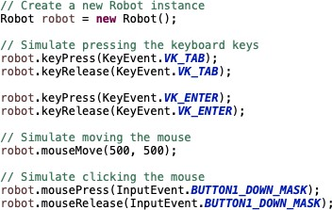

##### JavaScriptExecutor Interface

**JavaScriptExecutor** is an **interface** in Selenium WebDriver that **allows the execution of JavaScript code through Selenium.** It provides an another approach when regular Selenium locators are unable to perform the operation on a web element. We can use JavaScriptExecutor, to execute custom JavaScript code to interact with elements

1. Enter Text



1. Click the button.



1. Retrieve Page Title



1. Retrieve the Text



1. Refresh Page



1. Navigate Back



1. Navigate Forward



1. Interact with Hidden Element



1. Scroll to the bottom of the page



1. Scroll to the top of the page



1. Scroll to the specific element on the page



1. Scroll to the specific location/pixel



1. Horizontal Scroll



##### TakeScreenShot Interface

To take a screenshot with Selenium, we can use **getScreenshotAs()** from **TakesScreenshot** interface. So first, we have to **create an object** of TakesScreenshot by **downcasting** the **driver instance**

TakesScreenshot screenshot =(TakesScreenshot) *driver*;

Then we need to call the **getScreenshotAs()** and pass the **Output.FILE** as parameter and store inside the

**File Object**. In **java.io** package we have **File class** and we can set that equal to File.

File file = screenshot.getScreenshotAs(OutputType.***FILE***);

Once we take the screenshot, we need to **save the file somewhere in our project**. FileUtils.*copyFile*(file, **new** File("./src/test/resources/screenshot/xyz.png")); To s**ave the file**, we can use the **copyFile()** from **FileUtils class** and pass 2 parameters

* **Parameter1** will be the file object and
* **Parameter2** to location of the file where we want to store



##### Handling Broken Link

To find out if the link is broken or not, first we need to capture all the links from the page. To retrieve all the links, we can use the tagName locator because all the links in HTML DOM will have <a> tag and the link for the <a> tag will be stored inside 'href' attribute.

Using findElements() we can locate, retrieve, and store inside List<WebElement>. Once we have all the links stored inside List<WebElement> then we need to loop through each link and retrieve the href attribute value

Then we can create a **URL** object and open a connection to the link's URL by sending a request. We can use **HttpURLConnection** and pass url to open a connection. Once the connection is established then we can retrieve the response status code.

If the **response status code is greater than or equal to 400 then it is a broken link.** Otherwise, it is considered a valid link.

* **4xx** HTTP status code refers to a **Client-Error,**
* **5xx** status code refers to a **Server-Error**





##### Page Object Model (POM)

**Page Object Model** is a **design pattern**, used in my automation framework **which creates Object Repository for web UI elements**.

Using page object model:

* It reduces code duplication,
* Makes code cleaner,
* Easy to understand,
* And improves test maintenance.

In **Page Object Model**, for each **web page in our application**, I have a corresponding **Page Java Class.** This page class will contain the **WebElements of the web page** and **contains Page Methods** which perform operations on those WebElements.

For example, to **implement Page Object Model**:

* 1. First, I have to **inspect the WebElement** of the page
  2. Second, using **@FindBy annotation** I have to store the in WebElement Object. **@FindBy**



annotation is **used to find WebElement**.

* 1. Third, I have to create **Page Class Constructor,** and, in the constructor, **I need to call PageFactory.initElements method** by **passing the driver object and class reference**. **InitElements** method is **used to initialize web elements**.



* 1. Lastly, I will be **creating page methods** which **performs operations on those WebElements.**



##### Different ways to enter value to text field.

With Selenium, to **enter a value** in textfield we can use **sendKeys()** or **JavaScriptExecutor**





##### WebTable

After locating a webTable element, we can iterate through its rows and columns, then we can perform different actions, that involves retrieving data, searching for a specific value, or interacting with table elements.

* **Locate the table element:**

WebElement table = driver.findElement(By.tagName("table"));

* **Retrieve all rows in the table:**

List<WebElement> rows = table.findElements(By.tagName("tr")**);**

* **iterate through the rows and retrieve data from each cell:**

for (WebElement row : rows) {

List<WebElement> cells = row.findElements(By.tagName("td"));

for (WebElement cell : cells) {

String cellText = cell.getText();

// Perform actions with the cell data

} }

* **Access specific cells using row and column indexes:**

WebElement specificRow = rows.get(rowIndex);

WebElement specificCell = specificRow.findElements(By.tagName("td")).get(columnIndex); String cellText = specificCell.getText();

// Perform actions with the specific cell data

##### WebDriverManager

WebDriver Manager is a tool that helps in managing the WebDriver executables, it removes the manual effort of downloading the executable files, setting the paths, and constantly checking the versions, which is time-consuming and inefficient.

**To use WebDriverManager**

* First, we need to include the **dependency** in our project.
* Then, we can configure the WebDriver Manager to **download the appropriate WebDriver executable** for our target browser.



* When we run our test, WebDriverManger **automatically checks for the latest version** of the WebDriver executable **and downloads it** if it is not already present.
* After downloading, WebDriver Manager **sets the necessary system properties** to ensure that the executable is detected and used by Selenium.
* Finally, we can create an instance of the WebDriver for the desired browser



**Selenium Grid (Completed)**

##### What is Selenium Grid and how does it work?

Selenium Grid is used to run tests on different machines against different browsers in parallel.

**We use Selenium Grid in the following scenarios:**

* + Execute your test on different operating systems
  + Execute your tests on different versions of the same browser
  + Execute your tests on multiple browsers
  + Execute your tests in parallel and multiple threads

**Here’s how Selenium Grid works:**

* + **Hub**: Hub is the central point of the entire GRID Architecture which receives all requests. There is only one hub in the selenium grid. Hub distributes the test cases across each node.
  + **Node**:
    - Node is a remote device that consists of a native OS and a remote WebDriver.
    - It receives requests from the **hub** in the form of JSON test commands and executes then using WebDriver.
    - There can be one or more nodes in a grid.
    - Nodes can be launched on multiple machines with different platforms and browsers.
* **Test Execution:**

The client (test script) communicates with the hub to request a specific test configuration. The hub determines an available node that matches the requested configuration and assigns the test execution to that node. The **test script is then executed on the assigned node.**

* **Result Reporting:**

After the test execution, the results are collected and reported back to the hub. The hub in turn provides a report to the client.

##### What are the advantages of using Selenium Grid?

* Selenium Grid gives the flexibility to distribute your test cases for execution.
* Reduces batch processing time.
* Can perform multi-browser testing.
* Can perform multi-OS testing.

##### How to set up a Selenium Grid?

* **Set up the Hub:**
  1. Launch a machine or server that will act as the hub.
  2. Download the Selenium Server (also known as Selenium Standalone Server) from the official Selenium website. It is a JAR file that contains the necessary components for running the hub and nodes.
  3. Start the hub by running the following command in the command line: java -jar selenium-server-standalone.jar -role hub

The hub will start and listen for incoming test requests on a specified port (default is 4444).

* **Set up the Nodes:**
  1. Configure the nodes. For example, different browser versions, operating systems, or device emulators.
  2. On each machine or virtual machine that will act as a node, download the Selenium Server JAR file. Start the node by running the following command in the command line:

java -jar selenium-server-standalone.jar -role node -hub http://<hub_address>:<hub_port>/grid/register

Replace **<hub_address>** and **<hub_port>** with the **actual address and port** of the hub.

0. The node will register itself with the hub and make its capabilities (browser, version, platform) available for test execution.

* **Verify the Grid Setup:**
  1. Open a web browser and navigate to the hub's console by entering the hub URL in the address bar (e.g., http://<hub_address>:<hub_port>/grid/console).
  2. The console will display information about the connected nodes, their capabilities, and their availability for test execution.
* **Execute Tests on the Grid:**
  1. Modify your test scripts to use the hub's URL for remote WebDriver creation instead of the local WebDriver.
  2. Specify the desired capabilities for the test, such as browser type, version, and platform, to match the configurations available on the grid.
  3. Run your test scripts, and they will be distributed and executed across the nodes in the grid.

**API (Completed)**

##### API vs Webservice

* + Webservice is an API wrapped in HTTP Protocol and part of Internet
  + **All webservice are API, but APIs are not webservice** Because APIs can be tested in local systems as well without accessing the internet.
  + Web Service might not perform all the operations that an API would perform
  + A **web service needs a network** while an API does not need a network for its operation.

##### SOAP API vs RESTful API

**SOAP API:**

* + Simple Object Access Protocol.
  + It is used for message exchange between service and application in **XML format.**
  + Is a wrapper over HTTP protocol, internally **it used HTTP** protocol to transfer and receiver XML messages
  + **ONLY supports POST** Type Request

**RESTful API:**

* + Representational State Transfer.
  + RESTful APIs **commonly use JSON** (or sometimes XML) for message formatting, since it is a **simpler and more lightweight** data interchange format.
  + **Response** can be in format **HTML, XML, plain Text, JSON, PDF**, etc.
  + Data and functionality that a client can access from server called **Resource**
  + it uses standard **HTTP methods (GET, POST, PUT, DELETE)** to perform actions on resources.

##### HTTP METHODS

I worked with different HTTP Method, we have GET, POST, PUT, PATCH, DELETE methods

* **GET** is used to retrieve existing resource
* **POST** is used to create new resource
* **PUT** is used to update existing resource
* **PATCH** is used to update partial and
* **DELETE** is used to delete resource
  1. GET Request
* **GET** Method is used to **retrieve data from resource**.
* GET Method **does not modify data**.
* GET APIs should be idempotent(unchanged), which means that making multiple same requests must produce the same response from server until another HTTP Methods(POST or PUT) has changed the value of the resource on the server
* GET Method **does not contain body**. When sending GET Request we do not provide any method body
* For any given HTTP GET API, **if the resource is found on the server**, then it must return HTTP response code **200 (OK)** – along with the response body which is usually either ***XML or JSON content***
* In case **resource is NOT found on server** then it must return HTTP response code **404 (NOT FOUND)**
* If the **GET Request itself is not correctly formed**, then server will return HTTP response code

**400 (BAD REQUEST)**

* 1. POST Request

 POST Method is used to create a resource

* **If the resource has been created on the server**, the response SHOULD be HTTP response code **201(Created)** and contain an entity which describes the status of the request and refers to the new resource
* **Many times, the action performed** by the POST method might not result in a resource that can be identified by a URI. In this case, either HTTP response code **200 (OK) or 204 (No Content)** is the appropriate response status
* POST Method **requires a request body.**
* The data sent to the server with POST is stored in the request body of the HTTP request
  1. PUT Request
* PUT Method is primarily used to **update existing resource in a server**. If the resource does not exist, then PUT API may decide to create a new resource or not)
* If a **new resource has been created** by the PUT API, the server MUST inform the client via the HTTP response code **201 (Created)** response
* If **an existing resource is modified,** either the **200 (OK) or 204(No Content)** response code SHOULD be sent to indicate successful completion of the request
* PUT Method **requires a request body.**

**NOTE***: The difference between POST and PUT** is that PUT requests are idempotent. That is, calling the same **PUT request multiple times will always produce the same result**. In contrast, **calling a POST request repeatedly have side effects of creating the same resource multiple times**.

* 1. PATCH Request
* PATCH Methods are used to **make partial update on a resource**
* PUT requests also modify a resource entity so to make more clear - PATCH method is the correct choice for **partially updating an existing resource** and **PUT should only be used if you are replacing a resource in its entirety**
  1. DELETE Request
* DELETE Methods are used to **delete resources** (identified by the Request-URI)
* A successful response of DELETE requests SHOULD be HTTP response code **200 (OK)** if the response includes an entity(response body/message) describing the status
* 202 (Accepted) if the action has been queued
* 204 (No Content) if the action has been performed but the response does not include an entity (response does not have body/message)
* DELETE Operations are idempotent. If you DELETE a resource, it is removed from the collection of resources
* Repeatedly calling DELTE API on that same resource will not change the outcome- however calling DELTE on a resource a second time will return a **404(NOT FOUND)** since it was already removed
* DELTE Method does not require method body. We mention in the URI the resource information (id)
  1. HEAD Request
* HEAD Method is almost **identical to GET Method, but without the response body**
* In other words, when we perform GET Request the Server will return with response body, however when we perform HEAD Request the Server will not return response body
* HEAD requests are useful for checking what a GET request will return before actually making a GET request- like before downloading a large file or response body
  1. OPTION Request
* OPTIONS Method is used to **describe the communication options for the target resource**
* OPTIONS Method allows the client to determine the options and/or requirements associated with a resource, or the capabilities of a server, without implying a resource action or initiating a resource retrieval

##### Status Code





1. Authentication
2. What is Authentication?

u

* + Authentication is the process of **verifying the identity of the client** making a request to access or interact with an API.
  + It **ensures that only authorized users or applications can access the protected resources** or perform certain actions within the API.
  + Authentication is crucial for API security and helps **prevent unauthorized access.**

1. Types of Authentications
   * **Basic Authentication:**
     + The client sends **the username and password in base64-encoded** format with each request.
     + This method is simple but less secure as credentials are sent in each request.
   * **API Keys:**
     + Clients use **a unique API key,** typically provided by the API provider, to authenticate themselves.
     + The key is included in the request, either as a query parameter or in the headers.
   * **OAuth:**
     + OAuth is an authorization framework that allows users to **grant third-party applications limited access** to their resources **without sharing their credentials.**
     + It involves the exchange of access tokens after user authentication.
   * **JWT (JSON Web Tokens):**
     + JWT is a popular method for token-based authentication.
     + It uses **digitally signed tokens** to authenticated clients.
     + after successful authentication. Clients include the token in the request headers to authenticate themselves.
     + JWTs can contain information about the user or client.
2. Where do you add authentication?

We use the **"Authorization" header** field to include the authentication token. The value of the "Authorization" header typically follows a specific format based on the chosen authentication method.

For example:

**for Bearer Token**: **The value of the "Authorization" header** is **"Bearer {token}"**.

##### API Testing Process

In my current team, we do have both **UI and Web service User Stories**. When I am working with user story that is web service, I use different testing approach and tools in order to test.

All our webservice is RESTful API. In order to test:

1. First, **I need to understand the requirements**,
2. And need to make sure I **have all the information in order for me to make a request** to server.

For example, If I am **sending POST Request**:

1. **First**, I need to make sure I have the
   * **Endpoint**
   * **Headers if required**
   * **Query parameter if required**
   * **And Request body**
2. **Second**, using **SoapUI or Postman** I will do **manually webservice testing** to make sure I can send a request and get response for server
3. **Third**, once I send a request and server responds**, I need to validate if I am receiving correct status code**.
4. **Lastly**, after validating the status code, I will v**alidate the response body to make sure the expected and actual fields are matching.**

##### What do you validate from response?

When it comes to validation, depending on the requirements I will be performing different types of validation.

Initially I need to verify that the HTTP status code returned in the response is the same as the expected one. **For example**, a successful request typically returns a **200 OK** status code, while an error might result in a **400** or **500 Level** status code. We need to make sure that the status code aligns with the expected behavior of the API for the given request.

Then, I will validate the response body. When it comes to response body validation, it really depends on the requirement

* I might have to validate specific fields or required fields within the response body or
* I might have to validate everything in the response body or
* I might have to validate the structure of the response body or
* I might have to validate the response header and response time or
* I might have to validate the correctness of the data server responding by connecting to the application database and writing query to cross validate to ensure what the response body has aligned with the application database.

1. **Rest Assured Library**: Example of how to perform API Testing with Rest Assured Library

When automating APIs with **RestAssured Library**, I need to ensure that I have the required dependencies in my **pom.xml**.

In my automation framework I have **two important dependency** that allows me to automate and perform different types of validation depending on the requirement.

* + I have **RestAssured Library dependency** that will allow me to use the built-in feature to interact with the server and
  + I have **JsonPath dependency** that will allow me to extract data within the response body.

**Before making a request** I need to make sure I have

* + **Headers** if required
  + **Query Parameter** if required
  + **Authentication** if required
  + **RequestBody** if required

**Once I have all the information** to construct the request to server I will use built-in methods from RestAssured Library. The methods in **RestAssured Library** are **similar to Gherkin keywords** but in terms of **methods**.

In **Gherkin Language** we have **Given**, **When**, **Then**

* + **Given** is the **precondition**
  + **When** is the **action**
  + **Then** is the **outcome**

In **RestAssured** we have

* + **given()** method,
  + **when()** method,
  + **then()** method

**For example**, to make a **POST Request** using **RestAssured Library.**

* + First I will create **Response object**
  + Then I will set

**responseObj** = **given()**

.**headers()** and pass headers as argument

**.params()** and pass parameters as argument

**.body()** and pass the body as argument

**.when()**

**. post()** and pas the URL as argument

.**then()**

**.extract()**

**.response();**

**Depending on the requirement** I will be performing **different types of validation**. First I will **validate the response status code**. To get the status code. I will use **responseObject.getStatusCode()** method.

After the status code validation, I will be **validating the response body**.

For the **response body,** I am using **JsonPath dependency**. With **JsonPath dependency** I will be able to

**extract** the response body and **perform validation**. **To achieve that**, I will create **JsonPath Object**:

**JsonPath jsonPathObject** = **responseObject**.**jsonPath();**

Then I can pass the path of the **jsonObject** or **jsonArray** to **getString()** method from **JsonPath Class**. Once I am **done extracting** the **actual field values** from response body then I will be using **Assertions**

from **TestNG** to **check if the expected and actual values are matching**.

Within the **TestNG Assertions** we have **two different types**:

* + **Hard Assertions** and
  + **Soft Assertions**

All the methods in the **Hard Assertion Class** are **static**, so we don’t need to create a class object to access. We can simply say **Assert**.**assertEquals()**

The methods in the **SoftAssert Class** are **not static**, and we **need to create class object** then we will be able to use the methods.

The **main difference** between **Hard Assert** and **Soft Assert**.

* + In **Hard Assert**, when the **actual value** and **expected values does not match** then it will **throw exception** and **STOP the execution**
  + In **Soft Assert**, when the **actual value** and **expected values does not match** then it will **NOT throw exception immediately and the execution CONTINUES**.
    - In **Soft Assert**, **at the end of our script** we will use **assertAll()** method. This method will **collection the outcome of all assertions** whether **failed** or **passed**. If any of our **assertions failed** then **it will list out those and then throw an exception.**

##### **Karate API**: Example of how to perform API Testing with Karate API

For API automation I have used both RestAssrued and Karte APi

Currently I am using the Karate API and I can walk you through with one the scenarios I have automated

The structure of our framework is a bit different. For example, one of the API stories I have automated is to update existing record info.

So, what I have is JSON file where I can get the request body and the fields in the body are parameterized. I have a runner class which has the two annotations @RunWith and @KarateOptions.

And I have the feature file, in my scenario what I am doing is reading the request body from json file using the read method by passing the classpath of the file and store the result inside an object variable.

To create an object, I will use DEF objectName.

Then using the SET method, I will be replacing the values that I passed in my example table. Once I am done replacing the data, I set up the headers, query parameters, the path and making a PUT request to the server.

Once I have a response then I verify the status code and some of the response fields.

If I am verifying specific field in response then I will use the JSON path, and match method to validate.

##### How do you handle when the server response status code is in the 500 level?

When we have status code that is in 500 Level, then it means something wrong with the server. I would log the details of the error, including the request and response information, to help with troubleshooting.

If the error was a one-time occurrence, I would retest the API to see if the error still occurs. It's possible that the error was caused by a temporary issue on the server side.

If the error is consistent and occurs multiple times, I would report it to the development team. I would create defect and include the details of the error, along with any relevant logs or screenshots, to help the development team troubleshoot and fix the issue.

I would also validate other functionality related to the API to ensure that the error hasn't caused any unexpected side effects.

##### How do you handle when the server response status code is in the 400 level?

When we have status code that is in 400 Level, then it means something wrong with client side. I would first check the request data to ensure that it is correctly formatted and contains all the required parameters.

I would validate the response body and headers to see if they contain any additional information about the error (for example: authentication failure).

I would verify the API documentation to ensure that I am using the correct endpoint, parameters, and HTTP method.

If possible, I would try to reproduce the issue using the same request data in a tool such as Postman.

If the issue is reproducible or persistent, I would report it to the development team along with the details of the request and response. I would also provide any relevant logs or screenshots to help the development team troubleshoot and fix the issue.

1. **RestAssured Library:** How do you validate the response body, which dependency do you use?

**Depending on the requirement** I will be performing **different types of validation**. First I will **validate the response status code**. To get the status code. I will use **responseObject.getStatusCode()** method.

After the status code validation, I will be **validating the response body**.

For the **response body,** I am using **JsonPath dependency**. With **JsonPath dependency** I will be able to

**extract** the response body and **perform validation**. **To achieve that**, I will create **JsonPath Object**:

**JsonPath jsonPathObject** = **responseObject**.**jsonPath();**

Then I can pass the path of the **jsonObject** or **jsonArray** to **getString()** method from **JsonPath Class**. Once I am **done extracting** the **actual field values** from response body then I will be using **Assertions**

from **TestNG** to **check if the expected and actual values are matching**.

Within the **TestNG Assertions** we have **two different types**:

* **Hard Assertions** and
* **Soft Assertions**

All the methods in the **Hard Assertion Class** are **static**, so we don’t need to create a class object to access. We can simply say **Assert**.**assertEquals()**

The methods in the **SoftAssert Class** are **not static**, and we **need to create class object** then we will be able to use the methods.

The **main difference** between **Hard Assert** and **Soft Assert**.

* In **Hard Assert**, when the **actual value** and **expected values does not match** then it will **throw exception** and **STOP the execution**
* In **Soft Assert**, when the **actual value** and **expected values does not match** then it will **NOT throw exception immediately and the execution CONTINUES**.

In **Soft Assert**, **at the end of our script** we will use **assertAll()** method. This method will **collection the outcome of all assertions** whether **failed** or **passed**. If any of our **assertions failed** then **it will list out those and then throw an exception.**

Cucumber(Completed)

##### What is Cucumber?

**Cucumber** is a tool that supports **behavior driven development(BDD)** which is used to write acceptance tests for the application. It allows automation of test case in simple readable format called **Gherkin**

##### Advantages of Cucumber

There are many advantages of use Cucumber within our Framework. It is very easy to share our test scenarios with **non-technical team members**, **ability to generate user friendly cucumber report** and most importantly it is very easy to write the test scenarios using **Gherkin** format.

During our Sprint demo, when demoing user stories with the Stakeholders and Team, I am sharing the scenarios from the Feature file which reduces miscommunication.

##### Disadvantages of Cucumber

Based on my experience writing test scenarios and automating, one thing that **Cucumber does not have is the OOP Concepts**. For example, we are writing a lot of **repetitive Steps** in each Feature file, instead of having the capability to call another step or reuse steps from one Feature file to another Feature file.

It would be very helpful if we could re-use some of the steps instead of re-writing in a different Feature file.

But overall, **Cucumber has a lot of advantages and most importantly it reduces the gap between technical and non-technical team members.**

##### Cucumber Components

READ

The main components of Cucumber are **Feature File, Runner Class** and **Step Definition**. In my BDD Framework, the process of automating the User Story starts with writing the Scenario in Gherkin Format in the feature file.

**Each step in the Feature File** has the associate java method which is stored in the **Step Definition Class.**

**Runner Class** is where I am executing the Feature File and it links-up the Feature File and Step Definition. In Runner Class we have two important annotations **@RunWith** and **@CucumberOptions**

**@RunWith** annotation allows us to execute class as Cucumber Test and

**@CucumberOptions** allows us to specify different properties that will be applied to our test such as

**Feature**, **Glue**, **Tag**, **plugin**

**Feature property** where we provide the path of the feature file

**Glue property** where we provide the path of the step definition.

##### Runner Class

In Runner Class we have two important annotations **@RunWith** and **@CucumberOptions @RunWith** annotation allows us to execute class as **Cucumber Test** and

**@CucumberOptions** allows us to specify different properties that will be applied to our test such as

**Feature**, **Glue**, **Tag**, **plugin**

**Feature property** where we provide the path of the feature file

**Glue property** where we provide the path of the step definition.

##### Step Definition Class

**Step Definition** is a java class that **contains steps methods which are linked to a scenario step** in the **Feature file**. When Cucumber executes Scenario steps, it will look for a matching Step Definition method to execute.

##### Feature File

**Feature file** consists of different types of Keywords, including **Feature**, **Background**, **Scenario**, **Scenario Outline**, **Given**, **When**, **Then**, **And**, **Examples**.

Some of the keywords are mandatory when writing scenarios in feature file. For example,

**Feature** Keyword must be specified on top of each Feature file.

**Background** Keyword is used **when we have common step between different scenarios** in the Feature file.

**Given** is the **pre-condition**

**When** is the **action** we are performing

**Then** is the **outcome**

##### Scenario vs Scenario Outline vs DataTable

**Scenario** represents single testcase or scenario.

**Scenario Outline** is used to **execute the same scenario with different dataset**. When using **Scenario Outline**, we need to use the **Examples** Keyword and provide the different set data.

**DataTable** allows us to pass tabular data as an argument to a step in a scenario or scenario outline.

##### Background Keyword

**Background** Keyword is **used for common steps between all the scenarios** in the Feature file.

For instance, in my automation shakeout suite I have 5 different scenarios that are configured in the Jenkins. For each scenario we must be logged in and landed in the application dashboard page so those steps will be under **Background** keyword in feature file **which will be shared among all the scenarios.**

##### Hooks Class

**Cucumber Hooks** are the **@Before** & **@After** annotations that **run before and after each scenario in Feature file**. By using Cucumber Hooks, it **allows us to better manage the execution flow and reduce code redundancies**.

**TestNG(Completed)**

##### TestNG Annotations

|  |  |
| --- | --- |
| **Annotations** | **Description** |
| **@BeforeSuite** | Runs only once before all @Test annotation methods in the Test Suite |
| **@BeforeTest** | Runs before each @Test annotation method with <test> tag in xml file |
| **@BeforeClass** | Runs before @Test annotation method in current class |
| **@BeforeMethod** | Runs before each @Test annotation method |
| **@Test** | Method contains the test case |
| **@AfterMethod** | Runs after each @Test annotation method |

|  |  |
| --- | --- |
| **@AfterClass** | Runs after last @Test annotation method in current class |
| **@AfterTest** | Runs after each @Test annotation method with <test> tag in xml file |
| **@AfterSuite** | Runs only once after all @Test annotation methods in the Test Suite |

1. How do you handle data-driven testing in TestNG



To achieve **data-driven** testing in TestNG, we can the “**@DataProvider**” **annotation. To implement data driven testing in TestNG**,

* + **First**, I will create the **TestData Provider Method** that will contain the **test data**.
    - This method will have **@DataProvider annotation** and
    - **return** a **two-dimensional array of objects**.
  + **Secondly**, in my **@Test method**
    - I will **specify the data provider name** using **the dataProvider attribute.**
      * and **set that equal to my data provider name**.
    - The **test method parameters** need to be matched to the **test data provided** parameters.



* + Then I will **configure** the **TestNG XML File,** and in my **TestNG XML** file
    - I will **mention the class** that contains the **test method and the data provider method.**



* Lastly I will execute the **xml file**. **TestNG** then will **automatically invoke** the **test method for each data provided by the data provider method.**

##### TestNG Assertions

Within the **TestNG Assertions** we have **two different types**:

* **Hard Assertions** and
* **Soft Assertions**

All the methods in the **Hard Assertion Class** are **static**, so we don’t need to create a class object to access. We can simply say **Assert**.**assertEquals()**

The methods in the **SoftAssert Class** are **not static**, and we **need to create class object** then we will be able to use the methods.

The **main difference** between **Hard Assert** and **Soft Assert**.

* In **Hard Assert**, when the **actual value** and **expected values does not match** then it will **throw exception** and **STOP the execution**
* In **Soft Assert**, when the **actual value** and **expected values does not match** then it will **NOT throw exception immediately and the execution CONTINUES**.
  + In **Soft Assert**, **at the end of our script** we will use **assertAll()** method. This method will **collection the outcome of all assertions** whether **failed** or **passed**. If any of our **assertions failed** then **it will list out those and then throw an exception.**

##### How to PARAMETERIZE

**TestNG Parameters** are the arguments that we pass to the test methods.

There are two ways through which we can pass the parameters to the test methods

* **TestNG Parameters**
* **TestNG DataProviders**

For example, we **want to pass the environment related information** like **URL, username or password**

from file.

* In TestNG XML file we will have **<parameter> tag** with **name** and **value attributes**.
* Then in our **TestNG class**, **above the method declaration we can use @Parameters annotation**

and **pass the attribute name.**





##### How to PRIORITIZE Testcase

Testcase in TestNG executed in **alphabetical order. Prioritization** is one of the features of TestNG that allows us to **provide a sequence to the test methods.**

****The **default value** for the testcase **priority is zero**. If we **do not mention the priority** for the testcase it will take all the testcase as **priority = 0 and execute in alphabetical order.**

##### How to GROUP Testcase

**Grouping** is another important feature of TestNG, that allows us to **group test methods or classes into one or more groups. Grouping** is similar to **tagging** the testcase in **Cucumber Feature File**

We can group testcase by **regionName, releaseNumber or sprintNumber or by moduloName To achieve Grouping:**

* First in our test classes, we can assign groups using **groups attribute in test methods.**
* Then, in **TestNG XML File** we need to have **group tag** and **include tag.**



##### How to perform PARALLEL Testing with TestNG

TODO…

##### How to perform CROSS-BROWSER Testing with TestNG

TODO…

**JUnit(Complete)**

##### JUnit Annotations

With in my current automation framework, I am using **JUnit 4** and some of Junit annotations are:

**@BeforeClass**

* + Method with **@BeforeClass** annotation will run once before any of test methods in the current class.

**@Before**

* + Method with **@Before** annotation will run before each @Test method.

**@Test**

* + Method with **@Test** annotation is the test method to run.

**@After**

* + Method with **@After** annotation will run after each @Test method.

**@AfterClass**

* + Method with **@AfterClass** annotation will run once after all the test in the class have run in the current class.

**@Ignore**

* + Method with **@Ignore** annotation will not be executed. It will be ignored.

**Testing Types(Completed)**

##### Functional Testing vs Non-Functional Testing

**Functional Testing** and **Non-Functional Testing** are **two different types of software testing** which focus on different parts of application quality.

* + **Functional Testing** focuses on **verifying the functionality of the application against the requirements**. It makes sure the functionalities that were built by dev team meets the requirements.
  + **Non-Functional Testing** focuses on **testing the non-functional aspects of the application**

including the **performance**, **reliability**, **usability**, and **security**.

* + When performing the Non-functional Testing, we are testing the behavior of the **system under**
  + **different conditions.**

**QA department focuses on 2 parts**

1. **Functional testing**
2. **A, QA engineer (UI,API,DB testing) focused testing the functionality , manual tester**

**2, non, functional tester, a performance tester b, Security tester**

**IN my current project, we have PERFOAMNCE TESTER that take cares of the performance test activity i focus more on the functional testing and automation framework**

**This role requires 5-10 % of performance testing will be able to do that ?**

**This is why i am in the market i want to learn and work with different technology stack. With my current team i didn’t get chance to do performance testing but i would love to work with those tools, i will spend some time into and learn.**

**An example of Functional Testing** are

* + **Unit Testing,**
  + **Regression Testing,**
  + **Smoke Testing or**
  + **End to End Testing**

**An example of Non-Functional Testing** are

* + **Load Testing,**
  + **Usability Testing,**
  + **Stress Testing, or**
  + **Accessibility Testing**

**In my project,** I have focused mainly on performing the **Functionality Testing**. I am very comfortable performing **UI Testing, API Testing** and **DB Testing** for data validation.

I have **not done** any **Non-Functional Testing** including **Performance Testing** or **Security Testing** because we have separate team that handled.

##### Verification vs Validation

**Verification**

* + Is the **process of checking** the requirement document, design and technical document to make sure the software has been built according to the requirements.
  + It focuses on the **early stage of Software Development Lifecycle.**
  + The **main purpos**e of the verification to make sure the requirements are defined correctly.

**Example o in f Verification activities can be**

* + **Requirement review:** By checking the requirement documentations to check if they are clear, complete, and consistent.
  + **Code review:** By checking the source code to make sure there are no bugs or errors.
  + **Design document review:** By checking the software design to make sure it is aligned with requirements.

**Validation**

* + Is the **process of testing and validating** the **actual product against the requirement.**
  + Once the Dev team finishes the implementations and delivers to the QA team then we as a QA **perform different types of testing** to ensure the application functionality is aligned towards the requirements.

**Example of Validation activities can be:**

* + **Performing Functional Testing:** Testing the functionality against the requirements
  + **Performing Non-Functional Testing:** Testing the performance, or security testing
  + **Performing Usability Testing :** Testing the user friendliness and easy use of the application

##### Functional Testing Types

1. Unit Testing

**Unit Testing** is a type of testing where individual units or components of software tested.

**For my team,** the **Unit Testing** is done by the **Dev Team.** Before the **Dev Team** deploys the code to test environment, the code review needs to be done internally within the Developers then the **Unit Test Job** should be executed.

**One of the rules we have within our organization**, prior the **Testing Team** kicks of the Testing activity, the **Unit Test Job must be executed by the Developer** and the **pass percentage** should be **85 % or above**.

If the **Unit Test pass percentage below 85 %** then

* **Dev Team will not be able to deploy** and
* **Testing activity won’t start** until the **Unit Test failures are fixed.**

For my **automation scripts**, I do write **Unit Test** to ensure the code I have written is working properly. For Unit Testing, I have used **JUnit** and **TestNG**.

I have **not done Unit Test for developers code** but if it is something I have to do, I don’t mind doing as long as I have quick walks or code review with developer, so I have understanding about the requirement and source code.

1. Integration Testing

**Integration Testing** is a type of testing where **individual units are combined and tested as a group**. It focuses combining different components of the application and making sure it works correctly together and behaves as expected.

With my current application, I had to perform **Integration Testing** for the **Search Functionality**. The **Search Functionality** for our application consists of multiple components including.

* **search input field,**
* **search algorithm and**
* **search result display.**

The **Integration Testing,** I performed focused on making sure the **correct integration and behavior of different components**.

I had to:

* Verify that the search input field correctly handles different inputs.
* Validate that search algorithm interacts correctly with the search input and returns accurate results.
* Verify the search results are properly displayed and relevant information is presented.
* Validate the handling of errors related to search functionality.

1. Smoke Testing

**Smoke Testing** is a type of testing which is performed to check whether the **Critical Functionality** of the

**application is working correctly**, and **the environment is stable enough**.

1. Explain your Smoke Suite

**One of my responsibilities** is to ensure the first thing in the morning we perform the daily **Smoke Testing** and provide execution result update to the team prior daily stand up. **Initially when I joined the team**, the **Smoke Testing** was performed **manually** by our Functional Tester.

Once I had access to the tools and application, I was able to automate the Smoke Testcases and configure **Jenkins Job** to kick of **Monday – Friday 6AM**.

Currently, in our **Smoke Suite** we have **5 testcases** that focus on the main functionality of the application, and it kicks of daily by **Jenkins**. The execution takes about 2-3 minutes.

If any of the **testcases fails**, I usually **take a step back**, **refer to the logs** and **figure out the root cause** of the **failure**. Sometimes **failure** can be because of the

* **Test Data issue**
* **Or Environment related issue**
* **Or Test Script issue**
* **Or an application defect.**

Depending on the **failure type**, I usually take necessary steps and provide updates to the team during our **daily stand up**.

* If it is **Test Data issue**, or **Test Script issue**, I will **ensure to apply necessary fix** to the script then push to the remote and **re-execute the Smoke Job**.
* If it is an **Environment Related issue**, I will **document my observation** and put a word document file with screenshots and explanation **then reach out to the Environment Team** and let them know about the issue.
* If it is **Application Defect**, I will **cross validate against the requirement**, **double check to make sure I can reproduce**, then **check other environments to see if the defect exists in other regions**.
  + Once I am **done with my analysis and verification part** then I will put a **document together** and **provide steps to reproduce along with screenshots** and any additional information that will be helpful for our developer.
  + **Once I have put together the document**, then I will **create a defect in Jira and attach the file** then **bring it up during the stand-up meeting**, so the rest of the team is aware of the issue.

1. Sanity Testing

**Sanity Testing** is a type of testing performed to check whether the **critical and commonly used functionalities** of an application are working as expected **after minor code changes or bug fixes** by the dev team.

**Sanity Testing** focuses on **validating that the recent changes or fixes** have **not introduced new bugs or issues to the application.**

We can also consider **Sanity Testing** as a **subset of the Regression Testing** because it **focuses testing specific features** which have been **affected** by **recent changes**, instead of testing all features of application.

1. Smoke Test vs Sanity Test

**Smoke Testing** is performed to check whether the **Critical Functionality** of the **application is working correctly**, and **the environment is stable enough**.

**Sanity Testing** is performed to **check that the recent changes or bug fixes by Dev team** have not introduced any major issues to the application.

1. Regression Testing

**Regression testing** is a type of testing that focuses on verifying the **bug fixes or changes that were made to application code** by the Dev team and **didn’t introduce new defects or caused previously working functionalities to fail.**

**Regression Testing** makes sure the **existing features and functionalities** of the application **continue to work as expected after a code change or bug fix.**

1. Explain your Regression Suite

In my **Regression Suite**, I have about **185 Testcases.**

* Out of 185 Testcases, about **100 Testcases** are **UI related testcase.**
* and **85 API Testcases.**

It takes about **6 hours** to **execute the entire Regression Suite.**

We execute **Regression Suit every Friday at the end of the day before we log off.** We have **Jenkins Job** that is configured and prior logging off, one of the QA members will manually Build via Jenkins Dashboard.

1. Re-Testing Testing

**Retesting** is a type of testing that focuses on verifying that the **defect or issues reported in a previous testing cycle** have been **fixed correctly.**

**For example**, when I am **testing a functionality,** I found that the functionality is **not behaving according to the requirement**.

Then I will **take step back** and

* Try to **reproduce**,
* Double check the **requirement**,
* Find out the **type of issue** and then document everything then create a defect log on Jira.

When the **dev team fixes the defect** I reported, then I will **re-test by running the same testcase** to make sure the issue is fixed.

1. UAT Testing

**UAT (User Acceptance Testing)** is a type of testing performed **from an end user’s perspective** to make sure the **application meets** the **user requirements, expectations**, and **it does what it is supposed to do**.

**UAT Testing** is usually the **final phase of testing before it goes to production.**

**UAT** involves **real world scenarios** and **is usually conducted** by the **end users or stakeholders** who will be using the application.

The main **goal of UAT Testing** is to validate the application **functionality**, **usability**, and **overall user satisfaction.**

1. End-To-End Testing

**End-to-end** testing is a type of testing performed to make sure **the application functionality, data flow, user experience and different parts of the application layer** works as expected and meets the user expectations from **start to finish.**

For example,

In our application we have **Retrieval Page** where we can search by the **account number.**

When we search by account number then it will display the member information which the account belongs in web table format

After **verifying the search result** then I have to go back to the **application database** and **cross validate by writing query** with same account number and **making sure the resultset will have same output as what UI have displayed.**

##### Non-Functional Testing Types

1. Performance Testing

**Performance Testing** focuses on testing the **speed**, **responsiveness**, **stability**, **scalability** of an application under **different workloads**.

In our organization we have **Performance Testing Team**, that focuses on performing different types of testing including **Load Testing, Stress Testing, Volume Testing or Scalability Testing**.

I have **not done** Performance Testing, mainly focused on **Functional Testing**.

I am aware that our **Performance Team** uses **JMeter** which is **Java based library** and **I have strong Java background picking a new tool won't be challenging.**

1. Load Testing

**Load Testing** focuses on testing the **behavior and performance of the application under normal and peak load conditions**. It simulates realistic workloads and measures the application response time and behavior.

1. Stress Testing

**Stress Testing** focuses on testing the **behavior, stability and reliability** of the application **under extremely heavy load conditions.** It evaluates how software behaves under extreme condition and find out application breaking points.

1. Volume Testing

**Volume Testing** focuses on testing the **behavior and performance of an application** when **exposed to a large volume of data.** It evaluates how **software performance behaves** when the **volume of data increased** in the database.

1. Usability Testing

**Usability Testing** focuses on testing the **user friendliness** and **ease of use** of an application.

Usability testing is a method used in design and development to evaluate a product's user interface and overall user experience by testing it with real users

1. Compatibility Testing

**Compatibility Testing** focuses on testing the **application is compatible with different environments**, **operating system, browser or devices**.

The main goal of **Compatibility Testing** is to make sure the **application functions correctly and consistently** across different **platform, browser, and devices.**

1. Security Testing

**Security Testing** is a type of **Non-Functional Testing** that focuses on **finding the weaknesses**, **vulnerabilities,** and **potential security risks** within an application.

**Security Testing makes sure that the application is able to protect**

* The **sensitive data**,
* Maintain **confidentiality**, and
* **Defend** against any unauthorized access virus attacks.

1. Accessibility Testing

**Accessibility Testing** is a type of testing that **ensures the application being tested and is usable by individuals with disabilities** like hearing, color blindness etc.

1. Reliability Testing

**Reliability Testing** is a process of checking an application’s ability to perform its **intended functions without failures or errors** over **a specific period of time.**

1. Scalability Testing

**Scalability Testing** focuses on testing the performance of the application **when the number of users increases**. It makes sure the **application can handle** when **increase in user traffic and data volume**

1. Configuration Testing

**Configuration Testing** focuses on testing the **behavior and functionality** of an application across different configurations or settings.

# Testing Technique(Completed)

##### Black Box Testing

**Black-Box Testing** is a **technique** in which the **tester does not have access or knowledge of the source code**. The **functionality of the application** is tested **without looking at the code.**

I pretty much perform **Black-Box Testing** when testing the **User Stories that are assigned to me**.

When **testing the functionality**, I will be testing **against the requirement** to ensure the functionality performs as per **requirements expectations.**

##### White Box Testing

**White-Box Testing** is a **technique** in which is performed by **Developer**. In this case the person that is performing the testing **has knowledge of the source code**. **Unit Testing** is an example of **White Box Testing.**

##### Equivalence Partitioning

**Equivalence Partitioning** is a testing technique used to **design test cases** in which **input data is divided into partitions** of **valid and invalid values** and makes sure all partitions have the **same behavior.**

* + If a condition of one partition is true then the condition of another equal partition must also be true.
  + If a condition of one partition is false then the condition of another equal partition must also be false.

It **helps to reduce the number of test cases** and make sures we have **maximum test coverage**.

##### 4. +Boundary Value Analysis

**Boundary Value Analysis** is a testing technique used to **test boundary values** because the **input values near the boundary have a higher chance of error.**

##### Decision Table Testing

**Decision Table Testing** is a testing technique used to **test the behavior of the application** based on

**different combinations of their respective behavior** which is captured in a table format.

##### Error Guessing

**Error Guessing Testing** is an **informal testing technique** where we t**est the functionality based on our experience and knowledge to find defects.**

While using this technique, I usually put myself in **User Shoes** and **try different ways of testing to catch potential errors or defects.**

**Testing Approach(Completed)**

##### Positive Testing

**Positive Testing** is a testing approach in which we **verify the application behaves as expected when provided with valid input.**

##### Negative Testing

**Negative Testing** is a testing approach in which we **verify the application behavior when provided with invalid, or unexpected inputs**. It focuses on testing how the **application handles when invalid input** is provided by user.

##### Exploratory Testing

**Exploratory Testing** is an approach in which we **explore the system and test the functionality** without having all the requirements or set plan.

While we **play around with different functionality of the application**, we will **learn more about the application** and come up with proper testcase.

##### Ad Hoc Testing

**Ad-Hoc Testing** is an **informal and unplanned testing that involves exploring** and testing the application

**without following any testcases or documentation.**

Main purpose of **Ad-Hoc Testing** to find defects by randomly testing and not follow any documentation.

##### Monkey Testing

**Monkey Testing** is a testing technique in **which we enter any random inputs into the application** to find

**unexpected behavior, crashes or errors.**

**Defect (Completed)**

##### What do you do when you find a defect?

Once I find a defect, I usually take a **step back and perform a different set of checklists** before reporting to the team.

* + First I will try to **reproduce the defect**.
    - I will **note down the steps I took that led to the defect** as well as a**ny error messages or unexpected behavior I noticed.**
    - I will also **try checking with different browsers** and in **different regions** to ensure that issue does not exist in other regions.
    - I will also **double check the requirement** to make sure I didn’t miss anything from the requirement standpoint.
  + Once, **I was able to reproduce**, then I will **document the defect**.
    - I usually **create word document fill** and provide detailed report **describing the defect.**

**In this file I will include information including**

* + - * The **Environment** which the defect found,
      * The **expected behavior** and the **actual behavior**.
      * **Steps to reproduce the defect,**
      * I will also include **screenshots along with the logs that generated.**

For **Defect Reporting** we use **Jira**, once the **word document with defect description** is **ready** then I will create defect from **Jira** and attach the file.

After creating a defect on **Jira**,

* + I will **communicate** with my team and let the developer know about the defect.
  + Usually, **we connect via Teams**, and I will walk them through the defect report and will answer if they have any questions.

Once the **developer fixes the defect and re-deploy** I will **follow up and re-test**, **to make sure the issue is resolved.**

* + **If the issue is resolved** I will **update Jira with test results**, **update the team** and **close the defect**
  + **If the issue is not resolved**, then **I will re-assign back to developer** and **let them know.**

##### What does the Defect Report Consists of?

For **defect**, we use **Jira** and **when creating a defect report** there are **different fields** we have to provide including:

* + **Defect Title:** which describes the defect title.
  + **Defect Description:** usually for **defect description I prepare word document file** which includes
    - **Detailed descriptions** about the defect,
    - **Steps to reproduce**,
    - **Expected outcome and actual outcome,**
    - **Screenshots** and any **error messages** or **unexpected behavior.**
  + **Defect Severity:** which will **describe the impact of the defect** to the application.
  + **Defect Priority:** which will **describe the importance or urgency of fixing** the defect.
  + **Defect Environment:** in which environment the defect was detected.
  + **Sprint number:** Which **sprint the defect** was detected.
  + **Linked Issued:** which **links the defect to the user story** that might be blocked.
  + **Defect assignee:** which will be **someone from the team that will be responsible** for fixing the defect.

##### Severity vs Priority

**Defect Severity** refers to the **impact of a defect on the functionality and performance** of the application. It is a **measure of how severe or critical a defect is and how much it affects the application**

**There are 4 levels of Defect Severity: Critical, High, Medium** and **Low Critical:**

* + Is a **critical issue that causes a significant impact** to the application
  + **Example:** Application crashed, Unable to login

**High:**

* + The **main functionality is not working**, **business workflow is broken**, or **performance issues.**
  + **Example:** Retrieving member info not working

**Medium:**

* + Is an **issue that affects the functionality, but does not cause a major impact** on the application
  + **Example:** After adding new job title there is no success message

**Low:**

* + Is an issue that has **minimal impact on the applicatoin and may not require immediate attention**
  + **Example:** spelling mistake, alignments, look and feel issues

##### What you do if developer do not agree with a defect?

There were many times when the **developer did not accept the defect that I created**. I am very positive and get along with all my team members.

When **they do not agree**

* I usually **take a step back and try to understand from their point of view** and **go back to the requirement and see if there is something I missed or misunderstood.**

**After doing my analyses**,

* if **I still disagree** with the **developers point of view**, then I will **set up a meeting** and include the

**PO, BA, Dev**, and other **QA** in my team.

Basically, **during this meeting**

* I will **walk them through the scenario** and **go over my point of view** and let the **developer go over their point of view**.
* And then **gather feedback from the rest of the team.**

**o Based on the teams feedback and comments** we **will try to come to a common understanding and conclusion.**

As a QA and Developer,

* We might have **completely different points of view,** and this is **good for the project success and quality**.
* Sharing each other’s point of view and **choosing the one that benefits the project the most** is the **most important part during this process.**

##### After checking the regression execution report, we have test case failures, walk me through how you would fix the failed test cases.

In my current project,

* + We run the **regression suite** at the end of the day before we log off every Friday.
  + One of my main tasks every Monday when we are back is to refer to the Regression execution report results.
    - If we have failures then it is my responsibility to find out the cause of the failure.

What I usually do when going over the **regression failures**, is

* + **First take a step back and go over the execution report**.
  + I will **scan through** and **categorize the testcases that failed.**
    - Then I will **prioritize the failures by categorizing** the **failed testcases based on severity or impact**. I will focus on critical functionalities first.

**Once it is categorized**, then I will start **debugging the failures** by **going over the logs and stack trace** to find out the failure reason. Sometimes failure can be because of the

* **Test data issue**
* Or it can be **script issue.**
* Or it can be an **Environment issue.**
* Or it can be an actual **application defect**.

**Once I know the cause of the failure then I will take necessary action**

* If it is a **test data issue**, I will **come up with a new set of test data** and try to re-run and make sure it is working.
* If it is **script issue**, then I will i**mplement necessary changes to the code** to make sure we are handling the unexpected, scripted failure issue.
* If it is an **environment issue** then I will **create a document and put necessary information with screenshots and logs** then **touch base with the Environment Team and work closely with them** to resolve the issue and see how we can come up with a solution, so we do not run into similar issues in future.
* If it’s an **actual application defect**, then I will **follow the defect life cycle process** and **double check the requirement**, **try to reproduce and verify against different environment**, then create a document by providing steps to reproduce, screenshots and logs that will be helpful to the dev team. Then create a **defect on Jira and assign to the dev team.**

Once I am done with **Regression failure fixes**,

* I will **document and report the root causes of the failures** and provide a description of what fixes I have applied to fix the failures.

Lastly, we **usually re-group internally with QA Team** and **discuss the failures and the fixes** we have applied and **how we can avoid future execution to reduce the downtime.**

##### For instance, 2 days before release day you found a defect in the application, what do you do as a tester?

As a QA, if I found a **defect 2 days before the release.**

First of all, I will take a **step back and before creating panic to my team,**

* + I will **double & triple check the requirement**,
  + Try to reproduce,
  + Check other regions and try testing with different browser to make sure this an actual defect.

**And if it is an actual defect,**

* + I will create the **defect document** by
    - Providing steps to reproduce,
    - Environment related information,
    - Expected outcome and actual outcome,
    - Include the screenshots and logs that will be helpful to the team.

**Once I have put together the document**

* + I will **report** the **defect to the team IMMEDIATELY**. I will have quick meetings with the dev and PO and **walk them through the issue I have discovered.**

**Once the team is aware of the issue,**

* + Then I will **prioritize the defect**, by clearly communicating with the team the severity and impact of the defect to the application.

Meantime, if any other functionality that we think was impacted, we will try to run the **regression suite**

and make sure other parts of the application were not impacted.

I will also ensure my **manager is aware** of the defect and severity to the application.

**Once the management and leads are aware of the issue,**

* + We will come up with **plan action** and I will **work closely with development team** to **determine the feasibly of fixing the defect within the limited time frame** before release and how **QA team can test** and ensure it didn’t affect other parts of the application.

If needed **I will stay after work hours or spend weekends continuing the testing activity** and **check with QA manager** to see if we can receive help from other QA teams with testing activities.

##### How do you handle the production defect that was reported?

When a **production defect is reported**,

* + First I will take a **step back and go over the defect report and try to understand how to reproduce it.**

Once I have a clear picture of the issue,

* + Then I will **prioritize the defect based** on its severity and impact to the application.

I will **analyze** the defect and work closely with the dev team to go over the logs and **pinpoint the root cause of the defect.**

**During my analyses process,**

* I will try to **find the User Story that is related to the defect** and **go over the testcase we have done** while testing this functionality and **make note on how we missed** to test this specific scenario.

**By reproducing and identifying the root cause**,

* I will **gain more knowledge about functionality** and will work closely with the dev team on resolving the issue.

**Once the Dev starts working on fixing the issue**

* I will **monitor closely s**o when they f**inish with fixes and deploy to the testing environment**, I will r**etest the functionality** and make sure the issue is resolved.

**And once I finished with retesting**,

* I will kick off the **Regression Suite** to make sure the code changes **didn’t affect other parts of the application**.

**After fixing the issue,**

* It will be good practice to **regroup** with the team and go over what we can **improve so we can avoid similar types of issues in future.**

**Exceptions(Completed)**

##### How do you handle exceptions

To handle Exception in my automation script,

I use try-catch blocks to catch exceptions that may occur during test execution.

By encapsulating the code that might throw an exception within a try block, I can catch and handle the exception in the catch block.

In some cases, instead of using the try-catch block, we might use the throws keyword which we can define in the method definition that will indicate the exception might occur.

In my automation framework, whenever an exception occurs, I log the details of the exception using Log4J. Logging the unexpected exception is usually very helpful for troubleshooting and debugging to find the root cause of the exception.

##### Error vs Exception

Error usually refers to severe or critical which we cannot recover, and it is beyond the control of the application. It can be because of out of Memory error or stack overflow error. Usually, OutOfMemoryError or StackOerflowError we generally don’t handle programmatically.

Exception usually refers to problems that occurred within the application code and something we can handle programmatically.

In Java we have 2 types of Exceptions:

* + Checked Exception and
  + Unchecked Exception

Checked Exceptions are checked at Compile Time while Unchecked Exception checked during the Runtime.

##### Advantage of handling exceptions

When an exception occurs during the automation script execution, and if we didn’t handle properly then the execution will terminate and it can cause down times.

The advantages of handling exceptions are that we can avoid the script termination if one of our assertions failed, instead it can continue executing and report the result towards the end of the execution.

We can also generate proper error messages instead of system generated errors which will make the troubleshooting and debugging process much easier.

##### Types of Exceptions

In Java we have 2 types of Exceptions:

* + Checked Exception and
  + Unchecked Exception

|  |  |
| --- | --- |
| **Checked Exception** | **Unchecked Exception** |
| Checked Exceptions are checked and handled at Compile Time | Unchecked Exceptions are not checked or handled at Compile Time, instead it occurs at the time of the Execution which is also referred to Runtime Exception. |
| We cannot ignore Checked Exception, it must be handled before executing | We can ignore Unchecked Exception during the compilation time |
| Usually Checked Exception occurs when the chance of failure is too high | Unchecked Exception typically occurs due to programming mistakes |
| Example of some of common Checked Exception I have encountered are:   * ClassNoFoundException * SQLException * IllegalAccessException | Example of some of the common Unchecked Exception I have encountered are:   * NullPointerException * IndexOutOfBoundException * NoSuchElementException |

##### Try-catch-finally block

Try-catch-finally block is used for exception handling. During the automation script execution, if any exception occurs we can use try-catch-finally block to perform necessary action based on the exception.

Try block will contain a set of statements where an exception may occur. Usually in our automation script, if we think that certain statements in a program might throw an exception, then we can enclose them in try block and then handle the exception in catch block

Catch block follows the try block and used to catch and handle specific exception. We can have multiple catch block, each handling a specific type of exception. When an exception is caught, the program flow continues with the first catch block that matches the thrown exception type

Finally, block is optional and follows the catch block. In finally block we have code that is always executed, regardless of whether an exception occurred or not occurred. In my automation, I have used finally block for cases where I am dealing with database of files, we need to ensure the file that are opened and used by automation script is closed and database connection is closed.

##### Throw vs Throws Keyword

Throw keyword

The throw keyword is used to explicitly throw an exception from a method. In our automation script, if it does not matches the business requirement and if we need to throw the exception then we can use throw keyword. By using throw keyword followed by an instance of an exception class .

The throws keyword is used in the method signature to declare that a particular method may throw an exception. Using throws keyword, we can declare multiple exceptions at a time.

##### Java Exceptions Examples

**NullPointerException:**

Occurs when we try to access or perform an operation on a null reference.

**ArithmeticException:**

Occurs when we try divide number by zero.

**ArrayIndexOutOfBoundsException:**

Occurs when we try to access an array element with an invalid index.

**FileNotFoundException:**

Occur when we try to access a file that does not exist or cannot be found.

**IOException:**

Occurs usually when we are trying to read or write in a file.

**IllegalARgumentException:**

Occurs when an invalid argument is passed to a method or constructor.

##### Selenium Exceptions Examples

**NoSuchElementException:**

Occurs when an element we are trying to locate or interact with is not found on the web page.

**TimeoutException:**

Occurs when a certain condition, such as element visibility or presence, is not met within the specified time limit.

**StaleElementReferenceException:**

Occurs when the element we are interacted no longer exists in the HTML DOM.

**ElementNotInteractableException:**

Occurs when an element is present in the DOM but cannot be interacted with, like clicking or typing into it.

**NoSuchWindowException:**

Occurs when we try to switch to a window that does not exist.

**ElementClickInterceptedException:**

Occurs when an element is present on the page but is not clickable or intercepts the click action.

**UnexpectedAlertPresentException:**

Occurs when an unexpected alert appears on the web page and our script not handling.

**ElementNotSelectableException**

Occurs when we are trying to interact with an element that should be selectable but is not selectable.

**NoSuchSessionException**

Occurs when we are trying to interact with a WebDriver session that no longer exists.

**ElementNotVisibleException**

Occurs when the WebDriver tries to find an element that is hidden or invisible.

##### StaleElementReferenceException

When we have **StaleElementReferenceException**, it means that the **element we are trying to interact with is no longer attached to the HTML DOM**. It can happen if the DOM has been **refreshed or modified after the element was located.**

**To handle this exception,**

* + We can **re-locate the element**. If the element becomes stale because of DOM changes, we can refresh or re-locate the element before interacting with it.
  + We can use **explicit wait** to wait for elements to become available again.

##### Rest Assured Library Exceptions Examples

**InvalidStatusCodeException:**

Occurs when the response status code received from the API call does not match the expected status code.

**JsonPathException:**

Occurs when there is an issue with parsing or accessing data using JSONPath expressions. It can occur if the JSON response structure does not match the expected format or if the JSONPath expression is incorrect.

**SSLException:**

Occurs when there is an issue with SSL handshake during an HTTPS connection. It can occur if the server certificate is not trusted, expired, or does not match the requested hostname.

**RequestSpecificationException:**

Occurs when there is an issue with the request specification, such as missing or invalid headers, query parameters, or body content.

##### Database Exceptions Examples

**SQLException:**

Occur due to issues such as invalid SQL syntax, connection problems, or violations of database constraints.

**ClassNotFoundException:**

Occurs when the JDBC driver class for a specific database is not found. It typically occurs when the required database driver is not included in the classpath or is misspelled.

**SQLTimeoutException:**

Occurs when a database operation exceeds the specified timeout period. It occurs when the execution time of a query or transaction exceeds the timeout value set.

##### Karate API Exceptions Examples

**KarateException:**

Occur because of invalid feature file syntax, incorrect test configuration, or unexpected errors encountered during test execution.

**AssertionError:**

Occurs when an assertion in a Karate test fails. It occurs when the expected result does not match the actual result or when a condition specified in the test script is not met.

**HttpException:**

Occurs when there is an HTTP error status code returned by the API call. It occurs when the response status code is not in the expected range (e.g., 4xx or 5xx status codes).

**ValidationException:**

Occurs when there is an issue with data validation or schema validation in Karate. It occurs when the data or schema validation rules defined in the feature file are not satisfied.

**ConfigException:**

Occurs when there is an issue with the test configuration in Karate. It can occur if there are missing, or invalid configuration settings specified in the **karate-config.js** file.

**Challenges(Completed)**

##### Non-Technical Challenge 1

In my current project as an Automation Tester, one of the major challenges that I have faced is that every time I found a defect, the developer did not agree with me, and he would not accept it as a defect.

Most of the time We had to check with our BA for clarification.. Then I realized the requirements itself were not specific enough, so I understood the requirements differently than the developer.

In the sprint retrospective meeting, I mentioned that we should spend more time on the requirement clarification because that is the key for the project success.

The entire team agreed on my feedback and as a team we did overcome this challenge and the issue was resolved. I think the issue was the misunderstanding and lack of communication. If we come together as a team and discuss, then there is nothing, we cannot resolve.

##### Non-Technical Challenge 2

One of the biggest challenges my team faced was working under time constraint. When the Development Team didn’t deploy the code on time to our region then Testing Team didn’t have enough time for completing the testing activities.

And when the upper management kept asking us about the testing status, some of our team members simply focused on completing the task instead of testing thoroughly, focusing on quality testing or higher test coverage.

So, during the Sprint Retro, I suggested that we should work very closely with the development team and make sure that we are communicating on daily bases.

This insured that our testing team and the development team prioritize the important tasks and work on them first. Any user stories left, would be pushed to the next sprint since it’s not as important as the other ones.

##### Non-Technical Challenge 3

Another non-technical challenge I faced when Covid-19 came to existence and we started working remotely. I've been with the team almost a year by then, and we used to love attending meetings together.

Besides our ceremonies we had a brown bag session where developers and testers from different scrum teams joined together and shared their thoughts on new technologies, and so on. so after the covid we attended our meeting remotely and the engagement level was not as it used to be.

To overcome this challenge, I proposed during our sprint retro is to mandatory webcam on during each or our meetings. This helped us to keep focused and have an active engagement during our sessions. Now it doesn't even matter whether we are having our session online or in person, it has the same impact.

##### Technical Challenge 1

One of the technical challenges I have faced with my current project was during the development process of UI. development team didn’t provide ides or names.

I discussed with developers and brought up during the Sprint Retro meeting about the challenge I was facing and requested them to start adding unique value to the elements, so it will make the automation process a lot smoother.

Once I shared the difference between having the id vs creating a unique XPath and the amount of time I spent automating test cases, it added a lot of efforts. The development team agreed and started adding unique element values for our web application.

##### Technical Challenge 2

As an automation tester, I faced many challenges over the years, one of the most major challenges I had faced working on one of the applications I automated.

In the application my selenium script is supposed to locate an element on the webpage, but due to multiple factors selenium always gave Element Not Clickable Exception , and without clicking on that element the rest of script would fail, and it would be blocked, there was multiple factors to the reason why the element was not clickable, one is that there a pop-up frame that showed up every time and blocked the button,

so selenium wouldn't be able to locate it and I corrected that by having selenium scroll down the page, and there was a defect in the application that after the frame shows and you scroll down , the element I was looking for, would be un clickable which is a bug in the application, so

I corrected that but with a combination of explicit wait times, switching to the frame closing it and switching back to the default content , and then the original element I was looking for would be

visible and clickable

##### Technical Challenge 3

One of the challenges that I faced was the StaleElementException. Our application is dynamic and sometimes we have to navigate back and forth between pages within our application.

Some of the elements, were throwing the StaleElemenentException because it happens when the element is no longer attached to the DOM, or element has been deleted when a part of the page refreshes.

Stale element is basically an element which is not present anymore. In order to handle that exception, we can either refresh the page and try again, or implement the retry method

##### Technical Challenge 4

During my automation testing using Selenium, I faced a challenge related to timeouts and waits. There were scenarios where certain web elements took longer than expected to appear on the page or become interactive. This was particularly challenging when dealing with dynamic web applications or slower network conditions.

To overcome this challenge, I tried different techniques. First, I applied implicit and explicit waits provided by Selenium to pause the script execution and wait for specific conditions to be met.

Explicit waits allowed me to define custom conditions, such as element visibility or availability, and set a timeout for waiting.

This made sure that the automation script didn't proceed until the element was ready to be interacted with.

##### API Testing Challenges

In API testing, I met a situation where I needed to test an endpoint that required a complex authentication mechanism. The API used OAuth2 for authentication, and obtaining the access token was a multi-step process involving several API calls. To solve this challenge, I usedol the RestAssured framework, which provides excellent support for handling authentication. I implemented a custom authentication flow using Rest Assured's authentication mechanism and successfully obtained the access token. Then I included the token in subsequent API requests by adding it to the request headers. This approach allowed mt;bge to automate the testing of the authenticated API endpoints.

##### UI Testing Challenges

One of the technical challenges I have faced with my current project is working with

dynamic elements. It is when the web element is constantly changing its html path and I cannot use regular locators to locate such elements because they will simply not work.

In order to handle dynamic or complex web elements, I will use CSS SELECTOR (appending classes, WildCards), or XPATH (absolute, relative).

Absolute path is represented by a single slash / and starts all the way up from the root of the DOM to reach the desired element. But if during the development process any changes were made in the path, then the path expression will fail.

Sothat's why the Relative path is more appropriate to use between the two - it starts with a double slash I/ and it searches for the webelement anywhere in the DOM structure, so it's much shorter.

So both CSS SELECTOR and XPATH are good options to handle dynamic elements, but if I have to choose one of the two - I would go for the CSS SELECTOR simply because it is faster than xpath.

##### Manual Testing Challenges

When conducting API testing, I frequently encountered the challenge of dealing with large data sets. where some api endpoints require a lot of data in the body part, and they also often return a significant amount of data, and it is crucial to validate the correctness, completeness, and integrity of the returned data.

So, generating test data and validating responses manually was taking me so much time and was error prone since the responses contain a lot of data and nested objects and arrays.

To address this challenge I created test data generation scripts or used data mocking tools to simulate different scenarios.

I also developed techniques to handle validating responses using **json path** where I can access complex objects in the response and validate them, ensuring that the API responses were validated against the expected results.

##### Team Member Challenges

One of the challenges that I have faced with a team member , is with a developer **rejecting** the defects that I have found. When this happens what I like to do is set up a **meeting** that includes **myself, the developer, and the BA**.

In this meeting we **review the requirement** together , and the issue was the requirement wasn’t specific enough. So I have understood the requirement differently than the developer.

In the **sprint retrospective meeting** I mentioned we should spend more time on the requirement **clarification** because that is the key for the project success. The entire team agreed on my feedback and as a team we did overcome this challenge and the issue was resolved.

# FJ8Testcase(Completed)

##### How do you write an effective testcase?

To write an effective testcase, first of all it is important that I **understand the Requirements**. When **reviewing the requirements**,

* + I will try to put myself in **user shoes and think from QA standpoint** and
  + If there are any unclear or not clear then I will ask questions to get clarification.

Usually, PO walks us through during the **Sprint Planning** and I will be asking questions to ensure we are aligned from a **testing point of view.**

Once I **understand the requirement**,

* Then I will put **myself in user shoes** and come up with a **testing objective** on **how I will be testing the specific functionality.**
* By putting myself in the **users shoe** and **thinking outside box** I will be able to visualize on come up with different ways of testing.

**When coming up with Test cases,**

* I will design my testcase in such a way where each testcase is **independent** and **each test case focuses on testing a specific scenario**.

**Depending on the requirements**

* I will also be using different **testing approach and techniques** including
  + Positive testing, Negative testing,
  + Boundary analysis or
  + Equivalence partitioning technique.

I may also **prepare different test data** in order to test certain features.

For test data, we usually use the **test repository** and retrieve from there by **writing SQL Query** and in case if we do not have the test data then I will prepare from my end.

In our project, we write our **testcase in Gherkin format**. For **Testcase management** we use **Xray Plugin** which is part of the **Jira**. Once I am done writing in feature file, then I will move those testcase in Xray Repository.

Once I am done **writing my testcase**, I will set up **testcase review meeting** internally with my QA Team and have their feedback.

##### What are some common testcase design techniques/approaches do you use?

The common test case **design techniques or approaches** I have used are

* + Equivalence Partitioning Technique
  + Boundary Value Analysis Technique
  + Positive & Negative Testing approach
  + Ad Hoc and Monkey Testing approaches

**Equivalence Partitioning**

Is a technique which is used to **design test cases** in which **input data is divided into partitions** of **valid and invalid values** and makes sure all partitions have the **same behavior.** It **helps to reduce the number of test cases** and make sures we have **maximum test coverage**.

**Boundary Value Analysis**

Is a technique used to **test boundary values** because the **input values near the boundary have a higher chance of error.**

**Error Guessing Testing**

Is **a technique** where we t**est the functionality based on our experience and knowledge to find defects.**

**Positive Testing**

Is a testing approach in which we **verify the application behaves as expected when provided with valid input.**

**Negative Testing**

Is a testing approach in which we **verify the application behavior when provided with invalid, or unexpected inputs**. It focuses on testing how the **application handles when invalid input** is provided by the user.

**Ad-Hoc Testing**

Is an **unplanned testing that involves exploring** and testing the application **without following any testcases or documentation.**

**Monkey Testing**

Is a technique in **which we enter any random inputs into the application** to find **unexpected behavior, crashes, or errors.**

##### How do you ensure that the testcase cover all possible scenarios?

To ensure that my test cases cover all possible scenarios. Firstly, I make sure that I **understand the requirement clearly** so I can identify **different use cases, workflows, and scenarios** that needs to be covered based on the requirement.

When **coming up with test cases**, I usually **put myself in user shoes**, **think outside box** and **use different testing techniques and approaches** that best suit for the specific requirement, including

* + Equivalence Partitioning Technique
  + Boundary Value Analysis Technique
  + Positive & Negative Testing approach
  + Ad Hoc and Monkey Testing approaches

**By using these techniques**, I will be able **come up with different scenarios and quality test cases.**

For instance, **Negative testing approach** is crucial when testing the functionality, because we want to

**ensure the application can handle the error** and **behaves as expected when invalid input provided**.

When it comes to **edge cases and boundary conditions**. We can **reduce the number of testcase** and design test cases that cover **values just below, just above, and exactly at the boundaries of input ranges,** so we can still provide maximum coverage with less number of testcases.

Another effective approach we can incorporate is having the **testcase review session internally with other QA Team members**. Incase if I miss any scenario, my team members can catch and provide.

##### How do you manage and track test cases?

In my current team, we use **Jira** as our project management tool, and for test management we integrated it with **Xray**. **Xray** is plugin allows us to manage and track test cases throughout the testing process.

We can **create test cases directly** in **Xray** within the **Jira**. When creating a testcase we use regular templates that include fields such as

* **Test Case ID,**
* **Test Case Description,**
* **Test Steps,**
* **Expected Results, Actual Results, and**
* **Status.**

In **Xray**, we can create custom test issue types including

* **Testcase,**
* **Test Plan,**
* **Test Set, or**
* **Test Execution.**

We also have **Test Repository** in **Xray** which is used to **organize test cases.** We can create repositories based on **features**, **release** or **modulo**.

Within each **Test Repository**,

* We can create **individual test cases**,
* Create **parent-child relationship** between testcases if needed it,
* **Categorize** testcase based on **functionality**, or **priority level.**
* We can also **group** related testcases based on the **release** or **specific sprint.**

**Xray** also supports the **traceability of testcase to requirement**,

* We can **link the testcase to the respective user story in Jira** which will make our life match easier to track and see which requirements have testcases and which ones do not have testcase.

In case if we **found any defect during the testcase execution**, we can **create a defect and link defect to the corresponding testcase in Jira.**

One of the helpful features **Xray** offers is the **metrics and reporting features**,

* It allows us to **generate metrics and report** on **test case execution, coverage, and progress** so the management can refer to the progress we made.

##### How do you handle test cases that fail, and what do you do to resolve them?

When we have failed testcase what I usually do when going over the **failures**, is

* + **First take a step back and go over the execution report**.
  + I will **scan through** and **categorize the testcases that failed.**
    - Then I will **organize the failures by categorizing** the **failed test cases based on severity or impact**. I will focus on functionalities first.

**Once it is categorized**, then I will start **debugging the failures** by **going over the logs and stack trace** to find out the failure reason. Sometimes failure can be because of the

* **Test data issue**
* Or it can be **a script issue.**
* Or it can be an **Environment issue.**
* Or it can be an actual **application defect**.

**Once I know the cause of the failure then I will take necessary action**

* If it is a **test data issue**, I will **come up with a new set of test data** and try to re-run and make sure it is working.
* If it is **script issue**, then I will i**mplement necessary changes to the code** to make sure we are handling the unexpected, scripted failure issue.
* If it is an **environment issue** then I will **create a document and put necessary information with**

**screenshots and logs** then **touch base with the Environment Team and work closely with them** to resolve the issue and see how we can come up with a solution, so we do not run into similar issues in future.

* If it’s an **actual application defect**, then I will **follow the defect life cycle process** and **double check the requirement**, **try to reproduce and verify against different environment**, then create a document by providing steps to reproduce, screenshots and logs that will be helpful to the dev team. Then create a **defect on Jira and assign to the dev team.**

Once I am done with **testcase failure fixes**,

* I will **document and report the root causes of the failures** and provide a description of what fixes I have applied to fix the failures.

##### How do you identify test cases for regression testing?

With my current project, in our regression suite we have around 185 test cases and we usually execute end of the day before we log off every Friday.

We conduct regression test to verify the **bug fixes or changes that were made to application code** by Dev team **didn’t introduce new defects or caused previously working functionalities to fail.**

**Regression Testing** makes sure the **existing features and functionalities** of the application **continue to work as expected after code change or bug fix.**

When selecting test cases for regression testing, it is important to focus on effective and manageable test case selection.

* + I will concentrate on test cases related to recent code or functional changes. These areas are more likely to encounter issues.
  + Make sure the critical functionality of the application has testcases that cover different scenarios.
  + Include test cases in areas where there are frequent defects.
  + Include test cases that cover areas visible to the user, even if the issues are low in severity but

have high priority from the user's perspective.

* + Include all integration test cases to check for any issues that may arise when combining software modules.

##### What are testing metrics?

**Testing Metrics** are the way to measure and monitor the testing activity. It gives insights about testing progress.

Usually when we are discussing about the test metric, it usually answers questions like

* + Total number of test cases, how many passed/failed.
  + How many bugs found were fixed, closed, deferred, or reopened?
  + How long will it take to test?
  + Number of testcase automated vs not automated

**There are different types of metrics. We can have.**

**Test Case Execution Metric:**

Which measures the progress and efficiency of test case execution, including the number of test cases executed, passed, failed, blocked, or deferred.

**Test Coverage Metric:**

Which measures the percentage of requirements, or functionalities covered by the executed test cases.

**Defect Metrics:**

Which track the number of defects, severity and status of defects found during testing.

**Test Automation Metrics:**

Which tracks test automation coverage, execution time, number of testcase automated vs not automated.

##### Type of testcases to automate.

In my current team, we perform **in-sprint automation**, pretty much **majority of the user stories** we are testing needs to be **automated with in the same sprint**. There are some of testcase that may or may not qualify.

When it comes to **deciding which test case to automate**. We usually automate:

* + Test cases that are **executed repeatedly**. By automating repetitive testcase we can save a lot of time.
  + Test cases that **involve complex or repetitive steps.** With automation we can handle more efficiently and accurately compared to manual execution, which can reduce the chance of human errors.
  + If test cases **involve large data set or data driven scenario**, then we can generate random fake data based on the business requirement from script and use it our test case. Preparing test data manually will consume a lot of time.
  + Test cases that **focus on core functionality of the application**
  + Test cases with **long execution time**
  + Test cases that **require compatibility testing**. Where we test same scenario with different browser, device, or operating system.

##### Type of testcases not to automate.

When it comes to **deciding which test case to not automate**. We usually do not automate:

* + Testcases that **focus on the user experience**, **usability** or **visual aspect** of the application because with this testcase its challenging to automate.
  + Whenever we are **performing Exploratory Testing or Ad-Hoc Testing**. Because usually we test the application without any predefined testcases or requirement.
  + If the functionality of an application is **unstable or frequent changes** applied by dev team then we do not automate.

**SDLC(completed) in**

##### Describe SDLC Phase

**SDLC** is an approach to software development that involves a series of **phases** and

**activities.** The main phases of **SDLC** are:

* + **Planning, Analysis**
  + **Design**
  + **Development**
  + **Testing**
  + **Deployment, and**
  + **Maintenance**

Each phase has its own **set of activities and deliverables**, which help to ensure the software is developed to the highest standards.

###### SDLC Phase Summary

* **Planning:** involves determining the scope of the project, identifying requirements, and developing a project plan.
* **Analysis:** involves analyzing the requirements and designing a solution to meet those requirements.
* **Design:** involves creating a detailed design of the solution that was developed in the analysis phase.
* **Implementation:** involves coding, testing, and integrating the solution into the system.
* **Testing:** involves testing the solution to ensure it meets the requirements and functions correctly.
* **Deployment:** involves of production environment and making it available to end-users.
* **Maintenance:** involves ongoing support and maintenance of the application to ensure it continues to function correctly and meet the changing needs of the business.

# STLC (completed)

##### 1) Describe STLC Phase

**STLC i**s the **process of testing software** to make sure that the software meets the requirements. It helps to identify and resolve issues early in the software development process.

In STLC we have different phases, and each phase focuses on the different testing activities. Phase of STLC includes of:

* **Requirement Analysis**
* **Test Planning**
* **Test Case Development**
* **Test Environment Setup**
* **Test Execution**
* **Test Cycle Closure**

**STLC Phase Summary**

* **Requirement Analysis:** involves gathering and analyzing requirements from stakeholders to determine what needs to be tested and how it will be tested.
* **Test Planning:** In this phase, the test plan is developed, which includes identifying test objectives, defining the scope of testing, and identifying the testing environment and resources needed.
* **Test Case Design:** In this phase, test cases are developed based on the requirements and the test plan. This includes identifying test scenarios, test data, and expected results.
* **Test Environment Setup:** In this phase, the test environment is set up to replicate the production environment.
* **Test Execution:** The test cases are executed, and the results are recorded. This involves running tests, reporting defects, and retesting until all defects are resolved.
* **Test Closure:** In this phase, the testing process is completed, and the results are analyzed. This includes generating reports, reviewing the testing process, and identifying areas for improvement in future testing.